Build sequence cards
Read or ask an adult to read. Staff may cut on the table lines.
Cards | Cards
A  Find your plan and your flat marked card. | B  Check lines are 2 cm and 6 cm from the same long edge.
C  Fold the first outer panel up along its line. | D  Fold the other outer panel up. Keep the middle flat.
E  Set two stable supports 10 cm apart. Centre the model across them. | F  Label the model, record your work and store it for next week.
Follow the sequence and explain a check.

Keep the plan in view
Card: 20 cm long and 8 cm wide.
Fold at 2 cm and 6 cm from the same long edge.
Both outer panels turn up. The middle stays flat.
The middle is 4 cm wide. Each side is 2 cm high.
Fit across a 10 cm gap. Add no load today.

Words I can use
My next step is __.
Please steady the card while I __.
I checked __ and changed __.

Help card
Please help me with this step.
I can point to what I mean.
Please read the words or show the step.
I can ask for a pause or private talk.

A visual guide
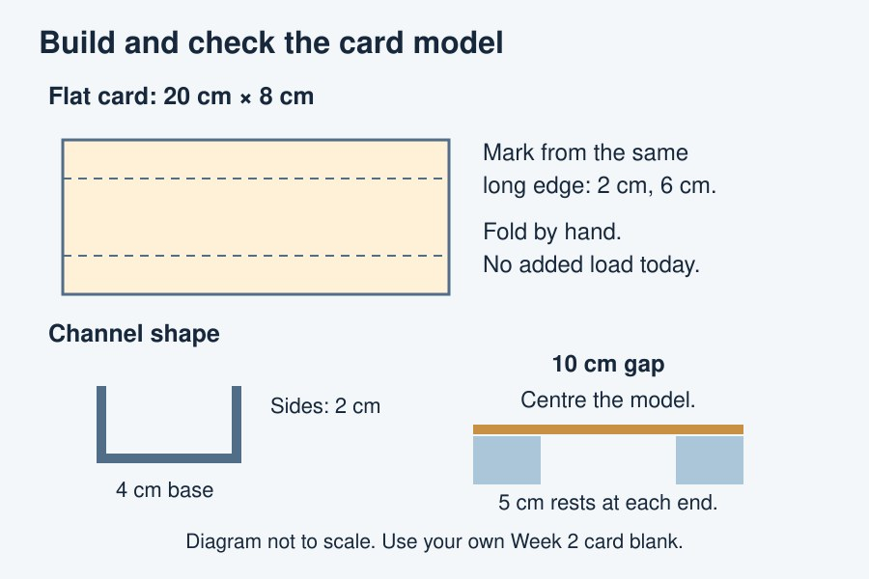
A small card model: two sides up and a flat middle.
The diagram is an example, not a record of your work. It is not to scale. Use a ruler for real dimensions.
I notice __.
The next step is __.
I can ask __ for help.

