Test sequence and stop cards
Read or ask an adult to read. Staff may cut on the table lines.
Cards | Cards
A  Check the model, tray and equal-height supports. Set a 10 cm gap. | B  Use the same set of three identical light blocks.
C  Put one block at the centre. Wait five seconds. | D  If stable, try two blocks, then three. Check for five seconds each time.
E  Stop if the model slips, splits or bends sharply. Tell the adult. | F  Use one result to suggest an improvement.
Follow the sequence and explain a check.

Keep the test fair
Same model and 10 cm gap.
Same type of light block.
Same central loading place.
Five seconds at each load tried.
Stop at three blocks or the first stop sign.
Record what happened, not what you hoped for.

Words I can use
At __ block(s), I saw __.
I stopped because __.
I would change __ because the test showed __.

Help card
Please help me with this step.
I can point to what I mean.
Please read the words or show the step.
I can ask for a pause or private talk.

A visual guide
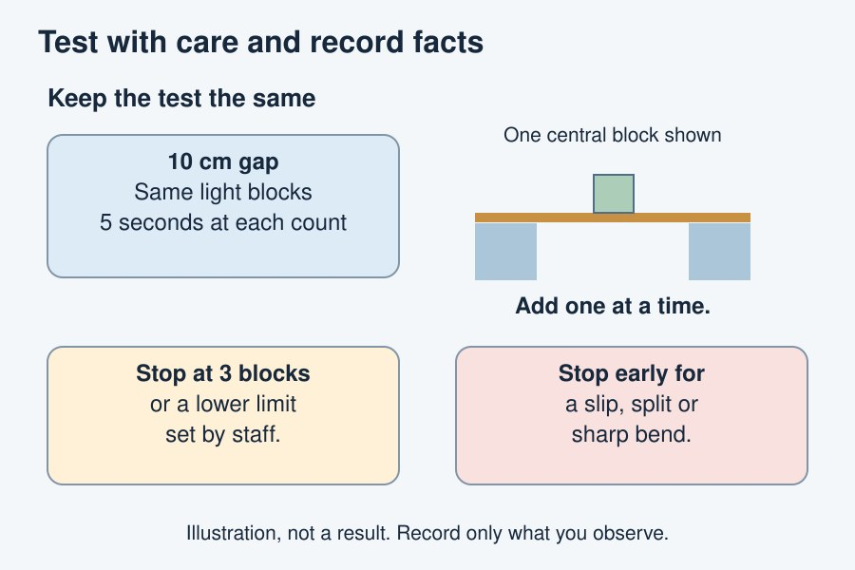
Test only to the agreed limit. Do not seek a collapse.
The diagram is an example, not a record of your work. It is not to scale. Use a ruler for real dimensions.
I notice __.
The next step is __.
I can ask __ for help.

