Process record cards
Read or ask an adult to read. Staff may cut on the table lines.
Cards | Cards
A  Find your marked plan, card model and actual test record. | B  A photo shows your folded model but no test.
C  An adult helped start a fold. | D  A process photo is missing.
E  Your test stopped when the model slipped. | F  A photo includes a pupil name or face.
Follow the sequence and explain a check.

What a caption needs
Say what the record shows.
Say what you did and what help you used.
Use an actual result in your evaluation.
Label a missing photo or later demonstration.
Keep pupil names and faces out of work-only images.

Words I can use
This shows __.
I did __ with help from __.
The test record says __.
I would change __ because __.

Help card
Please help me with this step.
I can point to what I mean.
Please read the words or show the step.
I can ask for a pause or private talk.

A visual guide
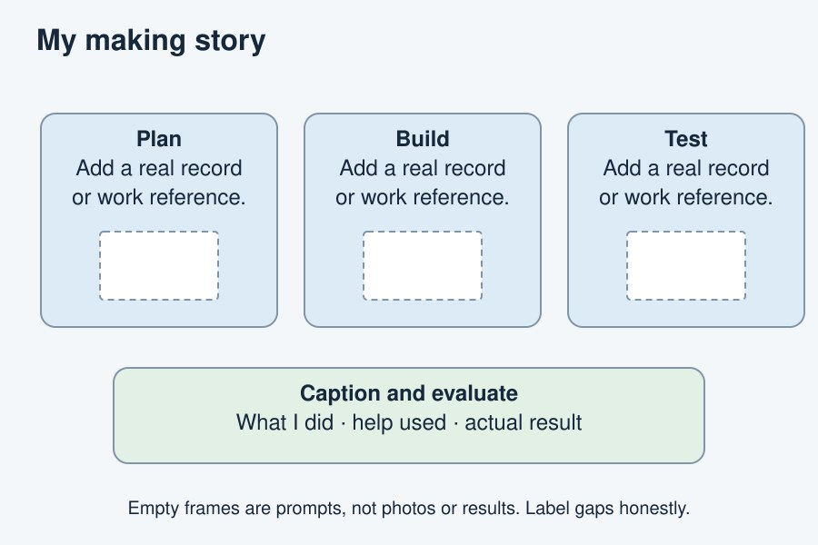
A caption says what happened. It does not invent a result.
The diagram is an example, not a record of your work. It is not to scale. Use a ruler for real dimensions.
I notice __.
The next step is __.
I can ask __ for help.

