Product presentation cards
Read or ask an adult to read. Staff may cut on the table lines.
Cards | Cards
A  Choose your model or a clear work-only photo. | B  Explain one step you completed.
C  Read the actual test record. | D  Choose one improvement.
E  Your audience asks a question. | F  Speaking to a group feels too much.
Follow the sequence and explain a check.

My explanation route
Show the product and its purpose.
Describe one making step and any help.
Use a real result or say it was not tested.
Suggest a change and explain why.
Listen to a question and respond.
Choose a mode and audience that help you.

Words I can use
My product is for __.
I made __ with help to __.
The test showed __.
I would change __ because __.
My answer is __ / I need to check __.

Help card
Please help me with this step.
I can point to what I mean.
Please read the words or show the step.
I can ask for a pause or private talk.

A visual guide
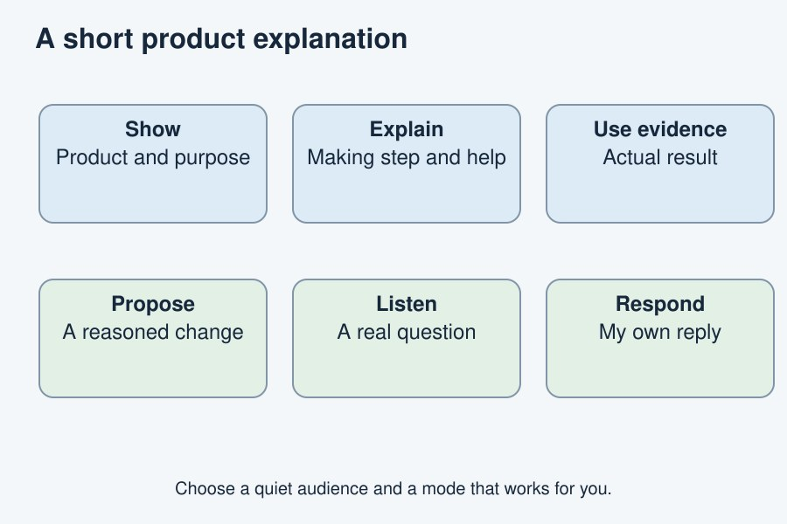
A clear explanation can be quiet, short and supported.
The diagram is an example, not a record of your work. It is not to scale. Use a ruler for real dimensions.
I notice __.
The next step is __.
I can ask __ for help.

