My peace and care record
12 November 2026 | P3
White paper | You can point, write or ask an adult to write.
My code ____ Date ____
In your book: show one fact and one way to show care. You do not need to tell a story from your life.

Words
peace, care, remember, space, kind, help, pass

Start
Some people __. I can __.

Model
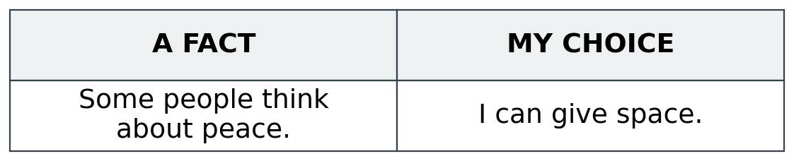
You can point to a card. An adult can write what you show or say. Hear it back in a quiet way. Keep it or change it.

Finish
One fact and one care choice. Keep them in your book.
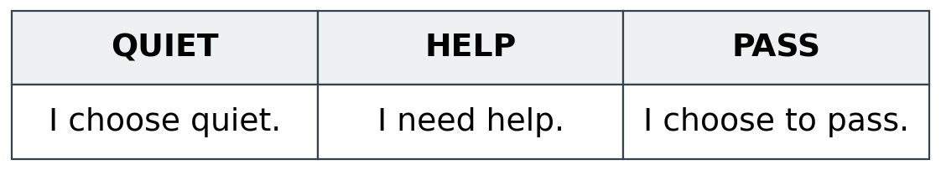
You can ask for help or pass on this task.

My peace and care record continued
12 November 2026 | P3
White paper | You can point, write or ask an adult to write.

Adult record
Pupil code ____ Actual date ____
HUM-BUILD-A2-W02-E1
Book/card/photo reference ________________________
Source fact selected or stated _____________________
Care choice selected or stated _____________________
Actual words or selected labels ____________________
______________________________________________
Mode: point / card / draw / write / scribe / usual aid
Actual prompts and adult-supplied content ___________
______________________________________________
Record: outcome shown / part shown / not yet shown
Private pass or neutral task, if used ________________
Adult reply and one NS ___________________________
Pupil’s own response or change ____________________
Unfinished check _________________________________
Actual review and banking ________________________
Use codes and roles only. No private story or names. Do not infer reflection from silence or copying. R follows actual reply, NS and own response; E follows actual banking.

