Peace and care
12 November 2026 | P3
Pink paper | You can point, write or ask an adult to write.
Route: Supported | My code ____
In your book: one fact and one care choice. You can point, draw a word or ask an adult to write.
1 Pick a fact card. An adult can read it.
2 Pick one care card. Point to your choice.
3 Tell or show an adult. They can write your words.

Words
peace, care, remember, space, kind, help, pass

Start
Some people __. I can __.

Model
These are words to help. Make your own choice.
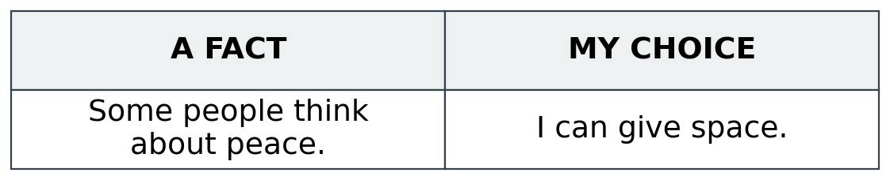

Finish
One fact. One care choice. Show an adult in a quiet way.
Need help? Show HELP. You can choose PASS. No need to say why to the group.

Peace and care continued
12 November 2026 | P3
Pink paper | You can point, write or ask an adult to write.
Route: Independent | My code ____
In your book: one fact and one care choice. You can point, draw a word or ask an adult to write.
1 Read or hear the short fact card.
2 Choose one way to show care.
3 Put one fact and your choice in your book.

Words
peace, care, remember, space, kind, help, pass

Start
Some people __. I can __.

Model
These are words to help. Make your own choice.

Finish
One fact. One care choice. Show an adult in a quiet way.
Need help? Show HELP. You can choose PASS. No need to say why to the group.

Peace and care continued
12 November 2026 | P3
Pink paper | You can point, write or ask an adult to write.
Route: Aspire | My code ____
In your book: one fact and one care choice. You can point, draw a word or ask an adult to write.
1 Pick one fact and one way to show care.
2 Add a reason if you wish. Use because __.
3 Let others choose their own way.

Words
peace, care, remember, space, kind, help, pass

Start
Some people __. I can __.

Model
These are words to help. Make your own choice.

Finish
One fact. One care choice. Show an adult in a quiet way.
Need help? Show HELP. You can choose PASS. No need to say why to the group.

