Help and choice cards
12 November 2026 | P3
White paper | You can point, write or ask an adult to write.

Ready starter
Start here. You can work in a quiet way.
1 Look at the care cards.
2 Choose one thing you can do.
3 Match, copy or point to your choice.

Words
space, wait, kind

Start
I can __.

Model
I can give space.
Pick a word | What I can do
space | Give space.
wait | Wait for a turn.
kind | Say a kind word.

Finish
One care choice. An adult can write your words. You can ask for help or pass.

Help and choice cards continued
12 November 2026 | P3
White paper | You can point, write or ask an adult to write.

My private help route
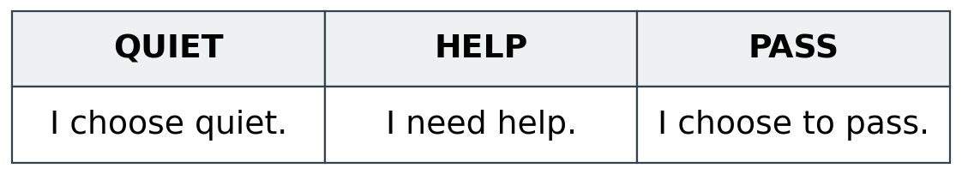
Show HELP or PASS. Or point to a word. An adult will help you in a quiet way. You do not need to tell the group why.

Words
quiet, help, pass, keep, change

Start
I choose __. I need __.

Model
I need help. I choose quiet.
An adult can write your words. Hear them back quietly. Point to keep or change.

A quiet task
You may draw a line, a dot or a shape.
Words: line, dot, shape. Start: I choose __.
Model: I choose a dot: • You may stop when you wish.

Finish
Show your choice to the adult. You can return when you are ready.

