Festival object cards
19 November 2026 | P3
Pink paper | You can point, write or ask an adult to write.

S1 Teaching objects
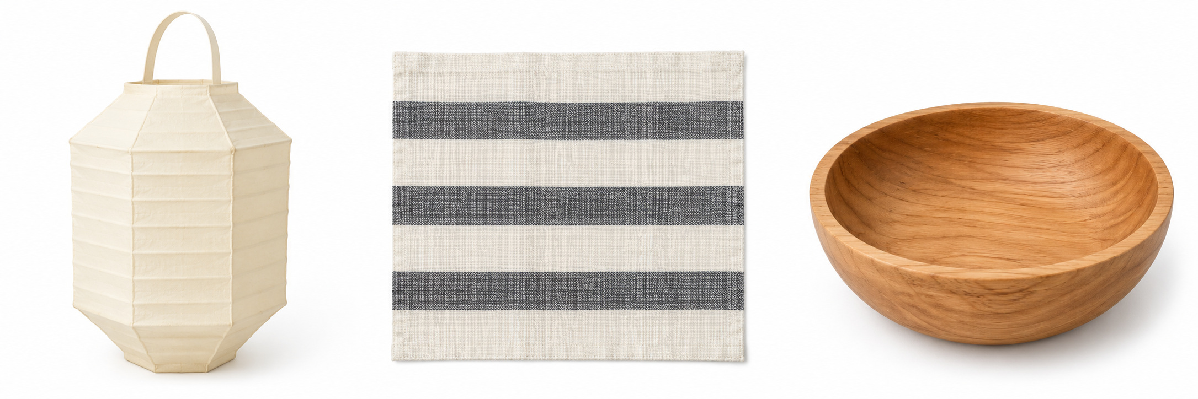
From left: A, B, C. These are made-up teaching designs.
Card | What the picture shows | Given material
A lantern | Folds and a loop | paper
B cloth | Stripes | cloth
C bowl | A round rim | wood
A picture cannot tell us how heavy it is or how it feels.

Words
round, stripes, folds, loop, paper, wood

Start
I can see __.

Model
I can see a round rim on the bowl.

Finish
Point to one feature. You can ask an adult to write.

Festival object cards continued
19 November 2026 | P3
Pink paper | You can point, write or ask an adult to write.

S2 Care at a festival
A festival is a special time people mark. Objects may matter to people. People may use them in different ways.
A lantern might be for a display. Cloth might cover a table. A bowl might hold things. These are guesses, not facts about a group.
Model: It might be for a display. We need more facts to be sure.

Care steps
1 Ask first. Wait for permission.
2 Follow the adult’s steps for that item.
3 Hold it low over the table with support.
4 Put it back on the mat with care.
Keep the paper loop safe. Do not lift by the loop. Use kind words. Look without touch if you wish.

Words
ask, wait, hands, low, mat, care

Start
I show care when I __.

Model
I show care when I ask first and wait.

Finish
Show the steps with an allowed card or copy. Or point to the steps and ask for help.

