Starter and choice cards
3 December 2026 | P3
Pink paper | You can point, write or ask an adult to write.

Ready starter
Look at the marks. These are practice shapes, not festival signs.
Pair | What to notice
○ ○ | Two circles are the same shape.
○ □ | A circle and a square are different shapes.

Words
same, different, circle, square

Start
These are __.

Model
Two circles are the same shape.

Finish
Point to one same pair and one different pair. An adult can read or write with you.

Next comparison
Use the story lines on A and B.
Words: both, stories. Start: Both __.
Model: Both groups share stories.
Finish: show the two story lines.

Starter and choice cards continued
3 December 2026 | P3
Pink paper | You can point, write or ask an adult to write.

My private choice
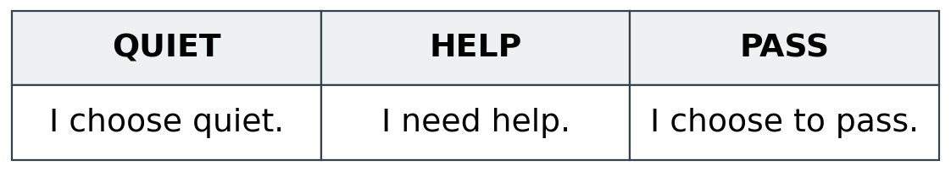
Show HELP or PASS, point, or tell an adult quietly. An adult can read a card with you.

Words
quiet, help, pass, keep, change

Start
I choose __. I need __.

Model
I choose quiet. I need help.

Comparison labels
Same | Different
stories / stories | sing / draw
special day / special day | lanterns / flags

Words
both, same, different, stories, sing, draw

Start
Both __. In A __. In B __.

Model
Both share stories. In A, some sing. In B, some draw.

Finish
One same pair and one different pair. Show the two source lines quietly.

