My feelings piece and arts log
BUILD Spring 1 Week 1 Tuesday 5 January 2027 P1 Year A Explore
I can make a short piece and tell you about my choice.
Weekly outcome: Use colour/sound to express a feeling.
I can find my test and chosen feeling.
I can use a mark or sound on purpose.
I can add my work and words to my arts log.
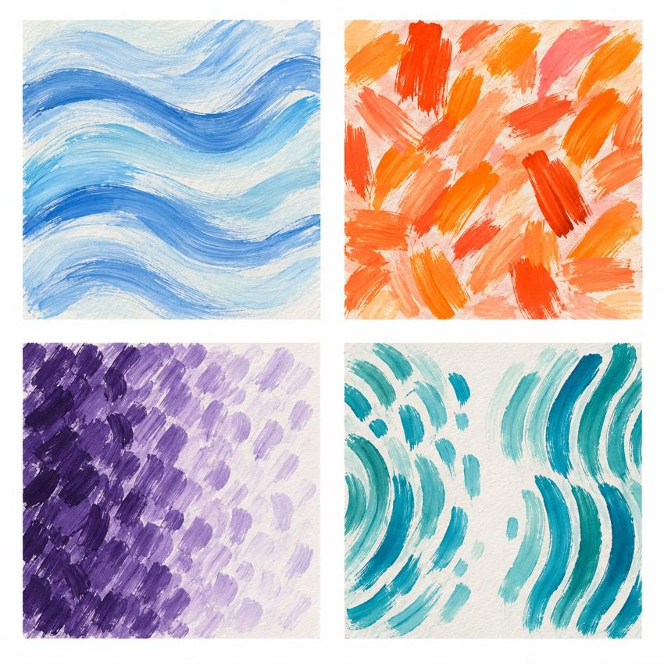
Original teacher models. These are possible readings. You may see or hear a different feeling.
Choose paint, sound or silent movement. GROW can also choose original words or drama. Work may be small. Ask for help or take a calm pause.

My task and routes
BUILD Spring 1 Week 1 Tuesday 5 January 2027 P1 Year A Explore

The main task
Use your test to make a small painting or sound piece.
Repeat your mark or short pattern.
Check one feature. Keep it or change it.
Keep a sketch, beat plan or adult witness note.
Add: I chose ___ because ___.

Supported
Find your test. Choose a mark or beat.
Make a tiny piece with an adult if needed.
Point to one part to keep or change.
Tell or show your choice for the log.

Independent
Make a small piece from your chosen test.
Use one feature on purpose.
Review it. Keep or change one thing and say why.
Add your work and words to the arts log.

Aspire
Complete the core piece and log.
Try one part in a new way.
Explain which version fits your idea best.
Keep the test and your reason, even if you keep the first version.

My words
I made ___.
My idea or feeling was ___.
I chose ___ because ___.
I kept / changed ___ because ___.
My work or witness record is ___.
Next I would like to ___.

Teacher models comparison
BUILD Spring 1 Week 1 Tuesday 5 January 2027 P1 Year A Explore
These are original teacher examples. They are not works by named artists.
Top left: flowing blue marks. Top right: short warm marks. Bottom left: dense marks become more open. Bottom right: a motif returns after a gap.
Which marks could fit a made-up feeling? Point to a feature and give your reason. A colour or sound can mean different things to different people.
I notice ___.
This could show ___ because ___.

My arts log entry
BUILD Spring 1 Week 1 Tuesday 5 January 2027 P1 Year A Explore
Actual date __________ Lesson ART_BUILD_S1_W01_P2
Use your own book or this log page. You can speak, sign or point. An adult can scribe your words and read them back.
Sketch your real work, or describe your sound or movement
I made ___.
My idea or feeling was ___.
I chose ___ because ___.
I kept / changed ___ because ___.
My work or witness record is ___.
Next I would like to ___.
Adult scribed my words: yes / no. I checked them: yes / not yet.
Staff note: actual help used and exact observed work. Record a first attempt as a first attempt.

