A small plan for a feeling
BUILD Spring 1 Week 2 Monday 11 January 2027 P5 Year A Explore
I can plan a small piece about a feeling.
Weekly outcome: Create art linked to an emotion (links PSHE).
I can choose a feeling for a made-up piece.
I can try two ways and choose one.
I can plan a start and an end.
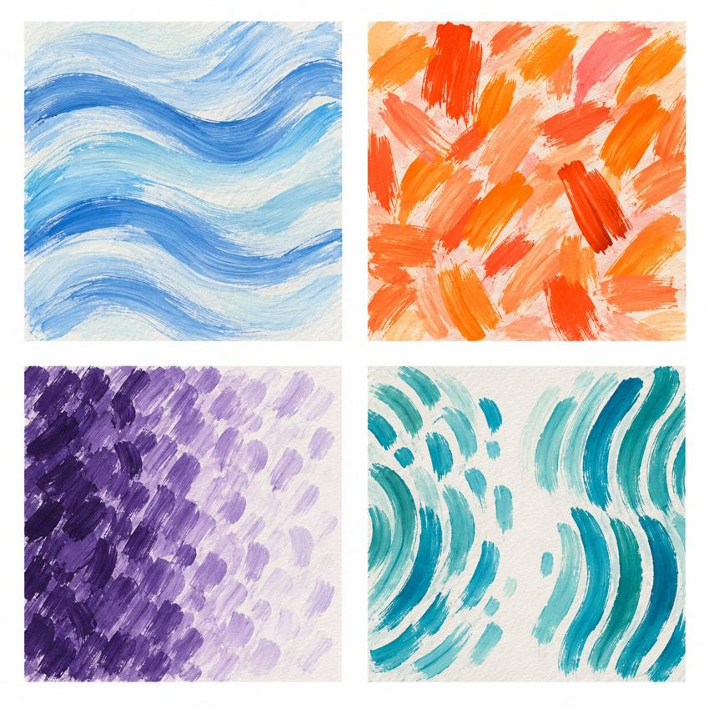
Original teacher models. These are possible readings. You may see or hear a different feeling.
Choose a quiet or silent route if helpful. Ask for help or take a calm pause. Use your own idea for an invented emotion.

My task and routes
BUILD Spring 1 Week 2 Monday 11 January 2027 P5 Year A Explore

The main task
In your book or arts log, choose a feeling.
Try two small marks, sounds or silent moves.
Choose one way. Make a tiny trial piece.
Plan your start and end for next time.
Keep your tests and say why you chose them.

Supported
Pick a feeling, or point to your own word.
Try two marks or moves with an adult.
Choose one. Make a tiny test piece.
Point to your start and end. Tell the adult your reason.

Independent
Choose a feeling for an invented piece.
Try two ways. Keep both tests.
Make a tiny trial with a start and an end.
Keep your plan and reason in your arts log.

Aspire
Complete your trial and plan.
Try one small change in the last part.
Say how it changes the effect.
Choose the end that best fits your idea.

My words
My piece is about ___.
My two tests were ___.
I chose ___ because ___.
First I will ___.
At the end I will ___.

Teacher models comparison
BUILD Spring 1 Week 2 Monday 11 January 2027 P5 Year A Explore
These are original teacher examples. They are not works by named artists.
Look at the type of mark, colour and space. Which feature could show an invented emotion? The same colour can mean different things to different makers.
I notice ___.
My own piece could show ___ by ___.

My arts log entry
BUILD Spring 1 Week 2 Monday 11 January 2027 P5 Year A Explore
Actual date __________ Lesson ART_BUILD_S1_W02_P1
Use your own book or this log page. You can speak, sign or point. An adult can scribe your words and read them back.
Sketch your real work, or describe your sound or movement
My piece is about ___.
My two tests were ___.
I chose ___ because ___.
First I will ___.
At the end I will ___.
Adult scribed my words: yes / no. I checked them: yes / not yet.
Staff note: actual help used and exact observed work. Record a first attempt as a first attempt.

