My skill before and after
GROW Spring 1 Week 2 Wednesday 13 January 2027 P5 Year A Explore
I can practise the same technique and compare my real before and after tests.
Weekly outcome: Develop a skill and record it in my arts log.
I can keep the same technique and test conditions.
I can practise, then keep an honest after test.
I can compare a feature and record my next step.
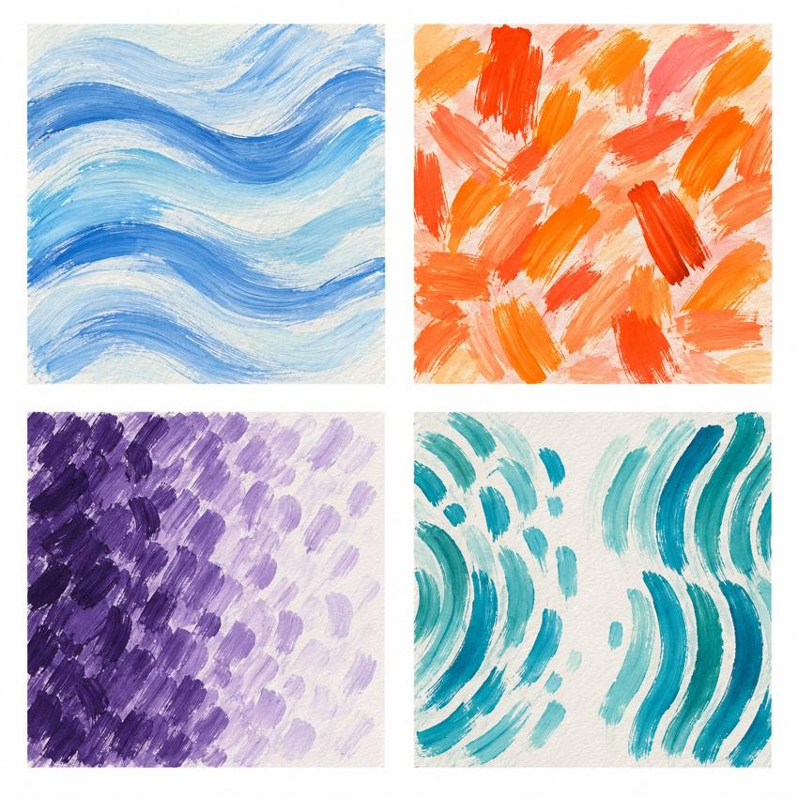
Original teacher models. These are possible readings. You may see or hear a different feeling.
Choose a quiet or silent route if helpful. Ask for help or take a calm pause. GROW keeps one chosen skill across both lessons and records a fair before and after test.

My task and routes
GROW Spring 1 Week 2 Wednesday 13 January 2027 P5 Year A Explore

The main task
Practise your one technique in two short rounds.
Use the same cue. Pause between rounds.
Make the same four-part after test. Keep both tests.

Supported
Find your first test and goal with an adult.
Keep the same four-part technique and cue.
Practise, then make a real after test.
Point to one detail. Tell or show your next step.

Independent
Use the same technique and cue. Practise your small goal.
Keep a matching four-part after test.
Compare one feature. Record your view, help and next step.

Aspire
Compare a clear feature in both tests.
Explain how your practice cue helped, or why it did not yet help.
Name one fair next test. The next level task is optional.

My words
My technique and goal were ___.
Before I ___. After I ___.
I notice ___ because ___.
I used this cue and help ___.
My next practice step is ___.

Comparing my skill tests
GROW Spring 1 Week 2 Wednesday 13 January 2027 P5 Year A Explore
Use your own before and after tests. A teacher model is not your evidence.

The same test
Keep the same chosen form and four-part task in both tests. Use the same size or pace guide. Record any help used.

Before
Keep your first four marks or a precise note of four quiet actions. Notice how even the gaps or pace are.

Practice
Choose one small target. Test it in short trials. Keep a note of what you did.

After
Try the same four-part test again. Record the result you get. It may be more even, the same or less even.

A fair view
Compare one feature in both records. Say what the practice may have helped. If the form changes for access, keep the old test and make a new before test for the new form.
My one skill was ___.
Before I noticed ___. After I noticed ___.
I think the practice ___ because ___.

My arts log entry
GROW Spring 1 Week 2 Wednesday 13 January 2027 P5 Year A Explore
Actual date __________ Lesson ART_GROW_S1_W02_P2
Use your own book or this log page. You can speak, sign or point. An adult can scribe your words and read them back.
Sketch your real work, or describe your sound or movement
My technique and goal were ___.
Before I ___. After I ___.
I notice ___ because ___.
I used this cue and help ___.
My next practice step is ___.
Adult scribed my words: yes / no. I checked them: yes / not yet.
Staff note: actual help used and exact observed work. Record a first attempt as a first attempt.

