An artist uses line and colour
BUILD Spring 1 Week 3 Monday 18 January 2027 P5 Year A Explore
I can find out how an artist uses line and colour.
Weekly outcome: Find out about an artist who expresses feelings.
I can name the artist or point to his name.
I can find two facts in the short description.
I can try my own idea with shapes.
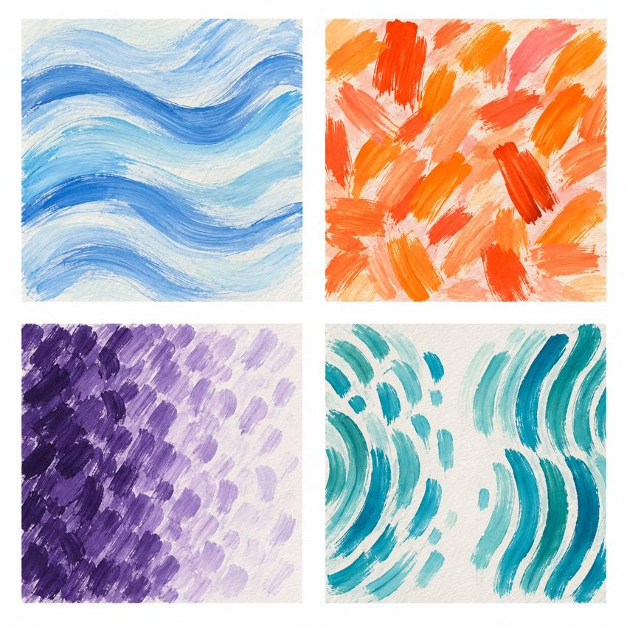
Original teacher models, not work by the artist. You may see or hear a different feeling.
Choose a quiet or silent route if helpful. Ask for help or take a calm pause. Use an artist method to make your own response.

My task and routes
BUILD Spring 1 Week 3 Monday 18 January 2027 P5 Year A Explore

The main task
In your book or arts log, name the artist.
Keep two facts from the description.
Make or draw three shapes of your own.
Try two layouts. Choose one for a made-up feeling.
Keep your tests and your own reason.

Supported
Listen to the artist card with an adult.
Point to or say cut shapes and moved shapes.
Try three own shapes close, then apart.
Choose a layout. Tell or show your reason.

Independent
Name the artist and find two facts.
Make two new trials with your own shapes.
Choose a layout for a made-up feeling.
Add the facts, tests and reason to your arts log.

Aspire
Complete the two trials and artist facts.
Try one new gap or line in your own design.
Say how it changes your reading.
Keep your own view and allow a different view.

My words
The artist is ___.
Two facts I found are ___ and ___.
My own test used ___.
I chose ___ because ___.
Next time I will ___.

Artist description and my response
BUILD Spring 1 Week 3 Monday 18 January 2027 P5 Year A Explore
Listen to the artist description. No copy of the artist's work is supplied.

Henri Matisse Cut-outs
Henri Matisse made art with line, colour and cut paper. He used line and colour to show feelings. He cut shapes from painted paper. He moved the shapes to try a new layout. We can read his art in our own way. We do not know his mood from it.

A detail and a view
What did he cut? What could he move?
How could moving your own shapes change the way your piece feels?
A fact comes from the card. A view is your own reading. We can use a method to make our own art.
One fact I found was ___.
My own piece could show ___ by ___.

My arts log entry
BUILD Spring 1 Week 3 Monday 18 January 2027 P5 Year A Explore
Actual date __________ Lesson ART_BUILD_S1_W03_P1
Use your own book or this log page. You can speak, sign or point. An adult can scribe your words and read them back.
Your own response sketch or observed action notes
The artist is ___.
Two facts I found are ___ and ___.
My own test used ___.
I chose ___ because ___.
Next time I will ___.
Adult scribed my words: yes / no. I checked them: yes / not yet.
Staff note: actual help used and exact observed work. Label a plan, trial or finished piece honestly.

