BUILD · Tuesday 26 January 2027 · P1 · ART_BUILD_S1_W04_P2

Knowledge organiser
A piece with my new texture
Weekly outcome: Try a new expressive technique.
I can use my new texture in a small piece.

Today I can
I can use the new way I tried.
I can keep or change one part for a reason.
I can show what I did in my arts log.

Words to use
texture — How a surface feels or looks.
rub — Move a tool back and forth.
light — With a small amount of force.
test — A small try before a piece.

One worked example
Teacher example only: the ridged marks suggest energy to me. Another maker may read them as calm.
Your idea may differ. Use your own words and choices.

BUILD · Tuesday 26 January 2027 · P1 · ART_BUILD_S1_W04_P2

Choose one task route

Supported
Find or remake two small tests.
Choose a texture and direct the adult.
Make a small piece or silent sequence.
Show one choice and your reason.

Independent
Use your chosen texture in a small piece.
Check one feature against your idea.
Keep or change it for a reason.
Keep your work and dated arts-log entry.

Aspire
Complete the same small piece.
Compare a first version with one small change.
Explain what the change does to the feeling.
Choose the version you want to keep.
Use one route at a time. You may change route with the adult.

BUILD · Tuesday 26 January 2027 · P1 · ART_BUILD_S1_W04_P2

Activity cards
Use these as prompts. Complete your response in your book, arts log or chosen art form.

1 0 to 15 seconds
Show yesterday tests and state the maker choice. Put a fresh small sheet over ridged card.

2 15 to 30 seconds
Rub one patch gently. Leave a gap before a second patch.

3 30 to 45 seconds
Make the second patch lighter. Point out the actual difference in marks.

4 45 to 60 seconds
Explain the decision. Show how the tests and piece stay together with a true log entry.

Your own making
Make your own choice. Keep or change one feature and give your reason.
Use or direct a short silent sequence: one texture, a still pose, a second texture, then stop. Choose the size or pace. Record the real sequence and the pupil meaning.

BUILD · Tuesday 26 January 2027 · P1 · ART_BUILD_S1_W04_P2

Two texture tests
Original class examples. These are not pupil work or evidence.
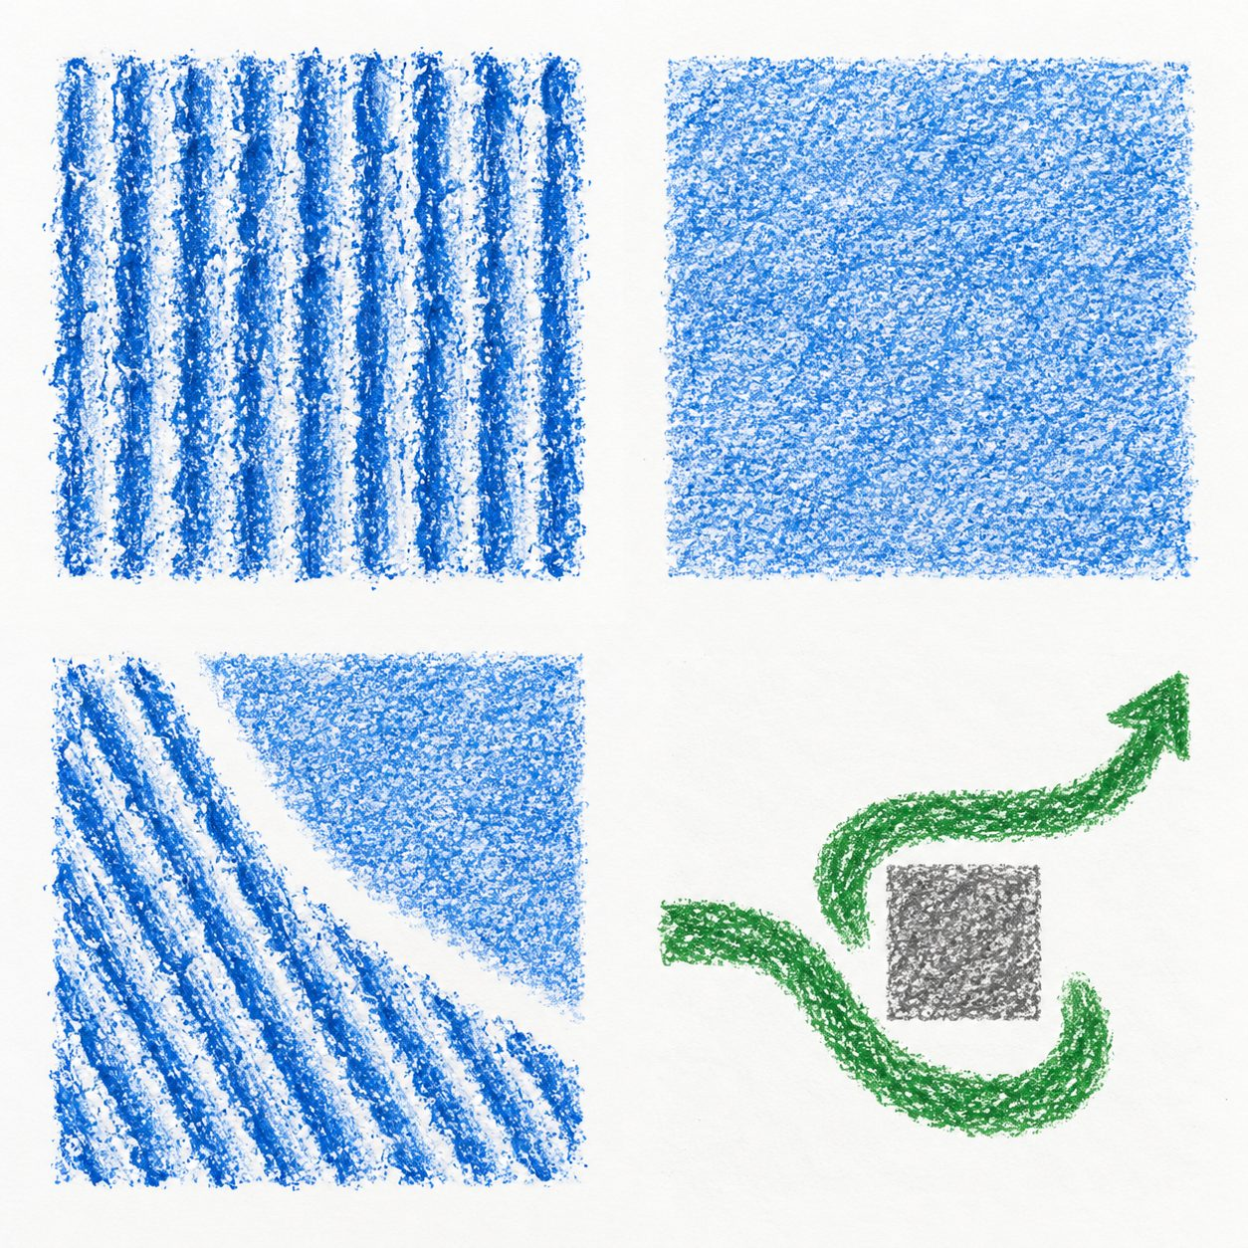

Ridged card
Paper rests on ridges. Gentle rubbing can reveal repeated lines.
The broken lines might suggest energy.

Smoother card
Paper rests on a flatter surface. The rubbing may be more even.
The softer patch might suggest calm.
Say what you notice. The maker can choose a different meaning.

BUILD · Tuesday 26 January 2027 · P1 · ART_BUILD_S1_W04_P2

My arts log
In your book or existing arts log. You can draw, speak, sign or direct an adult.
The new way I used was ___.
My piece is about ___.
I made ___.
I kept / changed ___ because ___.
My real work or witness note is ___.
Next I would ___.

Keep a true record
Actual activity date ___. Method used ___. Help used ___.
Adult scribed my words: yes / no. I checked them: yes / not yet.
Keep your own tests or actual work. A witness note should say exactly what happened.

