One real revision and its effect
GROW Spring 1 Week 5 Wednesday 3 February 2027 P5 Year A Explore
I can make one chosen change and record what it actually did.
Weekly outcome: Review and improve my work.
I can use my real review and choose one revision.
I can make that change and keep a true before and after record.
I can explain the actual effect, support and next step.
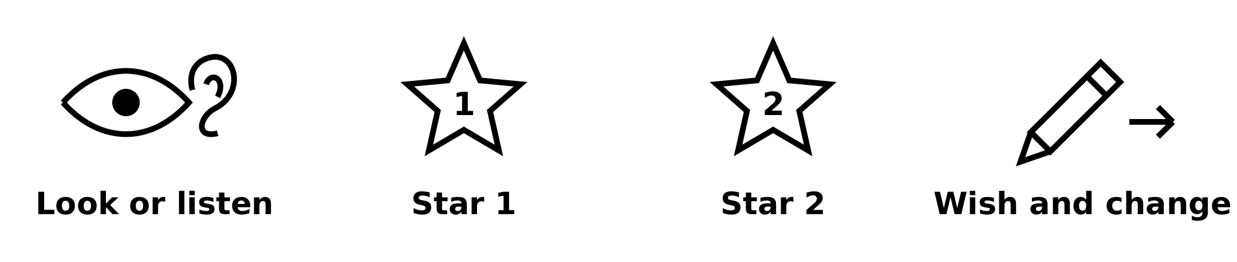
Picture prompts have words as well as symbols. Use your own real work; these prompts are not pupil evidence.
Choose a quiet or silent route if helpful. Ask for help or take a calm pause. Review against your real plan. Peer feedback is private and optional.

My task and routes
GROW Spring 1 Week 5 Wednesday 3 February 2027 P5 Year A Explore

The main task
Make your one chosen revision in the real piece or sequence.
Keep the actual before and after feature.
Say what changed and what effect you notice.
Record help and a truthful next step.

Supported
Find the real work and review with an adult.
Choose and make one small change.
Show the real before and after feature.
Say what the change did and what comes next.

Independent
Use your real review to make one chosen revision.
Keep actual before and after records.
Explain the effect, support and next step.
Use self or staff review if a peer comment is not used.

Aspire
Make the actual revision and keep the true result.
Explain how the change affects your intention.
Evaluate a real comment or your self-review.
The next level task is optional.

My words
Before I ___. I changed ___. After I ___.
The actual effect was ___ because ___.
The support I used was ___.
Feedback route: self / staff / one agreed private peer comment.
Peer comment: used / not used / declined / unavailable / stopped.
My current state and next step are ___.

My review and one revision
GROW Spring 1 Week 5 Wednesday 3 February 2027 P5 Year A Explore
Use your actual Week 3 plan and your own current work. Compare what you meant with what exists. If either is missing, make a fresh small starting point and date it honestly.

Self review
Check the resilience idea, chosen features, form and current stage. Identify a feature that matches the plan and one small change that could help.

Optional private peer comment
Ask only if both pupils choose it. Share only a part the maker agrees to show, privately and never to the class. Either pupil can stop. Keep at most one peer comment. If the route is not used, record that and use staff feedback or self-review instead.

One improvement made
Make the chosen revision. Keep a before note, the real change and the actual result. If a new version is needed, retain both versions. A change is not proof of a better effect; say what actually happened.
My chosen change was ___.
I changed ___. The result was ___.
The feedback source and next step are ___.

My arts log entry
GROW Spring 1 Week 5 Wednesday 3 February 2027 P5 Year A Explore
Actual date __________ Lesson ART_GROW_S1_W05_P2
Use your own book or this log page. You can speak, sign or point. An adult can scribe your words and read them back.
Before and revised work sketch or sequence notes
Before I ___. I changed ___. After I ___.
The actual effect was ___ because ___.
The support I used was ___.
Feedback route: self / staff / one agreed private peer comment.
Peer comment: used / not used / declined / unavailable / stopped.
My current state and next step are ___.
Adult scribed my words: yes / no. I checked them: yes / not yet.
Staff note: actual help used and exact observed work. Keep the starting work, real revision and support honest.

