Knowledge organiser
BUILD Spring 1 Week 6 Monday 8 February 2027 P5 Year A Explore
My arts choices this term
Weekly outcome: Add a review to my arts log.
I can use my real work to say what I tried and learned.

Today I can
I can choose real work from this term.
I can say what I tried and what changed.
I can start a review in my own words.

Words to use
review: Look back and say what you think.
choice: Something you chose to do.
change: Something you did in a new way.
log: A record of your arts work.
In your book or arts log. You may speak, sign, point, draw or direct an adult. Plan in any language.

Activity prompts
BUILD Spring 1 Week 6 Monday 8 February 2027 P5 Year A Explore
Use your own book or arts log. These prompts do not count as completed evidence.
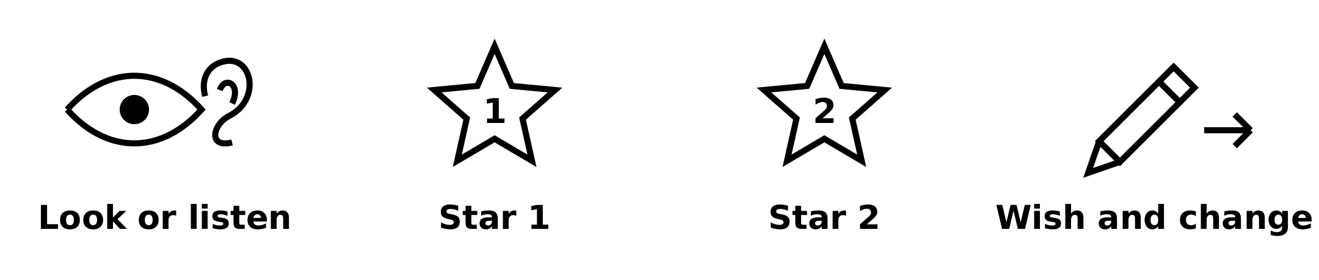
Look or listen. Use the stars for helpful features. Use the tool for a real change or next step.

1 Find
Choose actual work or a real witness note.

2 Notice
Point to a helpful feature.

3 Explain
Say one choice or change and its reason.

4 Check
Read the review back and match it to evidence.

Your own words
I made ___. I chose ___ because ___.
Read or hear your words back. Correct anything that does not match your meaning.

A review with evidence
BUILD Spring 1 Week 6 Monday 8 February 2027 P5 Year A Explore

Too vague
My art was good.
Ask which real feature the maker means.

A useful review
I made the pause longer. The ending was clearer to me.
This adult example links a real change to the maker’s view. Use your own details.
Use the pictures to help you talk about actual work. The model is an adult example, not your evidence.

My arts log record
BUILD Spring 1 Week 6 Monday 8 February 2027 P5 Year A Explore
Actual date __________. In your own book or arts log. Speak, sign or point if helpful; an adult can scribe and read your words back.
My real examples and dates are ___.
I made ___. I chose ___ because ___.
One part I changed was ___.
I learned ___. Next I want to try ___.
My words were scribed: yes / no. I checked them: yes / not yet.
Keep exact pupil words, real dates, source or work locations and actual help. The six-week grid follows. Keep any unfinished item marked as pending.

Six week evidence review
BUILD Spring 1 Week 6 Monday 8 February 2027 P5 Year A Explore
Use the real arts log. Choose one status for each outcome and add a short comment. A gap is not a failure. This grid does not award a qualification.
Wk | Weekly outcome verbatim | Tick one status | Evidence location and comment
1 | Use colour/sound to express a feeling. | [ ] Shown  [ ] More to do  [ ] Not yet seen | Date / location:  Pupil words / support:
2 | Create art linked to an emotion (links PSHE). | [ ] Shown  [ ] More to do  [ ] Not yet seen | Date / location:  Pupil words / support:
3 | Find out about an artist who expresses feelings. | [ ] Shown  [ ] More to do  [ ] Not yet seen | Date / location:  Pupil words / support:
4 | Try a new expressive technique. | [ ] Shown  [ ] More to do  [ ] Not yet seen | Date / location:  Pupil words / support:
5 | Review and improve my piece. | [ ] Shown  [ ] More to do  [ ] Not yet seen | Date / location:  Pupil words / support:
6 | Add a review to my arts log. | [ ] Shown  [ ] More to do  [ ] Not yet seen | Date / location:  Pupil words / support:
Staff and pupil review date __________. Record actual evidence dates, locations, pupil words and support. Keep adult observations separate. Shown means evidence seen for this weekly outcome; it is not an award-level judgement.

