Job picture cards
White Standard sheet
Explore jobs and what people do (careers).

Gardener
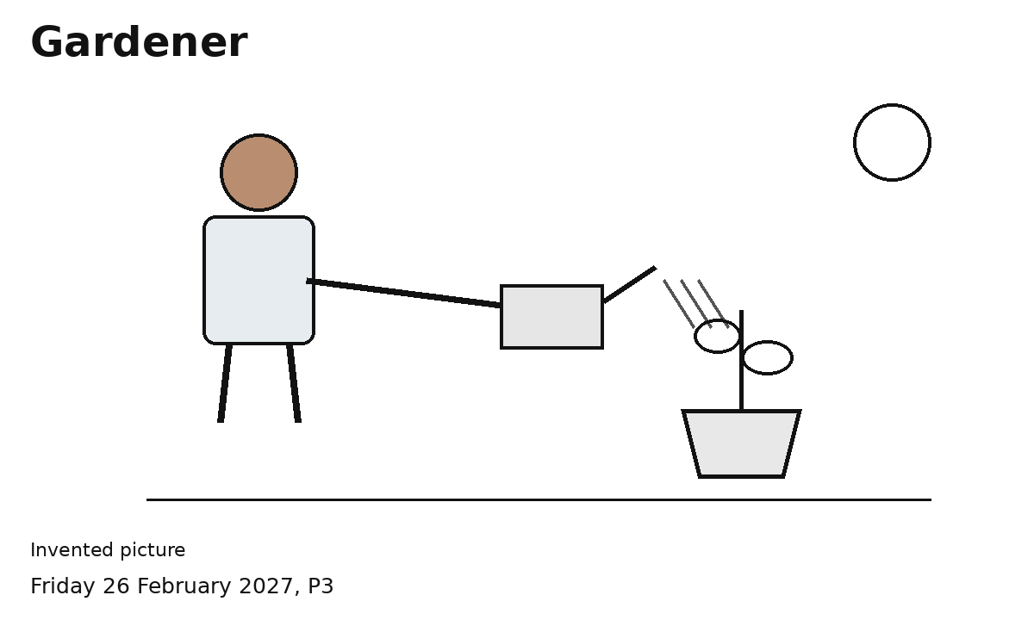
This worker looks after plants.
This worker waters a plant.
Invented worker example
Show or say what this worker does.
This is one way the job can look.

Cleaner
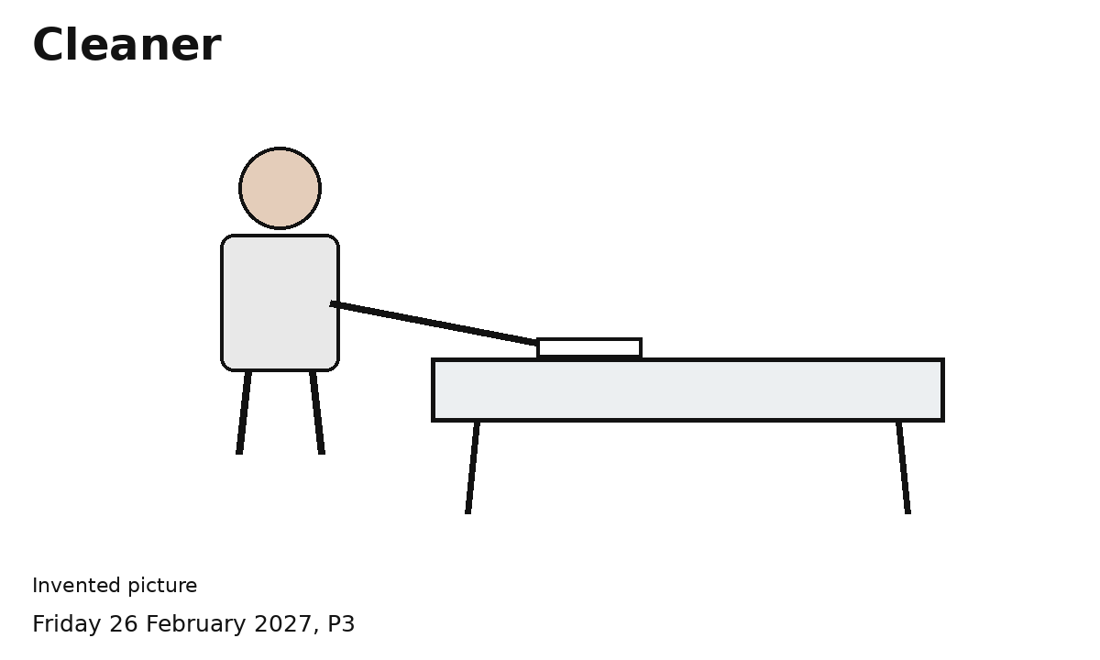
This worker helps keep a place clean.
This worker wipes a table.
Invented worker example
Show or say what this worker does.
This is one way the job can look.

Shop assistant
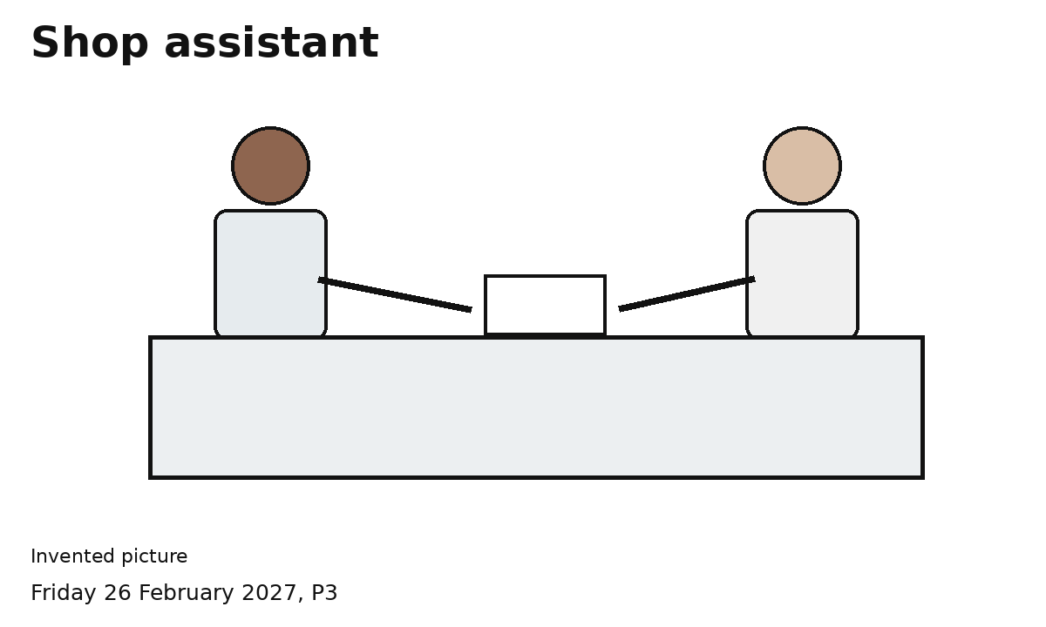
This worker helps a customer.
This worker helps at a counter.
Invented worker example
Show or say what this worker does.
This is one way the job can look.

Care worker
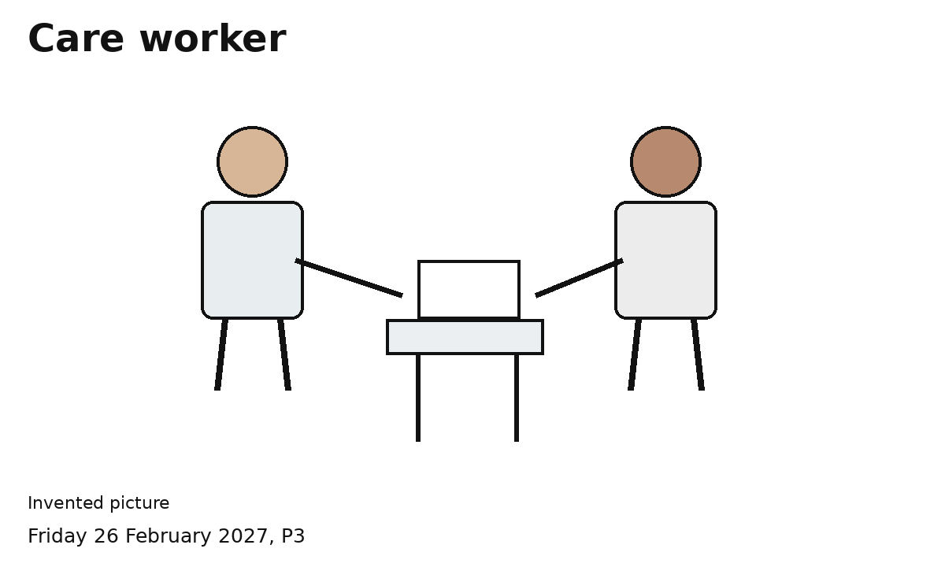
This worker helps a person with a daily task.
This worker helps a person.
Invented worker example
Show or say what this worker does.
This is one way the job can look.

