Jobs and what workers do
Pink Supported sheet
Explore jobs and what people do (careers).
These workers are made up.
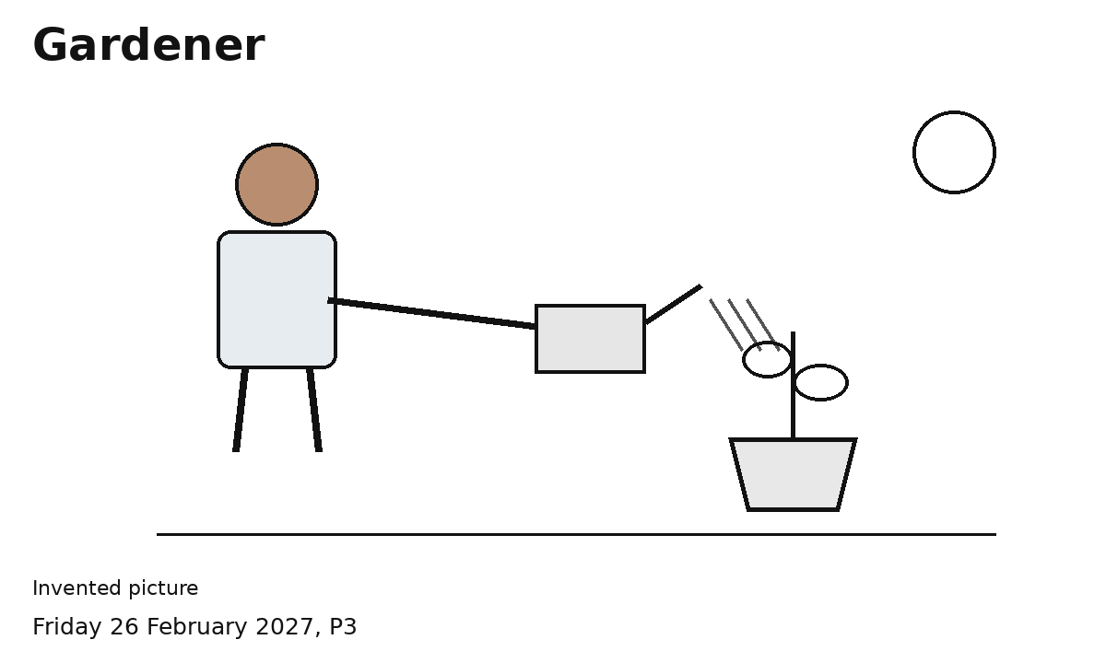
1 Pick a job. Show what the worker does.
2 Try a sort with help.
I can pick a job to find out about.
One picture at a time is fine.
You can point, speak or ask an adult to write.

