Dress a figure for a job task
Pink Supported sheet
Match tools/clothing to a job.
My job task ______________________
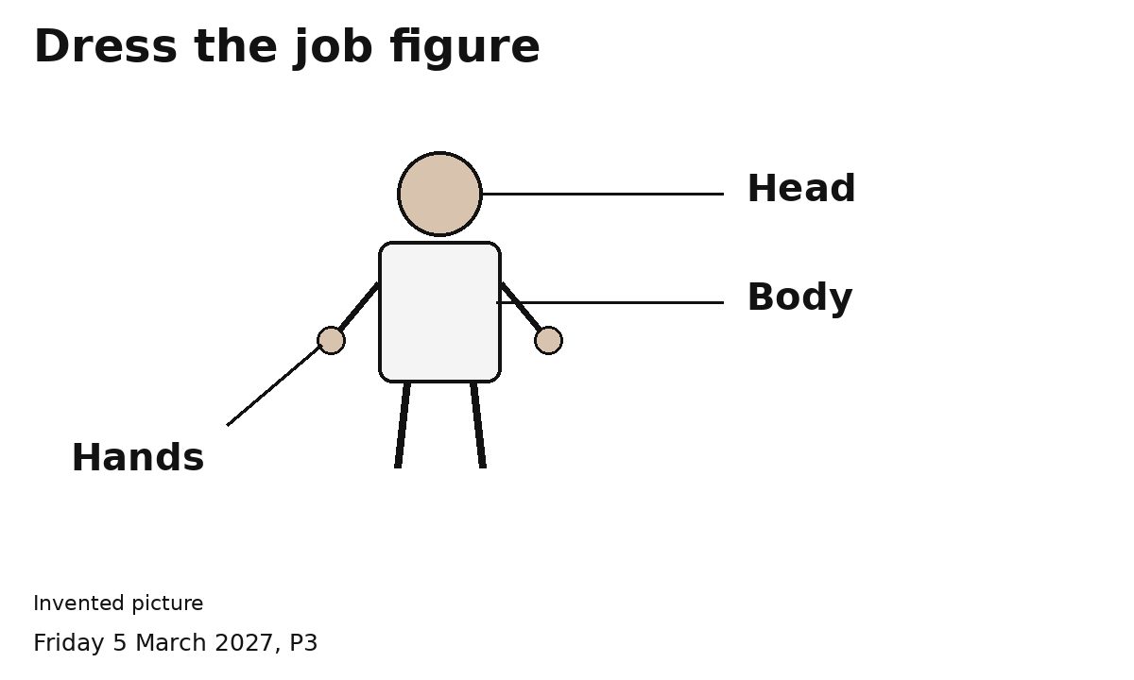
1 Match a picture to the figure.
2 Ask an adult to check.
I can use pictures.
I can ask to try a clean item. The adult checks it first.
It should fit and feel right. I can stop.

