Item matching cards
White Standard sheet
Match tools/clothing to a job.

Protective gloves
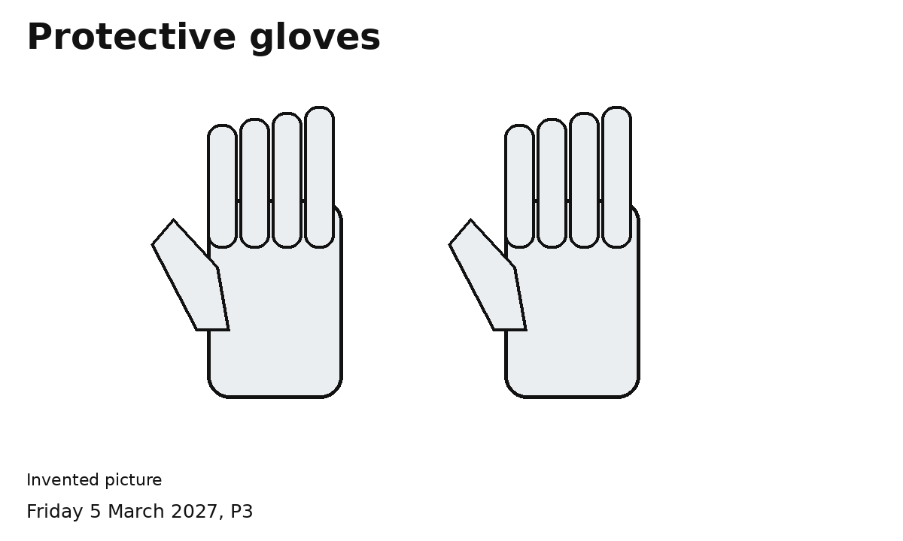
Suitable gloves help protect hands for the task.
A protective item
Which task could need this item?
Ask an adult to check the choice.

Safety helmet
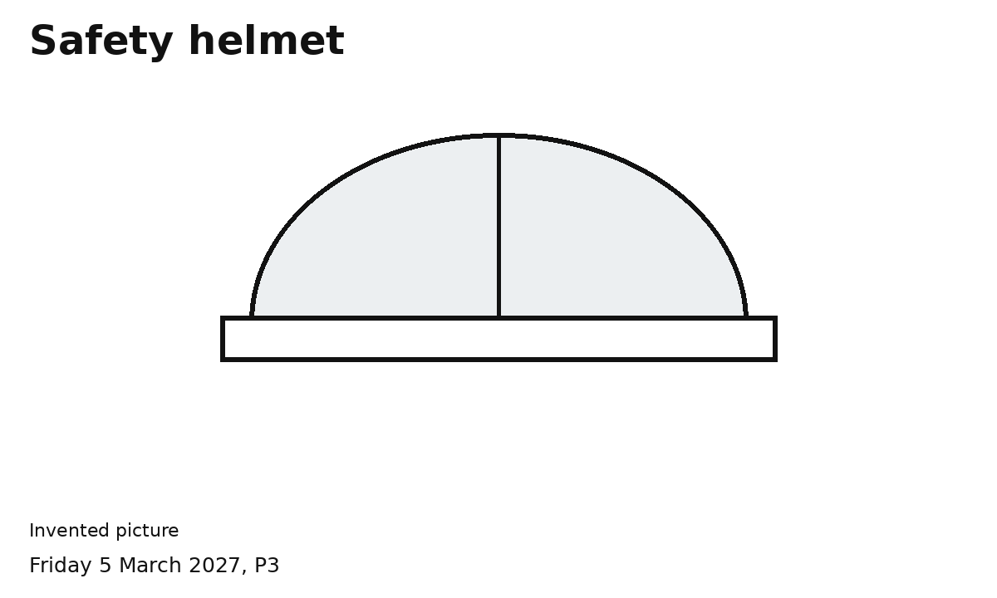
A suitable helmet helps protect a worker's head.
A protective item
Which task could need this item?
Ask an adult to check the choice.

High visibility vest
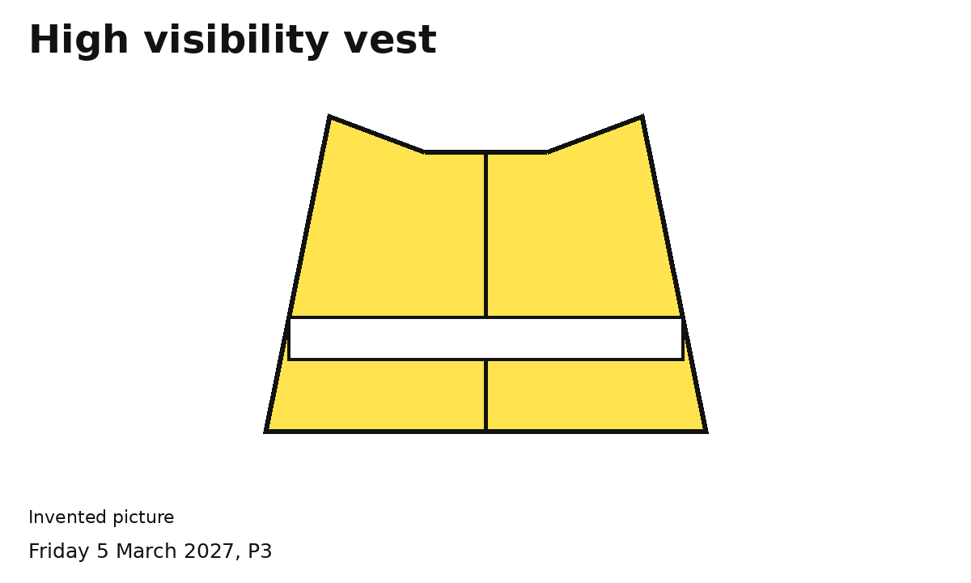
A suitable vest helps other people see the worker.
A protective item
Which task could need this item?
Ask an adult to check the choice.

Tools
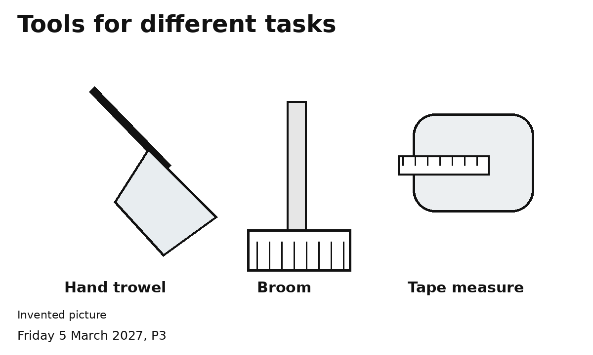
Hand trowel moves a little soil.
Broom sweeps a clear area.
Tape measure measures length.
A tool helps us do a task.
Match an item to a task card.

