Set up a classroom display
White Standard sheet
Carry out a simple work-related task.
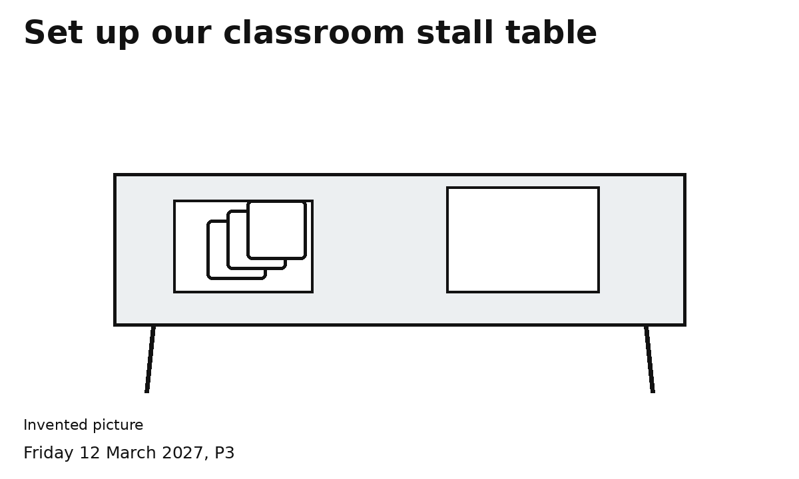
1 Clear the agreed space.
2 Lay the mat or plain paper.
3 Set out three cards and the sign.
4 Check the table.
Use the space agreed with the adult.
Ask for help with anything hard to reach.

