Our real classroom work task
White Standard sheet
Carry out a simple work-related task.
The picture is a made up example.
Our classroom job is real.
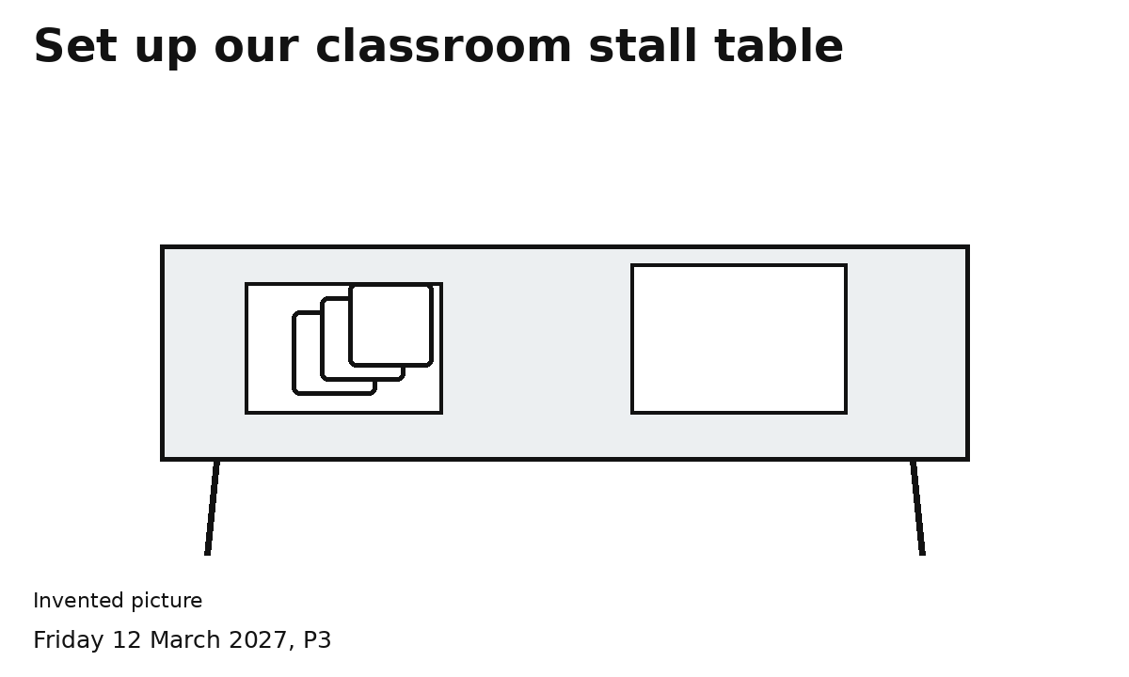
1 Clear the agreed space.
2 Lay the mat or plain paper.
3 Set out three cards and the sign.
4 Check the table.
Use light items. Ask for help if needed.
You can point, speak or direct an adult.

