Talk and prepare together
Pink Supported sheet
Practise asking and answering at 'work'.

1 Talk together
Greet. Ask for help. Answer.

2 Prepare together
Choose. Arrange three items and sign.
Check. Say the job is done.
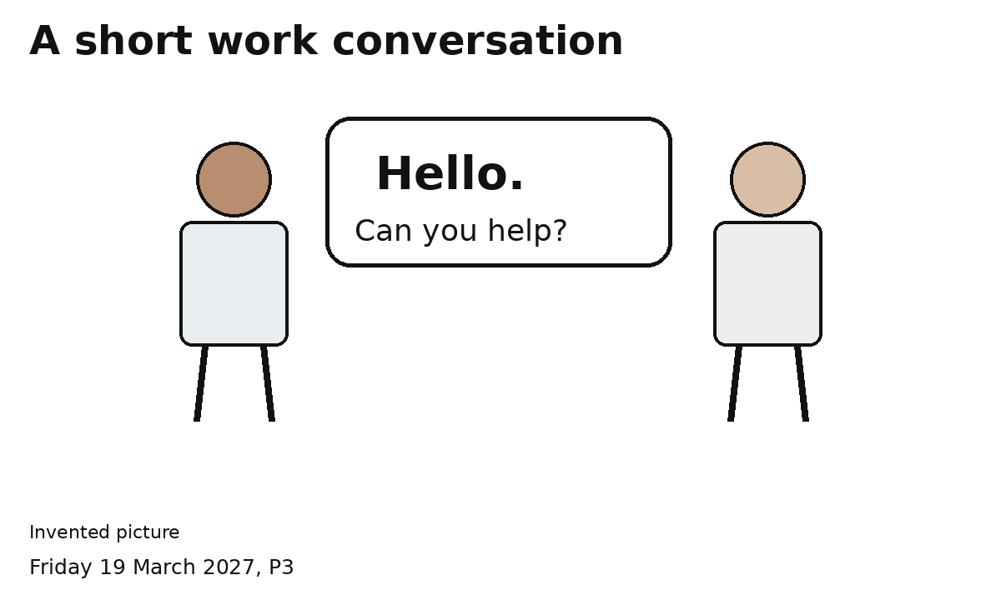
Both of us ask and answer.
Speak, point or gesture. An adult can help.

