Safe cutting and joining step card
Design and Technology LAUNCH Spring 2 Week 3 Thursday 11 March 2027 P1 Year A
Use this method only if it matches your approved design and actual material. The adult demonstrates, approves and supervises hand tools. Tools down before a question or pause.

1 Retrieve and check
Find the actual Week 1 design and Week 2 list, material choice, step plan and mock up. Ask the adult to approve the method, tools and support. If a record is missing, agree a new dated plan today and say it is new. Keep actual pupil choices visible.

2 Measure and mark
For the default, mark a body 120 mm by 260 mm and a channel strip 100 mm by 30 mm. Align ruler zero with the chosen edge. Recheck each size. Mark body folds at 80, 160 and 240 mm from the same short end. Mark both long channel folds at 10 and 20 mm from the same long edge. The adult checks before cutting.

3 Cut with approval
The adult shows the agreed scissor grip and a stable position. Keep the helping hand out of the blade path. Cut away from your body and other people. Turn the card to keep the line easy to reach. Close scissors and put them down to stop, speak or change position. Do not force thick card. Use prepared pieces or ask for help.

4 Prepare and test the join
With tools down, guide each fold with a ruler and press it with fingers. Do not use a sharp scoring edge. Trial fold the three faces into a triangle. The 20 mm tab goes inside the first face at the top seam. Check the triangle sits on its base and the open ends remain clear.
Written measurements control the work. This page is not a full size cutting template. Keep the actual plan beside the work.

Join check and improve
Design and Technology LAUNCH Spring 2 Week 3 Thursday 11 March 2027 P1 Year A

5 Make the agreed joint
Tape the top seam so the inside tab holds the triangle closed. Fold the retaining strip at both long marks into a shallow U. The 10 mm back flange lies against the bottom of the front sloping face. Tape that flange. The shelf projects out and the front stop faces upward toward the card. Do not flatten the channel or cover its opening with tape.

6 Stop and check
Tools down. Compare the actual stand with the plan. Ask the adult to clear the joint and test. Put one actual 80 mm by 60 mm paper card in the U channel against the slope. Keep hands away for 30 seconds on a level table. Lift the card out gently. No pushing, shaking, drop test or extra load. Record the real result.

7 Adjust and log
If a check shows a need, keep tools down and ask the adult. Adjust one approved feature, then recheck the same purpose. Log every real change, why it helps and what happened next. A new tape piece, revised fold or channel position must have a real reason. If no change is needed, record the checks and an approved refinement or next step honestly.

Alternative material or join
The default uses suitable thin card, approved scissors, finger folds and paper tape. No glue is needed. A different actual approved design needs its own checked sizes, method and support. Corrugated board may need prepared pieces. Dowel and soft wood are comparison choices from Week 2, not permission for wood cutting here. PVA is used only if the actual plan and adult label checks approve it, with full stated cure before testing. Never invent a cure time. Hot glue is comparison only and is not used. No power tools or heated tools are used.

Materials free route
With no card or safe equipment, use the supplied plan for a directed sketch or empty hand rehearsal. Say where you would cut, fold, join and stop to check. Log a proposed change as a proposal. Label the work planning or simulation. Actual cutting, joining, adjustment and testing evidence stay pending unless those actions take place.

Default measured construction plan
Design and Technology LAUNCH Spring 2 Week 3 Thursday 11 March 2027 P1 Year A
Use the written ruler measurements. This model plan is not to scale and is not a cutting template. Use the actual approved revised plan if it differs.
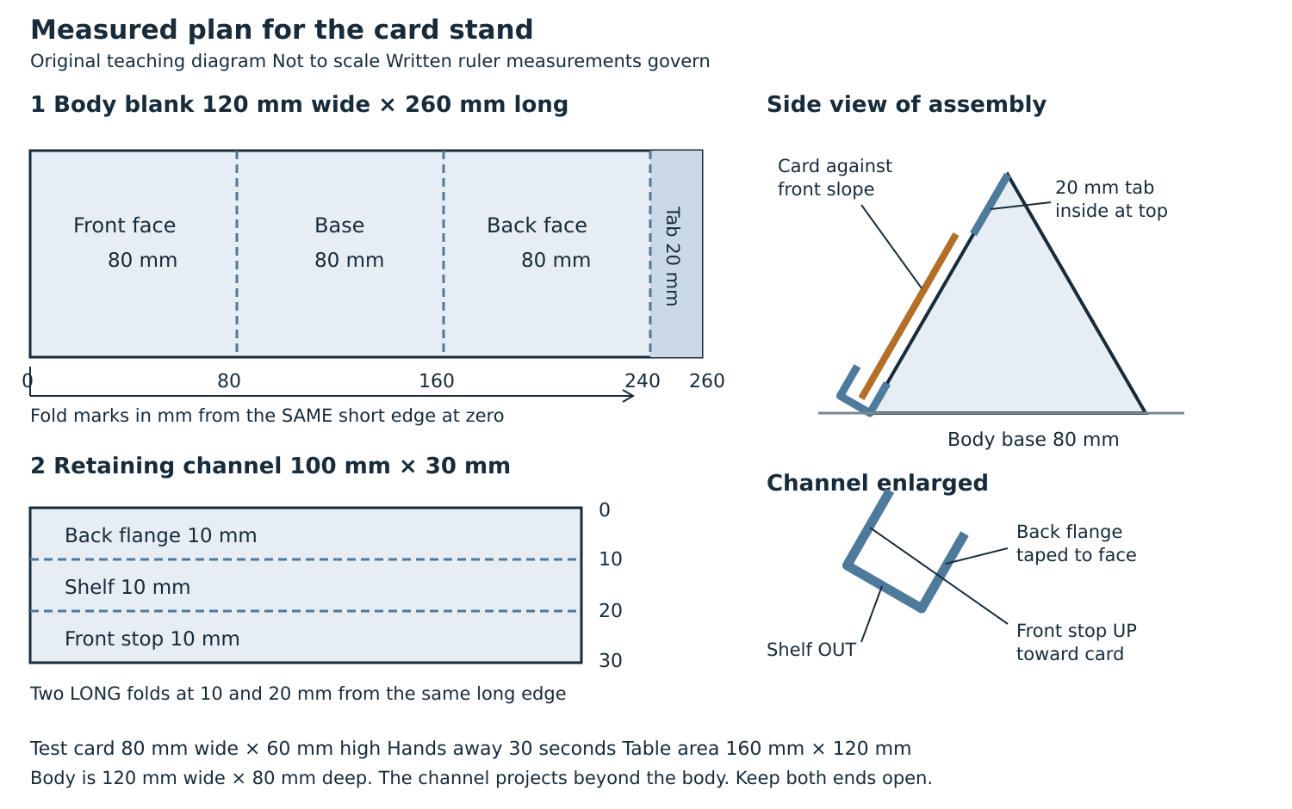
Body base target 120 mm by 80 mm. Check the actual whole stand including the U channel against the 160 mm by 120 mm table area target. Test one actual 80 mm by 60 mm paper card for 30 seconds with hands away after adult clearance.

