Construction making knowledge organiser
Design and Technology LAUNCH Spring 2 Week 3 Thursday 11 March 2027 P1 Year A
Weekly outcome verbatim: CONSTRUCTION: make, adjust and improve.
I can make from my checked plan and use real checks to improve the work.

Today I can
[ ] I can follow the approved cut and join with safe support.
[ ] I can stop and compare my work with my plan.
[ ] I can log each real adjustment and explain why it helps.

The problem and purpose
Invented client Sam needs one paper prompt card, 80 mm wide by 60 mm high, upright and readable on a level table. Make a small card stand. It should hold that card for 30 seconds with hands away, fit within a 160 mm by 120 mm overall table area including the channel, let the card lift out by hand and have smooth safe edges. The default body base is 120 mm by 80 mm. These are design targets. Check the actual stand. No heavy object or extra load is used.

The default plan
Default: one suitable thin card body 120 mm wide by 260 mm long. Mark folds across the width at 80, 160 and 240 mm from the same short end. This gives three 80 mm faces and a 20 mm joining tab. Fold a triangle and tape the tab inside the first face at the top seam. Add a 100 mm by 30 mm retaining strip with long folds at 10 and 20 mm from the same long edge. Fold a shallow U channel. Tape its back flange at the bottom of the front sloping face. The shelf projects out and the front stop faces upward toward the card. Leave the stand ends open. Use the actual approved revised plan if it differs.

A useful order
Retrieve the design. Check tools and support. Mark and recheck. Cut as agreed. Try the parts. Join. Stop and check. Make a safe change if needed. Log what happened.

Evidence to keep
Keep the actual work and the true stage reached. Record checks, each real change and why, pupil actions and adult help. An adult example is not your own practical evidence.
Use your book first. Rehearse in any language. A calm pause starts with tools down and work safe.

Build readiness and safety brief
Design and Technology LAUNCH Spring 2 Week 3 Thursday 11 March 2027 P1 Year A
Retrieve your actual Week 1 design and Week 2 plan. Confirm the chosen size, material and join. Wait for the adult before tools are issued.

Before making
[ ] The adult checks the real plan, tools, card and support before issue.
[ ] Use approved scissors only when the adult clears the route. No power tools or heated tools.
[ ] If card is too thick or hard to cut, stop. Use safe thinner or prepared card with adult approval.

During making
[ ] Keep the helping hand outside the cut path. Turn the card and cut away from your body and other people.
[ ] Close scissors and put them down before speaking or pausing. Carry closed and pass handle first as shown.
[ ] Fold with fingers and a ruler guide. No craft knives, sharp scoring blades, saws or drills in this default route.
[ ] Use paper tape for the cold join. Do not wrap tape around skin. No hot glue is used.

Before leaving
[ ] Put tools down before checking or adjusting. Ask the adult before a further cut.
[ ] Return counted tools and clear offcuts as agreed. Stop and tell the adult if a tool is damaged or missing. Do not search through sharp offcuts with bare hands.
[ ] Keep unfinished work and its record safe. Test only after adult clearance and when the joint is ready.
If any check is unclear, stop. The adult agrees a safe next step. A tick records an observed check, not permission for a different tool.

Default measured construction plan
Design and Technology LAUNCH Spring 2 Week 3 Thursday 11 March 2027 P1 Year A
Use the written ruler measurements. This model plan is not to scale and is not a cutting template. Use the actual approved revised plan if it differs.
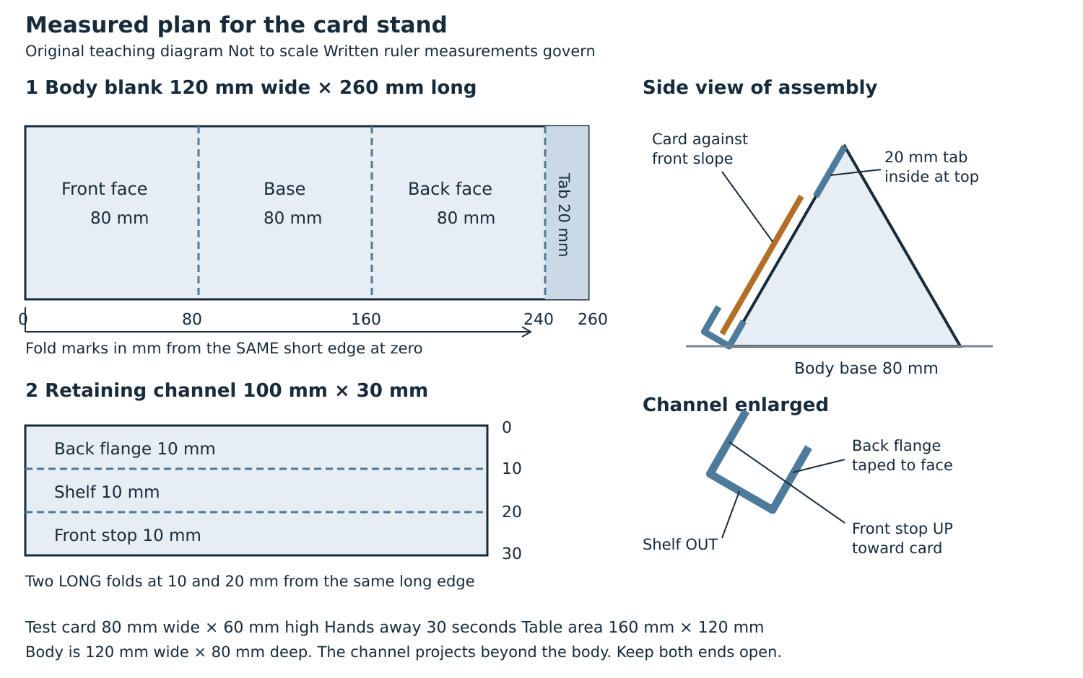
Body base target 120 mm by 80 mm. Check the actual whole stand including the U channel against the 160 mm by 120 mm table area target. Test one actual 80 mm by 60 mm paper card for 30 seconds with hands away after adult clearance.

Safe cutting and joining step card
Design and Technology LAUNCH Spring 2 Week 3 Thursday 11 March 2027 P1 Year A
Use this method only if it matches your approved design and actual material. The adult demonstrates, approves and supervises hand tools. Tools down before a question or pause.

1 Retrieve and check
Find the actual Week 1 design and Week 2 list, material choice, step plan and mock up. Ask the adult to approve the method, tools and support. If a record is missing, agree a new dated plan today and say it is new. Keep actual pupil choices visible.

2 Measure and mark
For the default, mark a body 120 mm by 260 mm and a channel strip 100 mm by 30 mm. Align ruler zero with the chosen edge. Recheck each size. Mark body folds at 80, 160 and 240 mm from the same short end. Mark both long channel folds at 10 and 20 mm from the same long edge. The adult checks before cutting.

3 Cut with approval
The adult shows the agreed scissor grip and a stable position. Keep the helping hand out of the blade path. Cut away from your body and other people. Turn the card to keep the line easy to reach. Close scissors and put them down to stop, speak or change position. Do not force thick card. Use prepared pieces or ask for help.

4 Prepare and test the join
With tools down, guide each fold with a ruler and press it with fingers. Do not use a sharp scoring edge. Trial fold the three faces into a triangle. The 20 mm tab goes inside the first face at the top seam. Check the triangle sits on its base and the open ends remain clear.
Written measurements control the work. This page is not a full size cutting template. Keep the actual plan beside the work.

Join check and improve
Design and Technology LAUNCH Spring 2 Week 3 Thursday 11 March 2027 P1 Year A

5 Make the agreed joint
Tape the top seam so the inside tab holds the triangle closed. Fold the retaining strip at both long marks into a shallow U. The 10 mm back flange lies against the bottom of the front sloping face. Tape that flange. The shelf projects out and the front stop faces upward toward the card. Do not flatten the channel or cover its opening with tape.

6 Stop and check
Tools down. Compare the actual stand with the plan. Ask the adult to clear the joint and test. Put one actual 80 mm by 60 mm paper card in the U channel against the slope. Keep hands away for 30 seconds on a level table. Lift the card out gently. No pushing, shaking, drop test or extra load. Record the real result.

7 Adjust and log
If a check shows a need, keep tools down and ask the adult. Adjust one approved feature, then recheck the same purpose. Log every real change, why it helps and what happened next. A new tape piece, revised fold or channel position must have a real reason. If no change is needed, record the checks and an approved refinement or next step honestly.

Alternative material or join
The default uses suitable thin card, approved scissors, finger folds and paper tape. No glue is needed. A different actual approved design needs its own checked sizes, method and support. Corrugated board may need prepared pieces. Dowel and soft wood are comparison choices from Week 2, not permission for wood cutting here. PVA is used only if the actual plan and adult label checks approve it, with full stated cure before testing. Never invent a cure time. Hot glue is comparison only and is not used. No power tools or heated tools are used.

Materials free route
With no card or safe equipment, use the supplied plan for a directed sketch or empty hand rehearsal. Say where you would cut, fold, join and stop to check. Log a proposed change as a proposal. Label the work planning or simulation. Actual cutting, joining, adjustment and testing evidence stay pending unless those actions take place.

Stop and check routine
Design and Technology LAUNCH Spring 2 Week 3 Thursday 11 March 2027 P1 Year A
Use this routine after marking, after cutting, after a trial assembly and before testing. Repeat it when a piece does not match the plan.

1 Tools down
Close scissors and put them down. Make the work safe before talking or checking.

2 Compare
Use the actual plan and ruler. Check size, folds, tab and channel. Name one real difference or a check that is met.

3 Ask and agree
Ask the adult if unsure. Agree one safe adjustment linked to the purpose before a tool moves.

4 Adjust one feature
Make the approved change with the agreed support. Do not add a new tool or material without approval.

5 Recheck and log
Repeat the relevant check. Record before, change, why, result and support. If the check cannot happen, write pending. Resume only when clear.

One check before a tool moves
Can I point to the approved line, the safe place for my fingers and the next action? If not, keep the tool down and ask the adult.

One check before a test
Is the joint ready for a test? A temporary joint is tested only as agreed. An adhesive join waits for its full label time. Never rush a joint to finish within the lesson.
The adult stays responsible for tool approval and supervision. A checklist does not clear an unsafe action.

Construction change log
Design and Technology LAUNCH Spring 2 Week 3 Thursday 11 March 2027 P1 Year A
Record each real adjustment while making. Add another entry in your book if needed. Keep the original plan and the changed version so the reason is clear.
Entry | What I found | What I changed and why
1 | _____________________ | _______________________________
2 | _____________________ | _______________________________
3 | _____________________ | _______________________________

Complete each entry
Date and stage ___. Original plan or measure ___. Actual check ___. Change ___. Reason linked to the purpose ___. Adult approval and help ___. Recheck result or pending ___.

If no adjustment was needed
Write no adjustment after checking ___. Give the real result. Do not invent a mistake or copy an example as your own work.

A model only
Adult example only: The card slipped during the first agreed test. I saw that the front stop was folded flat. With adult approval I refolded the U so the shelf projected out and the front stop faced up. I then repeated the 30 second test and recorded its actual result. This is a model account, not a pupil result.

My next step
The build is complete / partly made / a mock up / simulation ___. I still need ___. Evidence location ___. Words read back and confirmed yes / not yet ___.

Construction making evidence record
Design and Technology LAUNCH Spring 2 Week 3 Thursday 11 March 2027 P1 Year A
Outcome verbatim: CONSTRUCTION: make, adjust and improve.
Actual date ___. Private work reference ___. Week 1 design location ___. Week 2 plan location ___. Actual route practical / pupil directed adult handling / mock up / simulation ___.
Evidence feature | Actual observation or location
Material and approved join | ________________________________
Marking and cutting pupil role | ________________________________
Joining pupil role and adult role | ________________________________
Stop and check result | ________________________________
Each adjustment and why | ________________________________
Recheck result or still pending | ________________________________
Tool return and work stored safely | ________________________________

Pupil words
I made or directed ___. The adult did ___. One real check showed ___. I adjusted ___ because ___ / no change was needed after ___. My next step is ___. Words read back and confirmed yes / not yet ___.

Evidence boundary
Prepared pieces do not show pupil cutting. Adult making is recorded as adult making. A mock up shows its own stage. Empty hand rehearsal is simulation and leaves actual making evidence pending. This weekly record alone does not confirm the unit award.

