Weather risk facts and planning cards
Tuesday 16 March 2027 | P2 | 40 minutes | Year A
Humanities | LAUNCH | Spring 2 Week 4 | HUM-LAUNCH-S2-W04
White paper version. Read quietly, point, write, type, speak privately or direct a scribe who reads your words back. You may pass. No public answer or reading aloud is required.
Original learning summaries based on checked facts. No source extract, map or picture is reproduced. C codes identify the cards. G codes link to research titles and records in SOURCE_MANIFEST.json.

C1 Extreme weather and risk factors
Heavy rain, strong wind and extreme heat can cause impacts. Flooding can follow heavy or prolonged rain. Surface water flooding occurs when rain overwhelms drainage or cannot soak into the ground; it can happen away from a river. River flooding can follow heavy rain in a catchment. Hazard names the process that can cause harm. Exposure names who or what is in the affected area. Vulnerability is a condition that increases harm. Capacity is a strength or resource that helps. Research basis: G1–G6.

C2 Invented offline area records
All records below are invented for planning practice. Shared assumption: heavy rain lasts several hours. Likelihood and potential severity are given categories, not a real forecast, observation, warning or exact calculation. The map is invented and not to scale. B is planned water-storage land; its upper path is assumed to remain available. No pupil needs a live site.
Area | Exposure | Conditions and capacity | Flood likelihood | Potential severity
A | 30 homes and 1 water pump | Older drains have limited capacity; pump equipment is low. | High | Major
B | 0 homes and 1 footpath | Planned water-storage space and an upper path are available. | High | Minor
C | 6 homes and the only access bridge | The area relies on one access route; approaches could flood. | Medium | Major

Weather risk facts and planning cards
Tuesday 16 March 2027 | P2 | 40 minutes | Year A
Humanities | LAUNCH | Spring 2 Week 4 | HUM-LAUNCH-S2-W04
White paper version. Read quietly, point, write, type, speak privately or direct a scribe who reads your words back. You may pass. No public answer or reading aloud is required.

C3 Read likelihood and severity together
Likelihood asks how likely flooding is. In this invented guide, low means possible but not expected, medium means possible, and high means likely, not certain. Severity asks how serious impacts could be if flooding occurs. Minor means short disruption with few important assets affected. Moderate means some buildings or routes affected with alternatives available. Major means homes, important services or the only access could be disrupted. A and B share high likelihood but have different severity. C has medium likelihood and major severity. The guide gives no exact risk score. Research basis for the two-factor idea: G2; the classroom categories are newly constructed.

C4 Planning choices have limits
Improving and maintaining drains can reduce some surface water flooding, but their capacity can be exceeded and they cannot stop every river flood. Raising or protecting pump equipment can reduce service vulnerability while homes remain exposed. An additional planned access route can reduce dependence on one bridge, but needs land, funding and maintenance. A measure may change likelihood, severity or the ability to cope. No measure removes all risk. These are planning options, not instructions to enter a flooded place. Research basis: G3, G7; option examples are teacher-written.

Weather risk facts and planning cards
Tuesday 16 March 2027 | P2 | 40 minutes | Year A
Humanities | LAUNCH | Spring 2 Week 4 | HUM-LAUNCH-S2-W04
White paper version. Read quietly, point, write, type, speak privately or direct a scribe who reads your words back. You may pass. No public answer or reading aloud is required.

C5 Explain without blame or certainty
Vulnerability can arise from infrastructure, housing, environment and access to resources. These conditions are often outside an individual’s control. People and communities also have knowledge and strengths. Explain the condition and what support could change it. A risk judgement is about possible harm, not proof that harm will happen. Before a real decision, planners need updated evidence, local knowledge and professional judgement. This exercise supplies only invented assumptions. Research basis: G4–G7.

Original planning prompts
Compare A and B: same likelihood, different potential severity. Use exposure, vulnerability and capacity to explain why. Compare A and C: both have major potential severity, but their chance categories differ. What extra evidence would improve a choice? Choose one measure, explain a benefit and a limit, and keep the invented label visible.

D1 The parts of risk
Tuesday 16 March 2027 | P2 | 40 minutes | Year A
Humanities | LAUNCH | Spring 2 Week 4 | HUM-LAUNCH-S2-W04
White paper version. Read quietly, point, write, type, speak privately or direct a scribe who reads your words back. You may pass. No public answer or reading aloud is required.
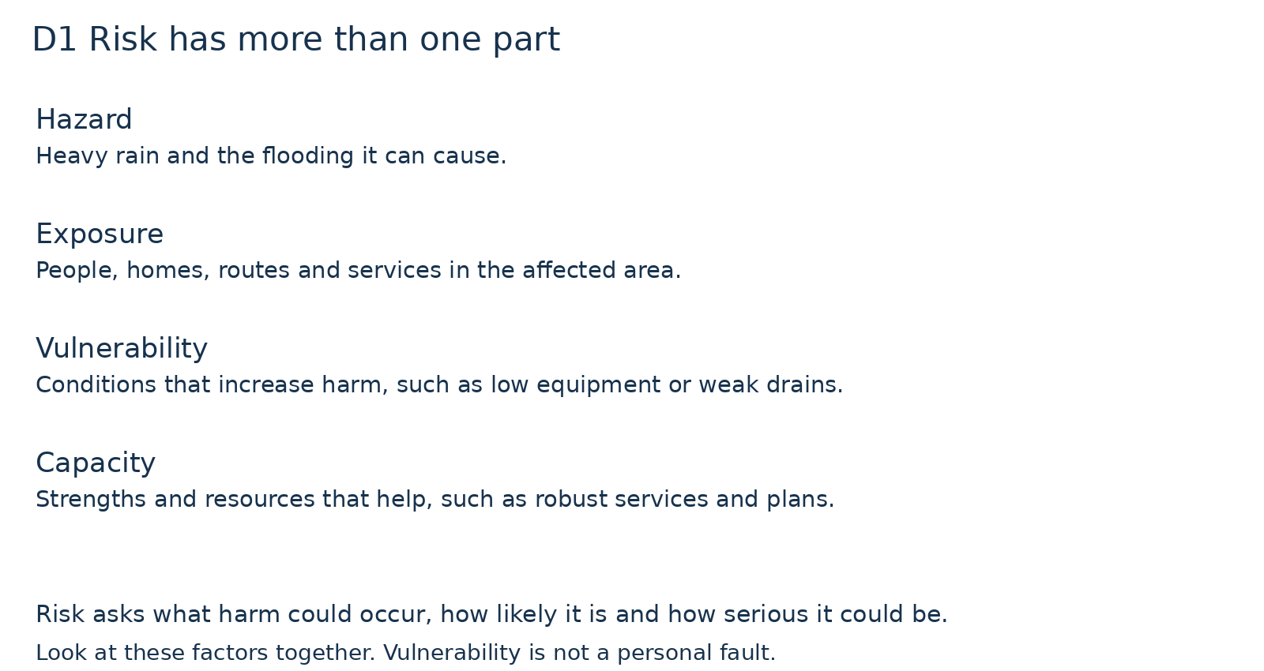
Use A to give an example of hazard, exposure and vulnerability. Use B to name one capacity.
Original concept guide. The factors are considered together; they are not a chain in which one automatically causes the next.

D2 Invented planning map
Tuesday 16 March 2027 | P2 | 40 minutes | Year A
Humanities | LAUNCH | Spring 2 Week 4 | HUM-LAUNCH-S2-W04
White paper version. Read quietly, point, write, type, speak privately or direct a scribe who reads your words back. You may pass. No public answer or reading aloud is required.
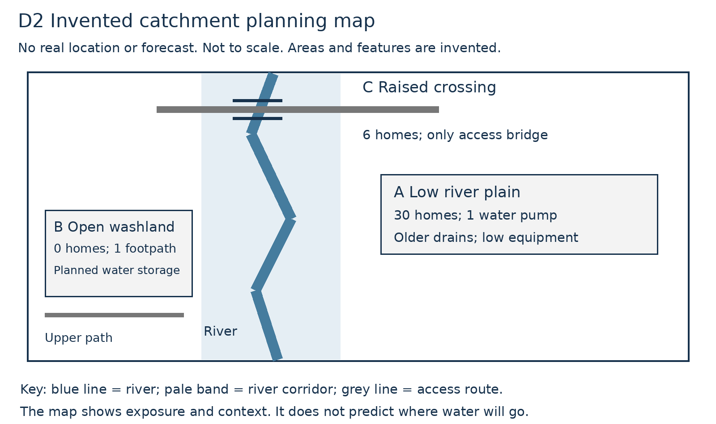
Locate the homes, pump, storage land and single bridge. Which features affect exposure or the ability to cope?
Invented map, no real place and not to scale. It shows context for the planning cards, not flood extent, a forecast or an official warning.

D3 Chance and possible harm
Tuesday 16 March 2027 | P2 | 40 minutes | Year A
Humanities | LAUNCH | Spring 2 Week 4 | HUM-LAUNCH-S2-W04
White paper version. Read quietly, point, write, type, speak privately or direct a scribe who reads your words back. You may pass. No public answer or reading aloud is required.
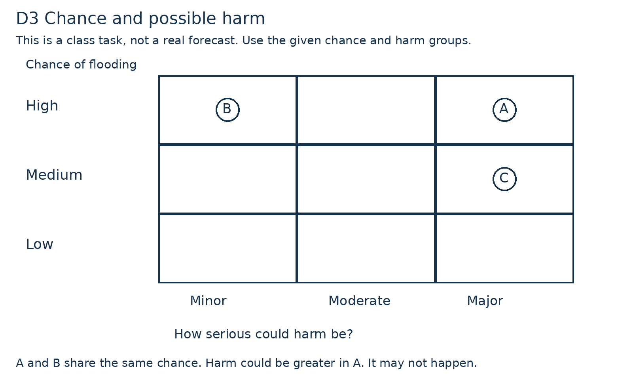
Read A and B across both axes. Why do their potential impacts differ although the likelihood category is the same?
Invented qualitative classroom guide. No overall score or official warning colour is assigned. Given categories are assumptions, not exact probabilities.

