Local area picture cards
28 January 2027 | P3
Pink paper | You can point, write or ask an adult to write.
A made-up town. Top row: then. Bottom row: now.
Left: high street. Middle: park. Right: bus stop.
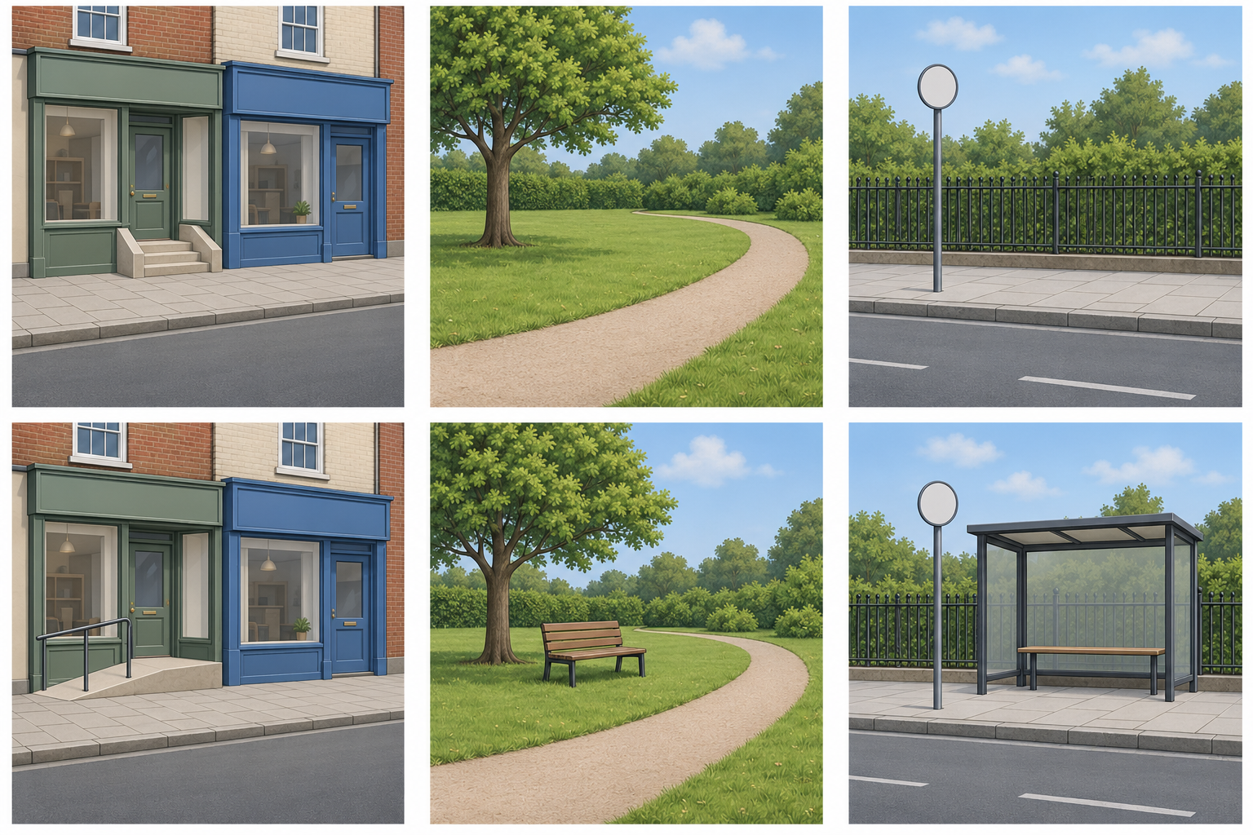
Words: park, tree, same. Start: Both have __.
Model: Both have a tree.

Finish
Match the park views. Find the tree in both.

Local area picture cards continued
28 January 2027 | P3
Pink paper | You can point, write or ask an adult to write.

Clues for our town
This town and its changes are made up. Use both views in a pair.
Place type | Then | Now | Still here
High street | Steps | Ramp | Shops
Park | No bench | Bench | Tree and path
Bus stop | No shelter | Shelter | Pole and fence

Words
then, now, steps, ramp, bench, shelter, same

Start
Then __. Now __.

Park model
Then | Now
There was no bench. | There is a bench.
The stop is on a bus route. The pictures do not tell us bus times or why things changed.

Finish
Choose one pair. Show or say one change. An adult can read with you.

