Then and now picture cards
11 February 2027 | P3
White paper | You can point, write or ask an adult to write.
Made-up places from Week 4. Top: then. Bottom: now.
Left: high street. Middle: park. Right: bus stop.
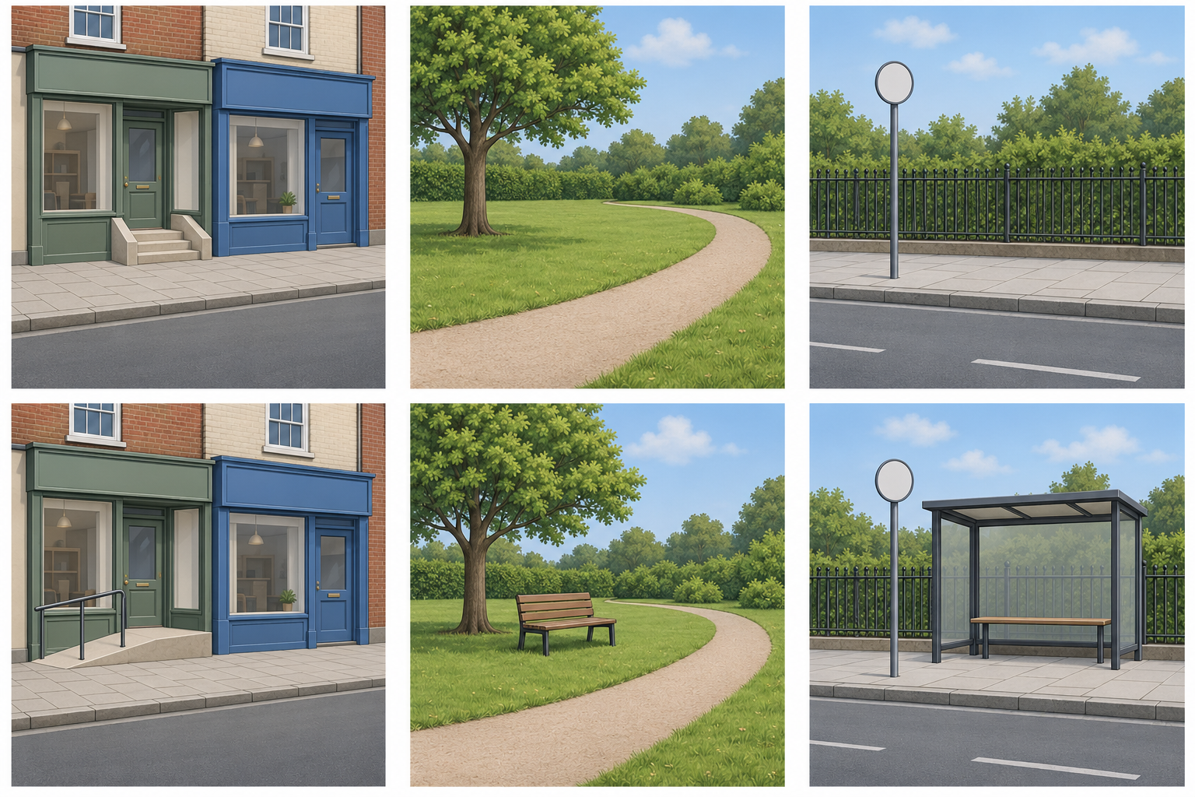
Words: then, now, tree, same. Start: Both have __.
Model: Both have a tree.

Finish
Match the park views. Find the tree in both.

Then and now picture cards continued
11 February 2027 | P3
White paper | You can point, write or ask an adult to write.

Choose one pair
These places and changes are made up. Use pictures or draw them in your book.
Place | Then words | Now words
High street | steps | ramp
Park | no bench | a bench
Bus stop | no shelter | a shelter

Words and start
then, now, steps, ramp, bench, shelter.
Then __. Now __.

Model — use the middle picture pair
Then | left panel | Now | right panel
Park picture: no bench | Park picture: a bench
Then there was no bench. | Now there is a bench.

Finish
Choose two views of the same place. Put then left and now right. Give each a caption.
We do not know when or why these changes took place.

