Four story faces
These faces are made up. Use the story words. A face is a clue, not proof.
A cross  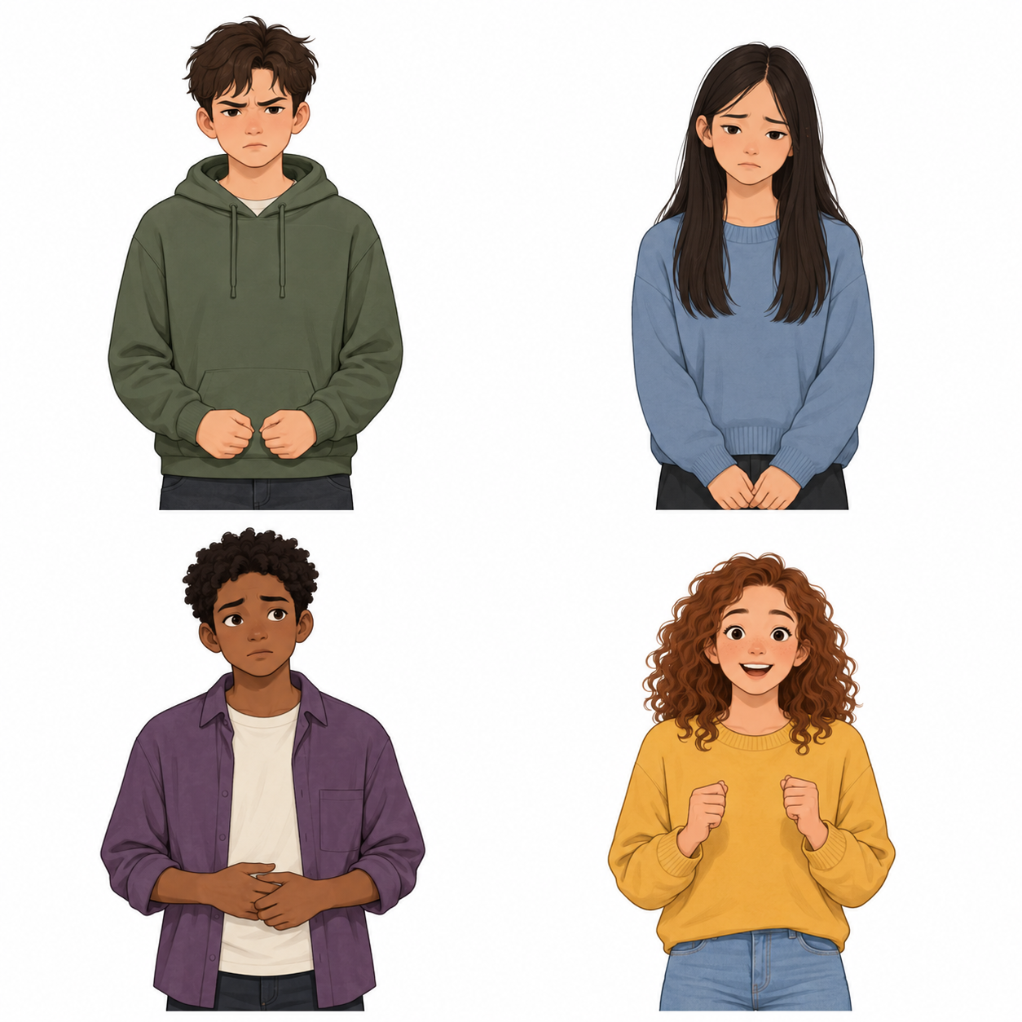 | B sad
C worried | D excited
Words: cross · sad · worried · excited.
Start: “The story says ... .”
Model: Story A says, “I feel cross.”
Point, read or use an aid. No one has to say how they feel.

Four body clues
A face or body may give a clue. It is not proof. Use the story words. Do not guess how a real person feels.

A cross
Hands may feel tight.

B sad
The body may feel slow.

C worried
The tummy may feel tight.

D excited
The body may want to move.

Use the story words
Two people may have the same clue and not the same feeling. A tight tummy does not prove worried.
Words: words · face · may · help.
Start: “A clue may ... . The words say ... .”
Model: Story A states cross. A face alone is not proof.
You can point or use an aid. No one needs to talk about their own body.

Four short stories
All stories are made up. Use these words, not your own life.

Story A A wait for a turn
A young person waits for a turn. They say, “I feel cross.” Their hands feel tight.
Help to try in the story: breathe or tell someone.

Story B A mark on a page
A young person sees a mark they did not plan on a drawing. They say, “I feel sad.” Their body feels slow.
Help to try in the story: tell someone or take space.

Story C A new short task
A young person will try a new short task. They say, “I feel worried.” Their tummy feels tight.
Help to try in the story: tell someone or breathe.

Story D A fun task soon
A young person will start a fun task. They say, “I feel excited.” Their body wants to move.
Help to try in the story: move or take space.
More than one safe step can fit. These pairs are just examples. A step may help. It need not make the feeling go away.
Words: cross · sad · worried · excited · help.
Start: “The story says ... . They could ... .”
Model: Story A: cross; tell someone. Other safe help can fit.

Four help steps
Use a step you know at school, with agreed help. You need not try it now.

1 breathe
Use the calm breath step you know, with help if needed.

2 move
Use a small safe move that is agreed with an adult.

3 tell someone
Tell a trusted adult. You can ask in private.

4 take space
Ask to use the agreed quiet place, with help.
More than one step may fit. No step must work for all people. Stop if a step feels bad. Ask for a new choice.
Words: breathe · move · tell · space.
Start: “They could ... .”
Model: Story A: “They could tell a trusted adult.”
Point to HELP. Ask a trusted adult in private. Use the school help route. If the adult is busy, ask another through that route. You can pass, pause and come back with help.

Aids for each task
Keep the words, start and model in view. Use a story, not your own life.

Starter
Words: cross, sad
Start: The story says ... .
Model: Story A says, “I feel cross.”

Model check
Words: cross, tight, tell
Start: The feeling is ... . Help is ... .
Model: Story A: “When I feel cross I can tell someone.”

Guided match
Words: sad, worried, excited, breathe, move, tell, space
Start: The story says ... . They could ... .
Model: Story A: cross; tell someone. Other safe help can fit.

Private hinge
Words: words, face, may, help
Start: A clue may ... . The words say ... .
Model: Story A states cross. A face alone is not proof.

Aids for your own story work

Help choice
Words: breathe, move, tell, space
Start: They could ... .
Model: Story A: “They could tell a trusted adult.”

Individual line or drawing
Words: cross, sad, worried, excited, breathe, move, tell, space
Start: When I feel ... I can ... .
Model: Story A: “When I feel cross I can tell someone.”

Feedback and exit
Words: feeling, help, ask
Start: A feeling is ... . A safe step is ... .
Model: Story A: cross; tell someone in private.

Draw or pick words
You can draw a story face or help step. Point to or label a feeling and safe help. An adult can write the words you pick. We do not grade art.

Help in private
Point to HELP. Ask a trusted adult in private. Use the school help route. If the adult is busy, ask another through that route. You can pass, pause and come back with help.

