Visual step cards
Year A | Autumn 2 Week 1 | 2 November 2026
I can save and find a file, and choose what to share.
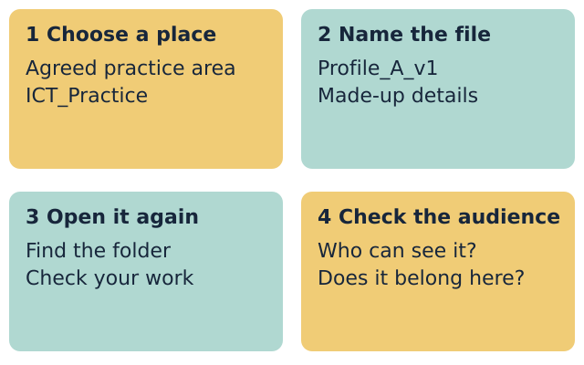
Choose the place: Use the practice area that staff show you.
Make a folder: Make W01_Profiles inside ICT_Practice.
Save a clear name: Save the made-up profile as Profile_A_v1 or Profile_B_v1.
Check it opens: Close it. Find the folder. Open the file and check the text.
Use made-up details only. Ask staff before sharing a file.

Words for files and profiles
Year A | Autumn 2 Week 1 | 2 November 2026

file
Work saved with a name.

folder
A place to group files.

personal information
Details linked to a person.

audience
The people who can see or hear it.

version
A saved copy at one stage of your work.

access
Being able to open or use a file.
Use one word to explain your work.
________________________________________________________________

Knowledge organiser
Year A | Autumn 2 Week 1 | 2 November 2026
I can save and find a file, and choose what to share.
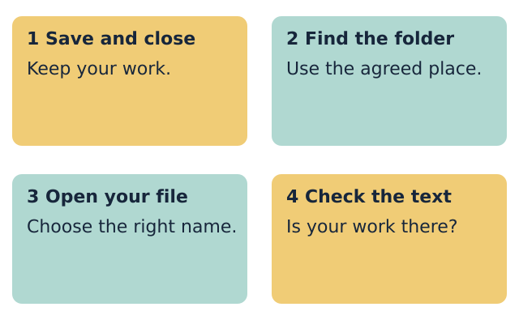
I made a folder in the agreed place.
I used a clear file name.
I opened the saved file and checked my work.
I used only made-up details.
I gave a reason for leaving out one detail.
A folder name does not make a file private. Check who can open it. Use only the details that fit the purpose and audience.

Fictional profile cards
Year A | Autumn 2 Week 1 | 2 November 2026
Both profiles are made up. Use one to make an introduction for a hobby group. The group can see the introduction.

Profile A
Hobbies: Sketching and making models
I like to draw designs before I build.

Profile B
Hobbies: Music and solving puzzles
I like to learn a tune in small steps.

Choose what belongs in the introduction
Detail card | Keep for this task or leave out
Profile label
General hobby
Home address
Contact number
Full date of birth
Account password
I would leave out ... because ...
________________________________________________________________
These are detail types for sorting. Do not add real values.

Supported route
Year A | Autumn 2 Week 1 | 2 November 2026
I can save and find a file, and choose what to share.
1. Choose Profile A or Profile B.
2. Ask for one step at a time.
3. Make the folder using the step cards.
4. Type the profile label and one general hobby.
5. Save, close, find and open your file.
6. Say which detail you left out and why.

Check my work
[ ] I made a folder in the agreed place.
[ ] I used a clear file name.
[ ] I opened the saved file and checked my work.
[ ] I used only made-up details.
[ ] I gave a reason for leaving out one detail.
My reason for leaving a detail out
________________________________________________________________
You may point, speak, type or ask for exact scribing. Each person keeps their own file and check.

Independent route
Year A | Autumn 2 Week 1 | 2 November 2026
I can save and find a file, and choose what to share.
1. Make W01_Profiles inside ICT_Practice in the agreed place.
2. Write a short hobby profile using the made-up card.
3. Use a clear file name ending in v1.
4. Save, close, find and open your file.
5. Check the reopened text matches your work.
6. Explain why the group does not need one private detail.

Check my work
[ ] I made a folder in the agreed place.
[ ] I used a clear file name.
[ ] I opened the saved file and checked my work.
[ ] I used only made-up details.
[ ] I gave a reason for leaving out one detail.
My reason for leaving a detail out
________________________________________________________________
You may point, speak, type or ask for exact scribing. Each person keeps their own file and check.

Aspire route
Year A | Autumn 2 Week 1 | 2 November 2026
I can save and find a file, and choose what to share.
1. Complete the Independent task first.
2. Add a useful sentence for the hobby group.
3. Save a new copy with v2 in the name.
4. Keep the first version.
5. Open both files and explain what changed.
6. Explain how you would check who can see the file.

Check my work
[ ] I made a folder in the agreed place.
[ ] I used a clear file name.
[ ] I opened the saved file and checked my work.
[ ] I used only made-up details.
[ ] I gave a reason for leaving out one detail.
My reason for leaving a detail out
________________________________________________________________
You may point, speak, type or ask for exact scribing. Each person keeps their own file and check.

My evidence record
Year A | Autumn 2 Week 1 | 2 November 2026
Use your made-up profile label. Keep this record with your work.
Profile label used:
________________________________________________________________
My file name:
________________________________________________________________
My folder:
________________________________________________________________
My saved file opens and shows my work: yes / not yet.
________________________________________________________________
I left out ... because ...
________________________________________________________________
My next step:
________________________________________________________________
My response to feedback:
________________________________________________________________

Staff observation
Date: __________ Support actually used: _____________________
Observed: folder / clear name / reopened content / reason for leaving a detail out. Record each as seen, supported or not yet seen.
Next-step prompt given: _________________________________
Pupil response heard or read back: ________________________

