Visual step cards
Year A | Autumn 2 Week 2 | 9 November 2026
I can make a clear document with a title, headings and short paragraphs.
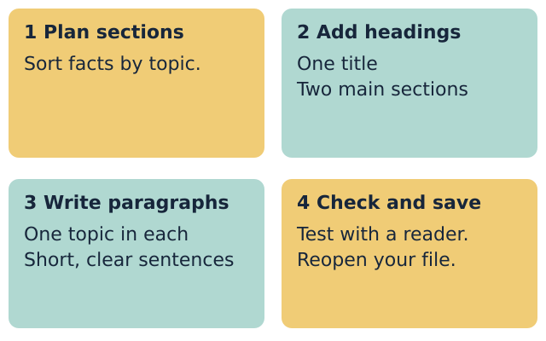
Plan the sections: Choose source A or B. Sort the facts into topics.
Set the title and headings: Use a title and two main heading styles.
Write the paragraphs: Put short sentences about one topic together.
Check and save: Ask a reader to find a fact. Save and reopen your file.
Use only the made-up source facts. Keep real personal details out.

Words for a structured document
Year A | Autumn 2 Week 2 | 9 November 2026

title
The name of the whole document.

heading
A label for one section.

paragraph
Sentences about one topic.

style
A set format that gives text a role.

audience
The people who will read the page.

proofread
Read again to find and fix mistakes.
Use one word to explain your page.
________________________________________________________________

Knowledge organiser
Year A | Autumn 2 Week 2 | 9 November 2026
I can make a clear document with a title, headings and short paragraphs.
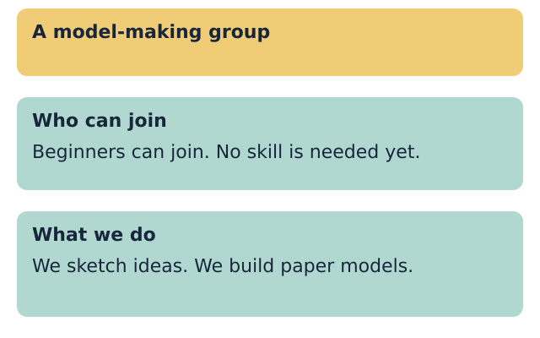
I used a title for the whole page.
I used two main heading styles.
I grouped facts in two short paragraphs.
I checked my facts and full stops.
I reopened my saved file and checked the text.
Use title and heading styles to give text a role. Keep body text left aligned. Use one topic per paragraph. Read the page before you share it.

Fictional source cards
Year A | Autumn 2 Week 2 | 9 November 2026
Choose one made-up group. Create a welcome sheet for someone who may join. Use the facts below. Do not invent a place, contact, fee or meeting time.

Source A A model-making group
Joining facts: Beginners can join. No skill is needed yet.
Activity facts: We sketch ideas. We build paper models.
Extra facts: We take turns with the materials. We share ideas respectfully.

Source B A music group
Joining facts: Beginners can join. You can start with a simple beat.
Activity facts: We listen to short tunes. We clap and copy rhythms.
Extra facts: We take turns to lead. We listen when another person has a turn.

Sort before you type
Choose a title. Group the facts under Who can join and What we do. Keep the extra facts for a stretch section.
This heading helps the reader find ...
________________________________________________________________

Supported route
Year A | Autumn 2 Week 2 | 9 November 2026
I can make a clear document with a title, headings and short paragraphs.
1. Choose made-up source A or source B.
2. Use the title and headings in the frame.
3. Write a short paragraph under each heading.
4. Choose the title and heading styles with help.
5. Ask a reader to find who can join.
6. Save, close and reopen the file. Check the text.

Planning frame
Title: A model-making group OR A music group
Who can join: Beginners can ...
What we do: We ... We ...

Check my work
[ ] I used a title for the whole page.
[ ] I used two main heading styles.
[ ] I grouped facts in two short paragraphs.
[ ] I checked my facts and full stops.
[ ] I reopened my saved file and checked the text.
One choice that helps my reader
________________________________________________________________
You may point, speak, type or ask for exact scribing. Each person keeps their own document and check.

Independent route
Year A | Autumn 2 Week 2 | 9 November 2026
I can make a clear document with a title, headings and short paragraphs.
1. Choose source A or B and plan your sections.
2. Add one clear title and two useful headings.
3. Use heading styles at the same level.
4. Write two short paragraphs using the source facts.
5. Check facts, spaces and full stops with a reader.
6. Save, close and reopen the file. Check the text.

Check my work
[ ] I used a title for the whole page.
[ ] I used two main heading styles.
[ ] I grouped facts in two short paragraphs.
[ ] I checked my facts and full stops.
[ ] I reopened my saved file and checked the text.
One choice that helps my reader
________________________________________________________________
You may point, speak, type or ask for exact scribing. Each person keeps their own document and check.

Aspire route
Year A | Autumn 2 Week 2 | 9 November 2026
I can make a clear document with a title, headings and short paragraphs.
1. Complete the Independent task first.
2. Use the extra facts for a Taking part section.
3. Use the same main heading level.
4. Ask your reader to find one fact in that section.
5. Use the feedback to improve one detail.
6. Save a new v2 copy. Keep v1 and explain the change.

Check my work
[ ] I used a title for the whole page.
[ ] I used two main heading styles.
[ ] I grouped facts in two short paragraphs.
[ ] I checked my facts and full stops.
[ ] I reopened my saved file and checked the text.
One choice that helps my reader
________________________________________________________________
You may point, speak, type or ask for exact scribing. Each person keeps their own document and check.

My evidence record
Year A | Autumn 2 Week 2 | 9 November 2026
Use the source letter. Keep this record with your own document.
Source A or B:
________________________________________________________________
My file name and folder:
________________________________________________________________
My title tells the reader ...
________________________________________________________________
My headings help the reader find ...
________________________________________________________________
I changed ... because ...
________________________________________________________________
My saved file opens and shows my work: yes / not yet.
________________________________________________________________
My response to the next-step prompt:
________________________________________________________________

Staff observation
Date: __________ Support actually used: _____________________
Observed: title / two heading styles / grouped paragraphs / accurate facts / reopened text. Record each as seen, supported or not yet seen.
Next-step prompt given: _________________________________
Pupil response heard or read back: ________________________

