Visual step cards
Year A | Autumn 2 · Week 2 | 9 November 2026
I can update two score variables when the player touches a pickup or a hazard.
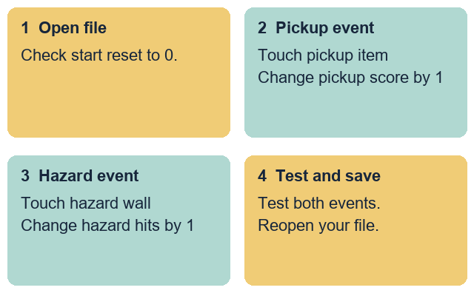
Open and check: Open your maze file. Check the start reset to 0.
Add pickup rule: When touching the pickup, change pickup score by 1.
Add hazard rule: When touching a hazard, change hazard hits by 1.
Test and save: Test both events. Save and reopen your file.
Use only the made-up project cards. Keep real personal details out.

Words for scoring events
Year A | Autumn 2 · Week 2 | 9 November 2026

event
A trigger that runs a rule in the game.

touching
A check for contact between two sprites.

change
Add to or take away from a variable value.

set
Fix a variable to one exact value.

pickup
An item the player collects to gain points.

hazard
An obstacle that adds a hit and sends the player back.
Use one word to explain how your pickup score goes up.
________________________________________________________________

Knowledge organiser
Year A | Autumn 2 · Week 2 | 9 November 2026
I can update two score variables when the player touches a pickup or a hazard.
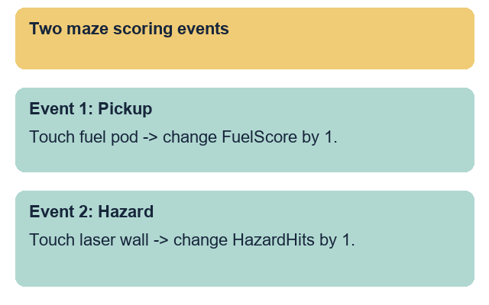
I added a rule that changes the pickup score by 1 on contact.
I added a rule that changes hazard hits by 1 on contact.
I used change blocks for events and kept set blocks for start.
I tested both events and the start reset with a partner.
I reopened my saved file and checked both event scripts.
Use change blocks inside touching checks so each contact adds to the score. Keep set-to-zero blocks on the start event so every turn begins fairly.

Fictional project cards
Year A | Autumn 2 · Week 2 | 9 November 2026
Choose your made-up maze card. Update both score variables from two game events. Use the rules below. Do not invent personal names, places or external accounts.

Source A A space maze project
Event rules: Touch fuel pod -> change FuelScore by 1. Touch laser wall -> change HazardHits by 1.
Reset rules: Return player to start pad after a hazard hit. Keep both scores set to 0 on start.
Extra rules: Check the variable drop-down on each change block. Stretch event: touch finish gate -> change FuelScore by 5.

Source B A deep-sea maze project
Event rules: Touch pearl shell -> change PearlScore by 1. Touch reef spike -> change ReefHits by 1.
Reset rules: Return player to start pad after a hazard hit. Keep both scores set to 0 on start.
Extra rules: Check the variable drop-down on each change block. Stretch event: touch finish gate -> change PearlScore by 5.

Plan before you build
Choose card A or card B. Match each touching event to the right change block and variable name. Keep the finish bonus for the Aspire route.
I used change instead of set because ...
________________________________________________________________

Supported route
Year A | Autumn 2 · Week 2 | 9 November 2026
I can update two score variables when the player touches a pickup or a hazard.
1. Open your maze file for project card A or card B.
2. Use the two-event scoring frame.
3. Add change pickup score by 1 inside the pickup check.
4. Add change hazard hits by 1 inside the hazard check.
5. Ask a partner to test both events and the start reset.
6. Save, close and reopen the file. Check both rules.

Planning frame
Card: Space maze A OR Deep-sea maze B
Pickup event: When touching pickup, change ... by 1
Hazard event: When touching hazard, change ... by 1

Check my work
[ ] I added a rule that changes the pickup score by 1 on contact.
[ ] I added a rule that changes hazard hits by 1 on contact.
[ ] I used change blocks for events and kept set blocks for start.
[ ] I tested both events and the start reset with a partner.
[ ] I reopened my saved file and checked both event scripts.
One reason to use change instead of set
________________________________________________________________
You may point, speak, build or ask for exact scribing. Each person keeps their own project file and check.

Independent route
Year A | Autumn 2 · Week 2 | 9 November 2026
I can update two score variables when the player touches a pickup or a hazard.
1. Open your maze file for card A or B and check the start reset.
2. Build the pickup contact rule to change the pickup score by 1.
3. Build the hazard contact rule to change hazard hits by 1.
4. Return the player to the start pad after a hazard hit.
5. Test pickup contact, hazard contact and start reset with a partner.
6. Save, close and reopen the file. Check both event rules.

Check my work
[ ] I added a rule that changes the pickup score by 1 on contact.
[ ] I added a rule that changes hazard hits by 1 on contact.
[ ] I used change blocks for events and kept set blocks for start.
[ ] I tested both events and the start reset with a partner.
[ ] I reopened my saved file and checked both event scripts.
One reason to use change instead of set
________________________________________________________________
You may point, speak, build or ask for exact scribing. Each person keeps their own project file and check.

Aspire route
Year A | Autumn 2 · Week 2 | 9 November 2026
I can update two score variables when the player touches a pickup or a hazard.
1. Complete the Independent task first.
2. Use the stretch rule to add a finish gate bonus event.
3. Change the pickup score by 5 when touching the finish gate.
4. Ask your partner to test pickup, hazard, finish and start reset.
5. Fix any block that updates the wrong variable.
6. Save a new v2 copy. Keep v1 and explain the change.

Check my work
[ ] I added a rule that changes the pickup score by 1 on contact.
[ ] I added a rule that changes hazard hits by 1 on contact.
[ ] I used change blocks for events and kept set blocks for start.
[ ] I tested both events and the start reset with a partner.
[ ] I reopened my saved file and checked both event scripts.
One reason to use change instead of set
________________________________________________________________
You may point, speak, build or ask for exact scribing. Each person keeps their own project file and check.

My evidence record
Year A | Autumn 2 · Week 2 | 9 November 2026
Use the project card letter. Keep this record with your own maze file.
Project card A or B:
________________________________________________________________
My file name and folder:
________________________________________________________________
My pickup event changes ... by ...
________________________________________________________________
My hazard event changes ... by ...
________________________________________________________________
I used change instead of set because ...
________________________________________________________________
My saved file opens and updates both scores on contact: yes / not yet.
________________________________________________________________
My response to the next-step prompt:
________________________________________________________________

Staff observation
Date: __________ Support actually used: _____________________
Observed: pickup event rule / hazard event rule / change vs set / both events tested / reopened file. Record each as seen, supported or not yet seen.
Next-step prompt given: _________________________________
Pupil response heard or read back: ________________________

