My object and care record
19 November 2026 | P3
Pink paper | You can point, write or ask an adult to write.
My code ____ Date ____
Keep a record in your book. Describe one thing you can see. Show an adult how you care for an allowed item.

Words
round, stripes, folds, ask, wait, care

Start
I can see __. I show care when I __.

Model
What I see | How I show care
The bowl is round. | I ask first and wait.
An adult can write your words or chosen labels. Hear them back quietly. Keep or change them.

Finish
One feature and one care step. Keep your own record.
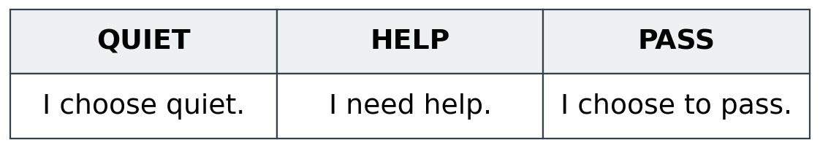
You may look instead of touch. Tell or show the adult your choice.

My object and care record continued
19 November 2026 | P3
Pink paper | You can point, write or ask an adult to write.

Adult record
Pupil code ____ Actual date ____
HUM-BUILD-A2-W03-E1
Book/card/photo reference ________________________
Item and mode: picture card / replica / observation only
Actual material used _____________________________
Visible feature selected or stated __________________
Exact words or labels _____________________________
______________________________________________
Observed care routine ____________________________
Stated care step, if not observed ___________________
Actual prompts or adult-supplied content ____________
______________________________________________
Outcome: shown / part shown / not yet shown
Touch declined or observation route ________________
Adult reply and one NS ___________________________
Pupil’s own response or change ____________________
Unfinished check _________________________________
Actual review and banking ________________________
Use codes only. Do not infer original-object handling, feel, weight, independent reading or a belief from a card response. R follows actual reply, NS and own response; E follows actual banking.

