My comparison record
3 December 2026 | P3
White paper | You can point, write or ask an adult to write.
My code ____ Date ____
Keep a record in your book. Use A and B. Show one similarity and one difference.

Words
both, same, different, stories, sing, draw

Start
Both groups __. In A __. In B __.

Model
Part | Worked model
Same | Both groups share stories.
Different | In A, some sing. In B, some draw.
You can point to two source lines. An adult can write your words. Hear them back quietly. Keep or change them.

Finish
One similarity and one paired difference. Keep your record.
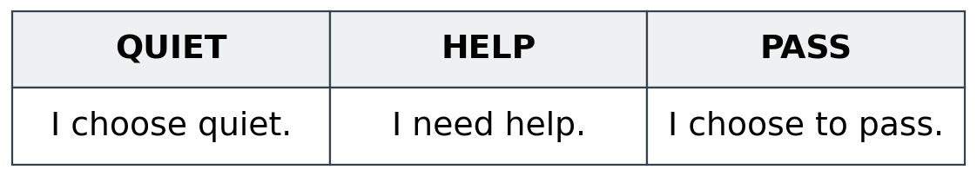
No need to tell the group about your own life.

My comparison record continued
3 December 2026 | P3
White paper | You can point, write or ask an adult to write.

Adult record
Pupil code ____ Actual date ____
HUM-BUILD-A2-W05-E1
Book/card/photo reference ________________________
Similarity selected or stated ______________________
Paired difference from A and B _____________________
Source lines used _________________________________
Exact words or chosen labels ______________________
______________________________________________
Response mode: point / match / draw / write / scribe / aid
Actual prompts or adult-supplied content ____________
______________________________________________
Outcome: shown / part shown / not yet shown
Optional question or further comparison ____________
Adult reply and one NS ___________________________
Pupil’s own response or change ____________________
Unfinished check _________________________________
Actual review and banking ________________________
Use codes only. Do not record personal beliefs or home details. Do not infer comparison from copying alone. R follows actual reply, NS and own response; E follows actual banking.

