Words for our practical
Reference mat · Read, point or say the word.
  role  The job I do in the team. |   hygiene  Keeping hands, food and kit clean.
  weigh  Find how heavy something is. |   batch  Food made in one go.
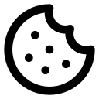  portion  One share of the food. |   allergen  Something that can cause an allergy.
  label  Words that tell us about an item. |   feedback  What people say we can improve.
I will use __ to choose __. I checked __. The feedback showed __. I will change __ because __.

