Words for our review
Reference mat · Read, point or say the word
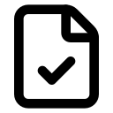 evidence  Work that helps show what I did. |  caption  A short note about one item.
 goal  What we want to achieve. | 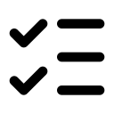 criteria  Checks that show success.
target  A clear result to aim for. | 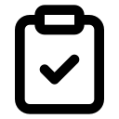 review  Check what worked and what to change.
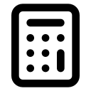 donation  Money we give to help a charity. | 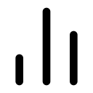 improve  Make something better.
This shows __. I chose __ because __. I will change __.

