Fabric choices for a purpose
Design and Technology LAUNCH Spring 1 Week 4 Thursday 28 January 2027 P1 Year A
Choose using a real sample result or the model descriptions. Do not claim an actual test from a picture.
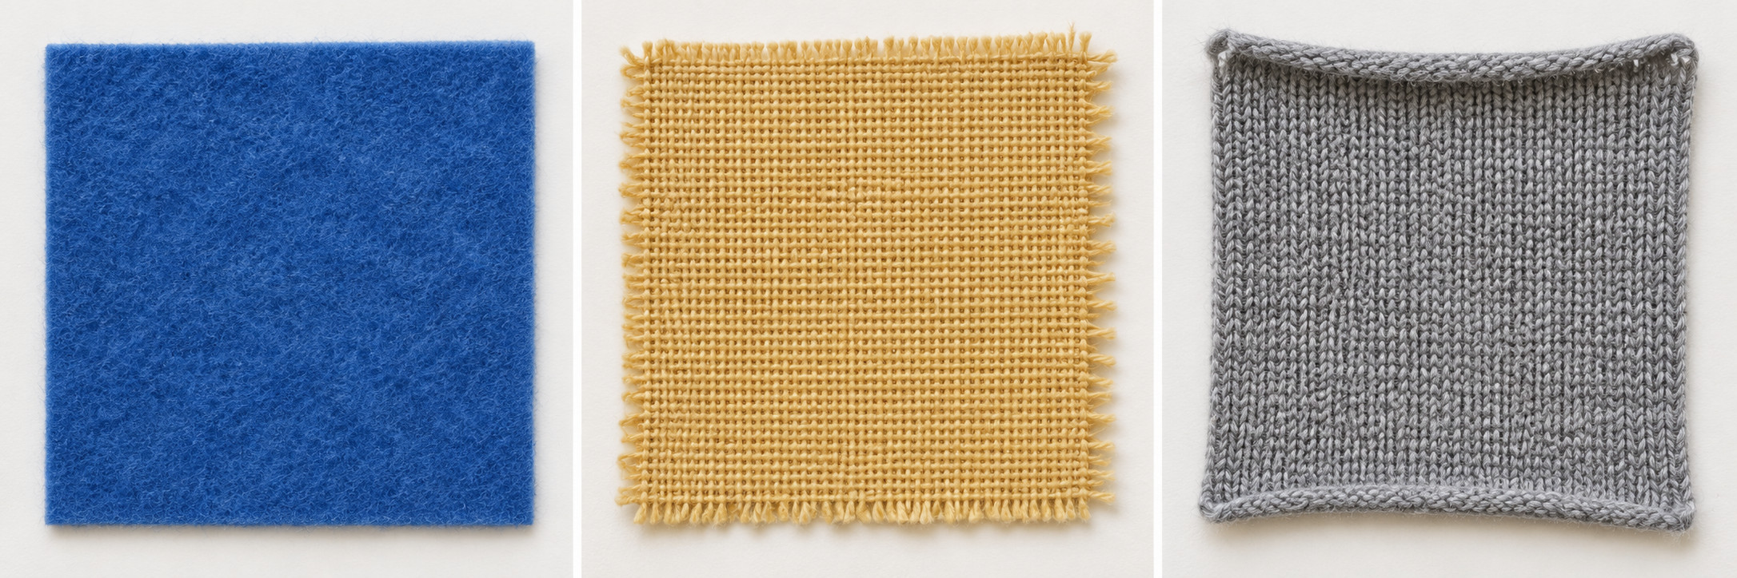
Original invented teaching photo. Left to right: felt, woven cotton, stretch knit. It shows appearance only. The pictured knit has a finished edge; the photo does not prove stretch, fraying or curling.
Generic sample | Model description | Link to the pouch
Non-fraying felt | Model: fairly firm, little stretch, cut edge does not fray. | May support the cards and avoid a fraying edge. Test the actual sample.
Woven cotton | Model: folds easily, little stretch across the weave, cut edge may fray. | May need edge finishing and support to keep its shape. Test the actual sample.
Stretch knit | Model: stretches, may curl at a cut edge, shape can change when pulled. | May be harder to measure and hold steady. Test the actual sample.

These descriptions and the supplied photo are model information. Real fabrics vary. If you test an actual sample, record its real result. If no sample is available, write model information used; do not claim a test.

Check an actual sample or use a model
Design and Technology LAUNCH Spring 1 Week 4 Thursday 28 January 2027 P1 Year A
With an adult, use the checks below on a real sample if available. No cutting, needle or adhesive is required today. If no sample is available, use the labelled model descriptions instead.

Stretch
With adult approval, hold a sample gently at two edges. Pull lightly across it, then release. Does it return to its shape?

Edge
Look at a cut edge. Does it shed threads, stay firm or curl? Do not pull threads out.

Firmness
Bend the sample gently. Could it support three cards without flopping? Keep this as a prediction until the pouch is made.

A result in your own words
Sample ___. Source actual sample / model information ___. Property ___. What I observed or read ___. What that could mean for the pouch ___. My choice and reason ___.

Be precise
An actual sample result tells you about that sample. A model description supports a planning prediction. Neither proves an unmade pouch passed its final fit and handling test. Record uncertainty and a later question.

Gentle handling
Do not force a stretch, tear an edge or pull out threads. Ask for adult handling or no-touch comparison if needed. A colour choice may matter to the user, but link at least one property to the job.

