Choosing fabric knowledge organiser
Design and Technology LAUNCH Spring 1 Week 4 Thursday 28 January 2027 P1 Year A
Weekly outcome verbatim: TEXTILES: choose fabric and technique for a purpose.
I can choose fabric and a joining method for a pouch and explain how they suit its job.

Today I can
[ ] I can link a fabric property to the pouch purpose.
[ ] I can compare joining methods and choose one.
[ ] I can record my own choice and a reason for next week.

The job
Design a small reusable pouch for three paper prompt cards. Each card is 60 mm wide and 80 mm high. Hold the cards upright. Join the sides and bottom; leave the top open. The pouch should be comfortable to handle, with no loose sharp parts.

The default design
Default plan: two fabric rectangles, each 100 mm wide and 120 mm high. This is 10 cm by 12 cm. Plan a seam line 10 mm inside the left, right and bottom edges. Leave the top open. These are written measurements, not a printed cutting template.

A reason that fits the purpose
Name a property, explain its effect, then make a choice. Example: the felt model is firm, so it may help support the cards. I choose felt and a hand-stitched join. This is an adult model, not your answer.

Resilience and change
If a sample or tool does not suit the job, revise the design and explain the change. Keep the actual choice for next week.
In your book. Plan in any language. A real test, model description and finished product test are different kinds of evidence.

A useful card pouch
Design and Technology LAUNCH Spring 1 Week 4 Thursday 28 January 2027 P1 Year A
Design a small reusable pouch for three paper prompt cards. Each card is 60 mm wide and 80 mm high. Hold the cards upright. Join the sides and bottom; leave the top open. The pouch should be comfortable to handle, with no loose sharp parts.

Written dimensions
Default plan: two fabric rectangles, each 100 mm wide and 120 mm high. This is 10 cm by 12 cm. Plan a seam line 10 mm inside the left, right and bottom edges. Leave the top open. These are written measurements, not a printed cutting template.
Feature | Default design
Number of pieces | Two fabric rectangles
Each piece | 100 mm wide by 120 mm high
Seam line | 10 mm inside left right and bottom
Opening | Top stays open
Contents | Three cards each 60 mm by 80 mm

What success will mean
The actual finished pouch should let the cards fit without force, hold them upright and stay joined at the sides and bottom when lifted gently. Check that it is comfortable to handle and has no loose sharp parts. Today we plan these tests; we do not claim they happened.

Your design
In your book, draw and label two pieces. Show the three joined edges and the open top. Written ruler measurements govern. Any changed size or opening needs the adult’s revised design check.

Fabric choices for a purpose
Design and Technology LAUNCH Spring 1 Week 4 Thursday 28 January 2027 P1 Year A
Choose using a real sample result or the model descriptions. Do not claim an actual test from a picture.
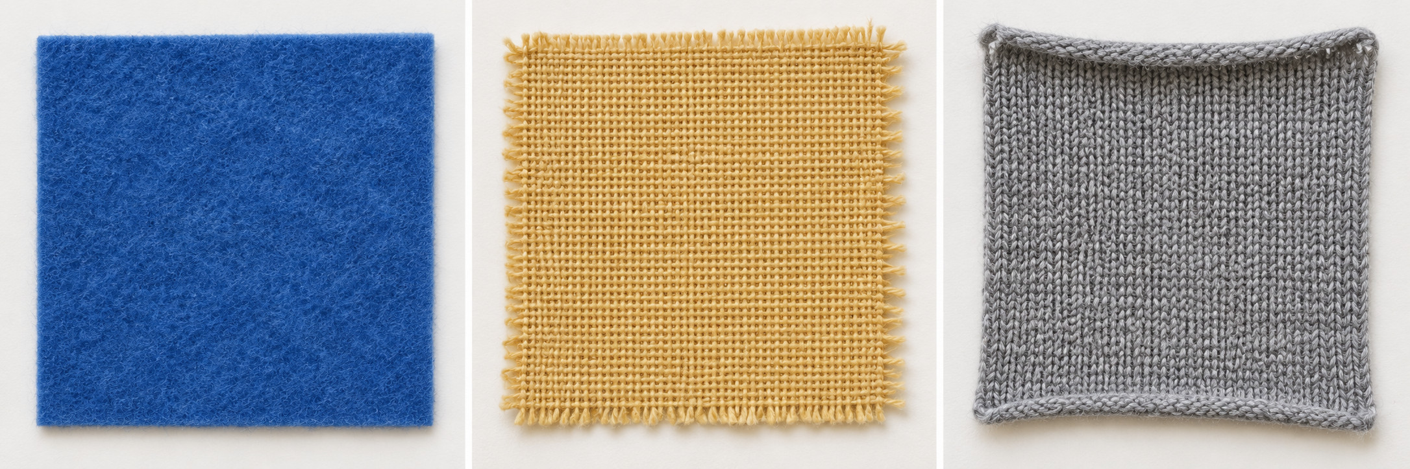
Original invented teaching photo. Left to right: felt, woven cotton, stretch knit. It shows appearance only. The pictured knit has a finished edge; the photo does not prove stretch, fraying or curling.
Generic sample | Model description | Link to the pouch
Non-fraying felt | Model: fairly firm, little stretch, cut edge does not fray. | May support the cards and avoid a fraying edge. Test the actual sample.
Woven cotton | Model: folds easily, little stretch across the weave, cut edge may fray. | May need edge finishing and support to keep its shape. Test the actual sample.
Stretch knit | Model: stretches, may curl at a cut edge, shape can change when pulled. | May be harder to measure and hold steady. Test the actual sample.

These descriptions and the supplied photo are model information. Real fabrics vary. If you test an actual sample, record its real result. If no sample is available, write model information used; do not claim a test.

Check an actual sample or use a model
Design and Technology LAUNCH Spring 1 Week 4 Thursday 28 January 2027 P1 Year A
With an adult, use the checks below on a real sample if available. No cutting, needle or adhesive is required today. If no sample is available, use the labelled model descriptions instead.

Stretch
With adult approval, hold a sample gently at two edges. Pull lightly across it, then release. Does it return to its shape?

Edge
Look at a cut edge. Does it shed threads, stay firm or curl? Do not pull threads out.

Firmness
Bend the sample gently. Could it support three cards without flopping? Keep this as a prediction until the pouch is made.

A result in your own words
Sample ___. Source actual sample / model information ___. Property ___. What I observed or read ___. What that could mean for the pouch ___. My choice and reason ___.

Be precise
An actual sample result tells you about that sample. A model description supports a planning prediction. Neither proves an unmade pouch passed its final fit and handling test. Record uncertainty and a later question.

Gentle handling
Do not force a stretch, tear an edge or pull out threads. Ask for adult handling or no-touch comparison if needed. A colour choice may matter to the user, but link at least one property to the job.

Choose a joining technique
Design and Technology LAUNCH Spring 1 Week 4 Thursday 28 January 2027 P1 Year A
Compare the job each method does and the controls it needs. The open-top pouch needs joined sides and bottom; it needs no fastening.
Method | Job | Control or limit
Hand running stitch | Small passes through both fabric layers join the sides and bottom. | Needs an approved needle, thread and close adult supervision. Default route for this pouch.
Fabric adhesive bonding | A suitable adhesive may join the layers. | Adult must approve the actual label, fabric use and method. Wait for full cure before testing. No guessed cure time, heat or solvents.
Button and loop or ties | A fastening can close an opening. | It does not replace joined sides and bottom. Our open-top pouch needs no fastening. Any change needs a revised approved design.

Default taught method
Plan hand running stitch through both layers along the three seam lines. Next week the adult will show threading, a knot, small even passes about 5 mm apart and securing the end. Today you choose and explain; do not start unsupervised needle work.

A choice with a reason
Adult model: non-fraying felt with hand running stitch. Its firm shape could help hold the cards. Stitch joins the sides and bottom without an adhesive cure wait. Check the actual felt and tools before making. Your choice needs your own reason.

Your own decision
In your book: I choose ___ to join the sides and bottom because ___. I do / do not need a fastening because ___. Adult tool or label check still needed ___.

My design decision
Design and Technology LAUNCH Spring 1 Week 4 Thursday 28 January 2027 P1 Year A
Use these headings in your book. You may speak, sign or direct an adult scribe. Keep your own choices and confirm any recorded words.

Purpose
A reusable open-top pouch for three 60 mm by 80 mm paper cards. My useful feature or access need ___.

Fabric and evidence
I choose ___. A helpful property is ___. This helps hold or handle the cards because ___. My source is an actual sample result / model information ___. A test not done stays pending.

Joining method
I choose hand running stitch / approved bonding / revised method ___. It joins ___. It suits the purpose because ___. A fastening is / is not needed because ___.

Shape and size
Sketch two 100 mm wide by 120 mm high fabric pieces. Mark the seam lines 10 mm inside left, right and bottom. Label the top OPEN. Record any adult-approved revised size or method ___.

Check and keep
One option I rejected and why ___. One change or question ___. Adult design review approved / pending ___. Tool or label checks needed ___. Date and book page ___. Support used ___.
An unmade design is not a completed pouch. Keep this actual decision for measuring and joining next week.

Textile tools and safe choices
Design and Technology LAUNCH Spring 1 Week 4 Thursday 28 January 2027 P1 Year A
Today is choosing and planning. Use the actual classroom tool routine. An adult must approve any tool, sample test or adhesive before use.
1 Wait for adult approval before handling needles, scissors or adhesive. Use only the agreed tools and supervision.
2 Count needles out and back into a safe container. Never put pins or needles in your mouth or leave them in a product.
3 For a pause, put tools down in the agreed place. Keep fingers clear of a needle exit point. Tell the adult about a lost or damaged tool.
4 Use adhesive only after the adult checks the actual label and fabric. Follow the full cure instructions before testing. No heat, irons or solvent route is taught.
5 Today is choosing and planning. A model picture or empty-hand rehearsal does not prove textile testing or making.

If a concern appears
Stop. Put the tool down in the agreed place. Tell the adult about a missing needle, damaged tool, unexpected material or discomfort. Restart only after the adult has resolved the concern.

No materials or tools
With no fabric, tools, paper or printer, hear the purpose and model descriptions. Point, speak or sign a choice. Explain one property and one reason. Rehearse the plan with empty hands. An adult records exact confirmed words when a recording method is available. Mark transcription pending until it exists. Keep actual sample tests and textile making pending.

Record real support
In your book: my actual sample or source ___. Action I did ___. Action an adult did ___. Tool use not done ___. My choice and reason ___.

