Artists find different ways
GROW Spring 1 Week 1 Monday 4 January 2027 P6 Year A Explore
Explore two descriptions of artists' work, test an artistic idea and plan a first response.
Weekly outcome: Explore how artists express resilience and change.
I identify a detail in a description of an artist's work.
I test repetition or a change in my chosen art form.
I explain one choice for my own response.
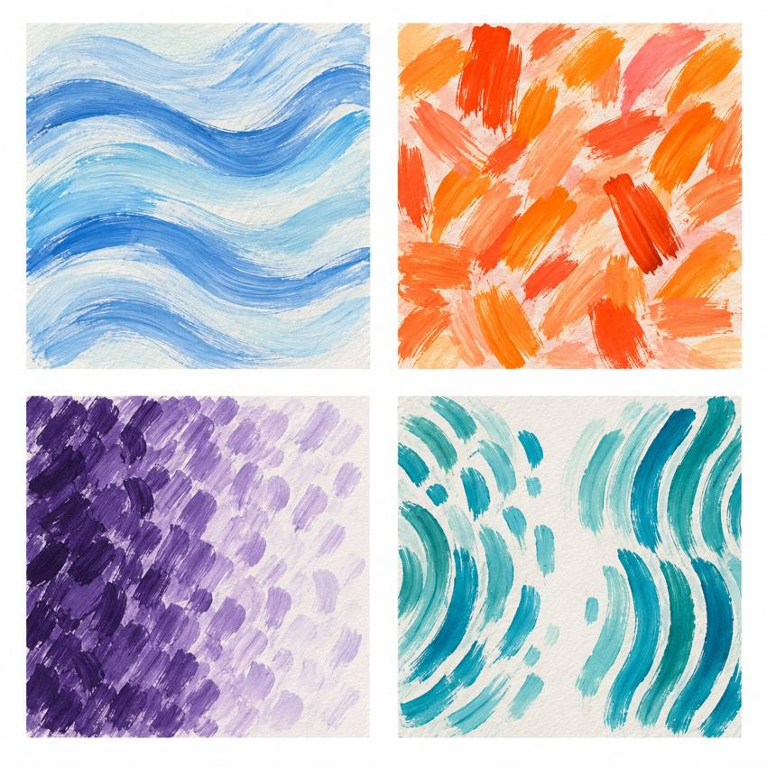
Original teacher models. These are possible readings. You may see or hear a different feeling.
Choose paint, sound or silent movement. GROW can also choose original words or drama. Work may be small. Ask for help or take a calm pause.

My task and routes
GROW Spring 1 Week 1 Monday 4 January 2027 P6 Year A Explore

The main task
Make a small first response about resilience or change. Use your own subject.
Repeat a feature. Change one thing. You may pause or ask for help.

Supported
Choose Matisse's movable shapes or Thomas's repeated marks from two spoken descriptions. Use an adult's model for the first repeat, then choose your own change. Say, point or dictate: 'I chose ... because ...'.

Independent
Identify a detail from each artist card. Make two short trials in your chosen form, then choose one feature for your own first response and explain why.

Aspire
Try the same idea in two forms. You could use marks, then gestures. Choose one form. Say why it fits your idea. The next level task is optional.

My words
An artist detail I noticed was ...
My own first response used ...
I chose this because ...
Next time I will test ...

Artist descriptions and comparison
GROW Spring 1 Week 1 Monday 4 January 2027 P6 Year A Explore
Read these descriptions aloud. No copy of either artist's work is supplied. Use a general method to make your own response.

Henri Matisse Cut-outs Later career
Henri Matisse made paintings and later developed cut-outs as artworks in their own right. Assistants painted paper. He cut shapes and directed their arrangement. The shapes could move while he tested an idea. This gives us a way to discuss changing a method and revising a design.
What could Matisse change before the shapes were fixed?
How might moving a shape help an artist keep an idea going?

Alma Thomas The Eclipse 1970
Alma Thomas developed an abstract painting style using repeated coloured marks. Nature and space helped her find ideas. In The Eclipse, made in 1970, a dark blue centre sits within rings of colour. The centre is off to one side. This arrangement can suggest a moment of movement and change.
Which two details does the description give us?
How could repeating marks help us show a change?
A fact comes from the description. A personal reading starts with This suggests ... to me. Art can show change without telling us an artist's private feelings.

My arts log entry
GROW Spring 1 Week 1 Monday 4 January 2027 P6 Year A Explore
Actual date __________ Lesson ART_GROW_S1_W01_P1
Use your own book or this log page. You can speak, sign or point. An adult can scribe your words and read them back.
Sketch your real work, or describe your sound or movement
An artist detail I noticed was ...
My own first response used ...
I chose this because ...
Next time I will test ...
Adult scribed my words: yes / no. I checked them: yes / not yet.
Staff note: actual help used and exact observed work. Record a first attempt as a first attempt.

