A first response to change
GROW Spring 1 Week 1 Wednesday 6 January 2027 P5 Year A Explore
I can develop my first response, test a change and record how an artist's idea helped me.
Weekly outcome: Explore how artists express resilience and change.
I make or direct an original response to resilience or change.
I test one adjustment and describe its effect.
I add evidence and a personal view to my arts log.
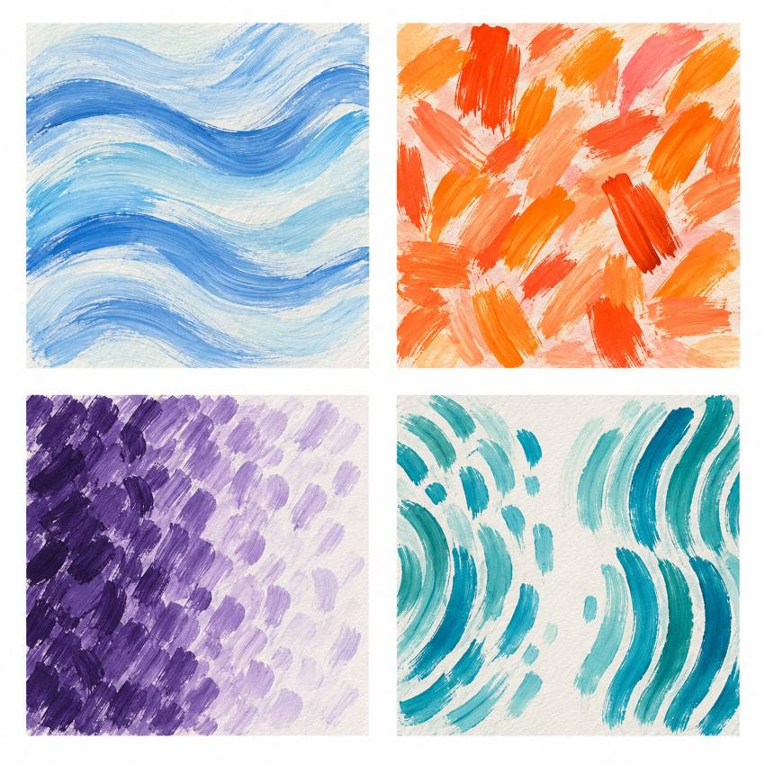
Original teacher models. These are possible readings. You may see or hear a different feeling.
Choose paint, sound or silent movement. GROW can also choose original words or drama. Work may be small. Ask for help or take a calm pause.

My task and routes
GROW Spring 1 Week 1 Wednesday 6 January 2027 P5 Year A Explore

The main task
Develop your own response. Test one change. Choose the version to keep.
Use a quiet or silent route if you prefer. You may pause or ask for help.

Supported
Choose one change from two options. Adult models only its first step. Make or direct the rest and complete 'I changed ... It helped because ...' orally or through a scribe.

Independent
Make your first response. Test one change. Choose which version to keep. Say how an artist's method helped you.

Aspire
Use two features in your piece. Say how they work together. How might someone else read your art? Keep or change a feature. Say why. The next level task is optional.

My words
The artist idea I explored was ...
My own response shows ... through ...
Before, I ... After my test, I ...
I kept or changed ... because ...
My next step is ...

Artist descriptions and comparison
GROW Spring 1 Week 1 Wednesday 6 January 2027 P5 Year A Explore
Read these descriptions aloud. No copy of either artist's work is supplied. Use a general method to make your own response.

Henri Matisse Cut-outs Later career
Henri Matisse made paintings and later developed cut-outs as artworks in their own right. Assistants painted paper. He cut shapes and directed their arrangement. The shapes could move while he tested an idea. This gives us a way to discuss changing a method and revising a design.
What could Matisse change before the shapes were fixed?
How might moving a shape help an artist keep an idea going?

Alma Thomas The Eclipse 1970
Alma Thomas developed an abstract painting style using repeated coloured marks. Nature and space helped her find ideas. In The Eclipse, made in 1970, a dark blue centre sits within rings of colour. The centre is off to one side. This arrangement can suggest a moment of movement and change.
Which two details does the description give us?
How could repeating marks help us show a change?
A fact comes from the description. A personal reading starts with This suggests ... to me. Art can show change without telling us an artist's private feelings.

My arts log entry
GROW Spring 1 Week 1 Wednesday 6 January 2027 P5 Year A Explore
Actual date __________ Lesson ART_GROW_S1_W01_P2
Use your own book or this log page. You can speak, sign or point. An adult can scribe your words and read them back.
Sketch your real work, or describe your sound or movement
The artist idea I explored was ...
My own response shows ... through ...
Before, I ... After my test, I ...
I kept or changed ... because ...
My next step is ...
Adult scribed my words: yes / no. I checked them: yes / not yet.
Staff note: actual help used and exact observed work. Record a first attempt as a first attempt.

