Two ideas for resilience
GROW Spring 1 Week 3 Monday 18 January 2027 P6 Year A Explore
I can plan two different ideas and choose one for a reason.
Weekly outcome: Plan an artwork on the theme of resilience.
I can make two small rough plans.
I can show how each idea links to resilience.
I can choose one idea and give a reason.
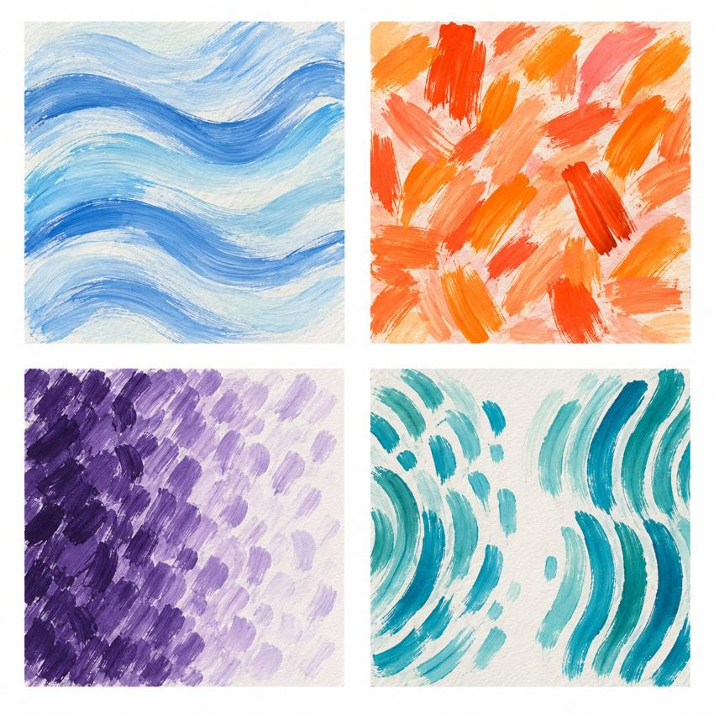
Original teacher models, not work by the artist. You may see or hear a different feeling.
Choose a quiet or silent route if helpful. Ask for help or take a calm pause. Keep two small ideas, choose one and plan what you will need.

My task and routes
GROW Spring 1 Week 3 Monday 18 January 2027 P6 Year A Explore

The main task
Make two small rough plans in your chosen form.
Use different subjects, layouts or sequences.
Add a short note to show what each idea means.
Choose one plan and say why.

Supported
Choose a picture or short sequence plan.
Make two small ideas with an adult if needed.
Point to what is different. Choose one.
Finish: I chose ___ because ___.

Independent
Make two different small plans in your chosen form.
Label the feature that could show resilience.
Choose one idea. Explain why it fits your intention.
Keep both plans and your reason.

Aspire
Complete both rough plans and choose one.
Explain one strength and one limit of each idea.
Say why the chosen idea can be made with simple tools or no tools.
The next level task is optional.

My words
My two ideas were ___.
Each idea could show resilience by ___.
I chose ___ because ___.
The feature I will use is ___.
Next time my plan needs ___.

Two ideas and one plan
GROW Spring 1 Week 3 Monday 18 January 2027 P6 Year A Explore
In your book, make two small plans. A thumbnail is a quick rough sketch. For sound or movement, use short action notes.

Plan A and Plan B
Plan A quick sketch or short action notes
Plan B a different idea or arrangement

My choice
Which idea could show resilience? Choose one and say why. Resilience can include a pause, help or a new way forward.

My materials and actions
Name what you need and count the items. Keep the plan small. List what comes first, next and last. Add a time, space and safe stop cue. If you need no art materials, say which actions or adult help you will use.

Before making
Check that materials are available. Change the plan if needed. Keep both small plans, your reason, materials plan and next step in the arts log. This is a plan, not completed artwork.

My arts log entry
GROW Spring 1 Week 3 Monday 18 January 2027 P6 Year A Explore
Actual date __________ Lesson ART_GROW_S1_W03_P1
Use your own book or this log page. You can speak, sign or point. An adult can scribe your words and read them back.
Chosen plan sketch or ordered action notes
My two ideas were ___.
Each idea could show resilience by ___.
I chose ___ because ___.
The feature I will use is ___.
Next time my plan needs ___.
Adult scribed my words: yes / no. I checked them: yes / not yet.
Staff note: actual help used and exact observed work. Label a plan, trial or finished piece honestly.

