My plan ready for making
GROW Spring 1 Week 3 Wednesday 20 January 2027 P5 Year A Explore
I can develop my chosen plan and explain how I will make it.
Weekly outcome: Plan an artwork on the theme of resilience.
I can label a layout or ordered sequence.
I can plan materials, access, steps and time.
I can use feedback to check what my plan still needs.
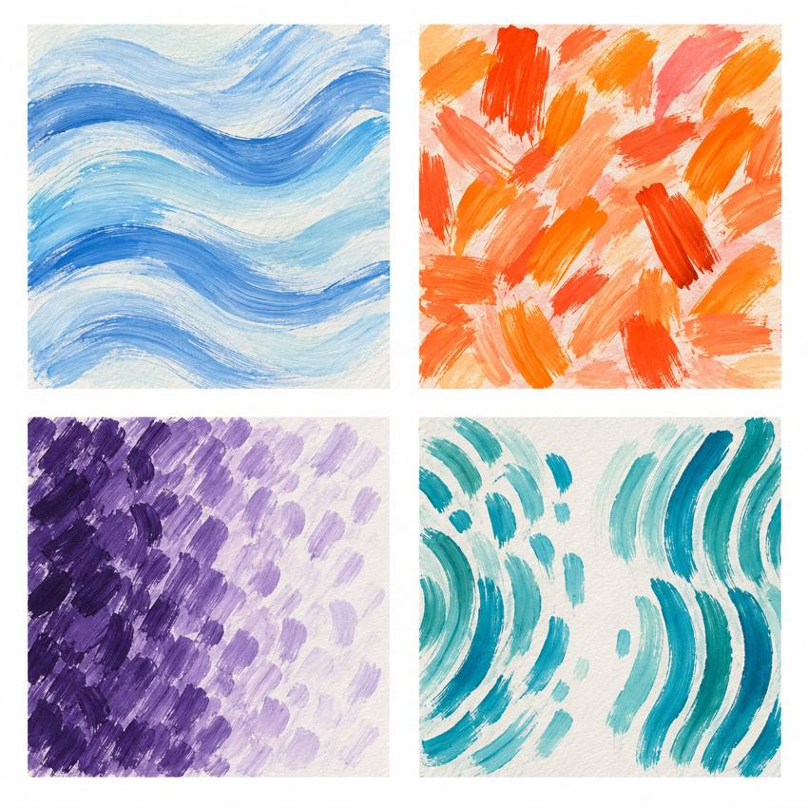
Original teacher models, not work by the artist. You may see or hear a different feeling.
Choose a quiet or silent route if helpful. Ask for help or take a calm pause. Keep two small ideas, choose one and plan what you will need.

My task and routes
GROW Spring 1 Week 3 Wednesday 20 January 2027 P5 Year A Explore

The main task
Develop your chosen layout or sequence. Add short labels.
Count the tools you need, or choose a no-materials route.
List the steps, space, access choice and a draft time plan.
Say how you will check the meaning.

Supported
Find the plan you chose.
Use one heading at a time with an adult.
Add labels or ordered actions. Count tools, or say no tools.
Choose steps and time. Tell or show one next check.

Independent
Label your chosen layout or sequence.
Plan counted tools, space and access, or a no-tools route.
Put the making steps in order. Add a draft time plan.
Use feedback to check one detail. Keep your reason.

Aspire
Check how the plan fits your intended meaning.
Explain one choice about tools, time or access.
Consider a practical question and record your own decision.
The next level task is optional.

My words
My plan shows ___ through ___.
My materials and amounts, or no-tools route, are ___.
My steps and draft time plan are ___.
I kept or changed ___ because ___.
Before making I need to check ___.

Two ideas and one plan
GROW Spring 1 Week 3 Wednesday 20 January 2027 P5 Year A Explore
In your book, make two small plans. A thumbnail is a quick rough sketch. For sound or movement, use short action notes.

Plan A and Plan B
Plan A quick sketch or short action notes
Plan B a different idea or arrangement

My choice
Which idea could show resilience? Choose one and say why. Resilience can include a pause, help or a new way forward.

My materials and actions
Name what you need and count the items. Keep the plan small. List what comes first, next and last. Add a time, space and safe stop cue. If you need no art materials, say which actions or adult help you will use.

Before making
Check that materials are available. Change the plan if needed. Keep both small plans, your reason, materials plan and next step in the arts log. This is a plan, not completed artwork.

My arts log entry
GROW Spring 1 Week 3 Wednesday 20 January 2027 P5 Year A Explore
Actual date __________ Lesson ART_GROW_S1_W03_P2
Use your own book or this log page. You can speak, sign or point. An adult can scribe your words and read them back.
Chosen plan sketch or ordered action notes
My plan shows ___ through ___.
My materials and amounts, or no-tools route, are ___.
My steps and draft time plan are ___.
I kept or changed ___ because ___.
Before making I need to check ___.
Adult scribed my words: yes / no. I checked them: yes / not yet.
Staff note: actual help used and exact observed work. Label a plan, trial or finished piece honestly.

