BUILD · Monday 25 January 2027 · P5 · ART_BUILD_S1_W04_P1

Knowledge organiser
New marks from texture
Weekly outcome: Try a new expressive technique.
I can try a rubbing to show a feeling.

Today I can
I can try the new way with help if I need it.
I can compare two tests.
I can choose one and say or show why.

Words to use
texture — How a surface feels or looks.
rub — Move a tool back and forth.
light — With a small amount of force.
test — A small try before a piece.

One worked example
Teacher example only: the ridged marks suggest energy to me. Another maker may read them as calm.
Your idea may differ. Use your own words and choices.

BUILD · Monday 25 January 2027 · P5 · ART_BUILD_S1_W04_P1

Choose one task route

Supported
Pick a feeling or point to a choice.
Direct an adult through two small tests.
Choose one texture.
Say or show why you chose it.

Independent
Choose a made-up feeling.
Make two texture tests with the same crayon.
Pick the texture that fits your idea.
Keep both tests and your reason.

Aspire
Complete the same two tests.
Try a lighter sweep on a small spare area.
Say what changes in the marks.
Choose a version for a reason.
Use one route at a time. You may change route with the adult.

BUILD · Monday 25 January 2027 · P5 · ART_BUILD_S1_W04_P1

Activity cards
Use these as prompts. Complete your response in your book, arts log or chosen art form.

1 0 to 15 seconds
Put ridged card on the table. Lay thin paper over it. Hold the paper edge.

2 15 to 30 seconds
Place the crayon on its side. Make four light back-and-forth sweeps.

3 30 to 45 seconds
Lift the paper. Notice the ridges. Make a small second test over smooth card.

4 45 to 60 seconds
Compare the actual marks. Choose a test and explain a possible feeling.

Your own making
Make your own choice. Keep or change one feature and give your reason.
Make a smooth glide and a stop-start hand path, with a still end pose. Choose one texture for the invented feeling. Pupil may direct the adult or use eye-pointing. Staff record the actual movement method, not rubbing.

BUILD · Monday 25 January 2027 · P5 · ART_BUILD_S1_W04_P1

Two texture tests
Original class examples. These are not pupil work or evidence.
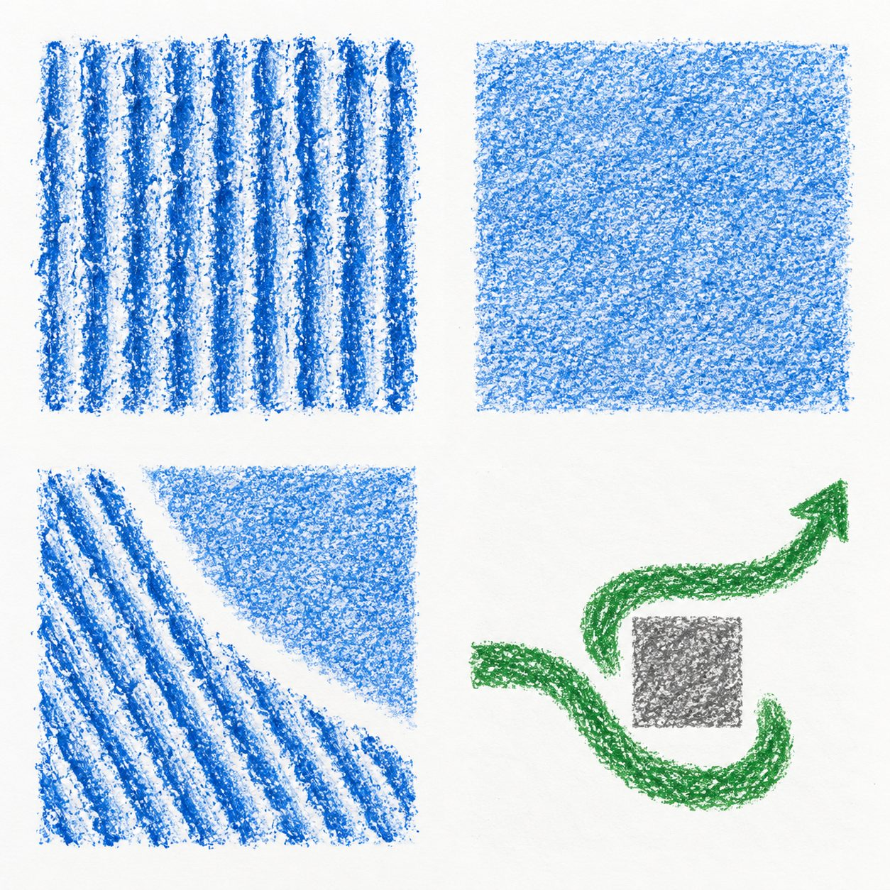

Ridged card
Paper rests on ridges. Gentle rubbing can reveal repeated lines.
The broken lines might suggest energy.

Smoother card
Paper rests on a flatter surface. The rubbing may be more even.
The softer patch might suggest calm.
Say what you notice. The maker can choose a different meaning.

BUILD · Monday 25 January 2027 · P5 · ART_BUILD_S1_W04_P1

My arts log
In your book or existing arts log. You can draw, speak, sign or direct an adult.
The new way I tried was ___.
My two tests were ___.
My feeling or idea is ___.
I chose ___ because ___.
Next time I will ___.

Keep a true record
Actual activity date ___. Method used ___. Help used ___.
Adult scribed my words: yes / no. I checked them: yes / not yet.
Keep your own tests or actual work. A witness note should say exactly what happened.

