GROW · Wednesday 27 January 2027 · P5 · ART_GROW_S1_W04_P2

Knowledge organiser
Developing my resilience piece
Weekly outcome: Create my resilience-themed piece.
I can develop my piece and explain my changes.

Today I can
I can continue my piece from the real next step.
I can check it against my intended idea.
I can log my decisions, changes and actual stage.

Words to use
resilience — Finding a way forward, with help or a change of plan.
intention — The idea or effect you want to show.
decision — A choice you make.
revise — Change part of a plan or piece.

One worked example
Teacher example only: I finished the route. I tested a longer gap but kept the short gap because I wanted a clear, steady turn.
Your idea may differ. Use your own words and choices.

GROW · Wednesday 27 January 2027 · P5 · ART_GROW_S1_W04_P2

Choose one task route

Supported
Read your next step with an adult.
Make or direct one small part.
Choose what to keep or change.
Confirm what is finished and what comes next.

Independent
Continue from the real first version.
Check one feature against your intention.
Explain your keep-or-change decision.
Log the actual stage and next step.

Aspire
Complete the core making task.
Compare the first version and a new test.
Explain which effect fits the intention.
Use or decline feedback with a reason.
Use one route at a time. You may change route with the adult.

GROW · Wednesday 27 January 2027 · P5 · ART_GROW_S1_W04_P2

Activity cards
Use these as prompts. Complete your response in your book, arts log or chosen art form.

1 0 to 15 seconds
Show Monday first version beside the plan and read the real next step.

2 15 to 30 seconds
Complete the next section or final actions.

3 30 to 45 seconds
Try one small change in the gap or pause. Compare both real versions.

4 45 to 60 seconds
Choose a version, explain why and record whether the actual piece is complete.

Your own making
Make your own choice. Keep or change one feature and give your reason.
Develop or direct a short silent sequence. Staff witness the final order, pauses, changes, help and pupil meaning. No recorded media is required.

GROW · Wednesday 27 January 2027 · P5 · ART_GROW_S1_W04_P2

First version and chosen version
Original class examples. These are not pupil work or evidence.
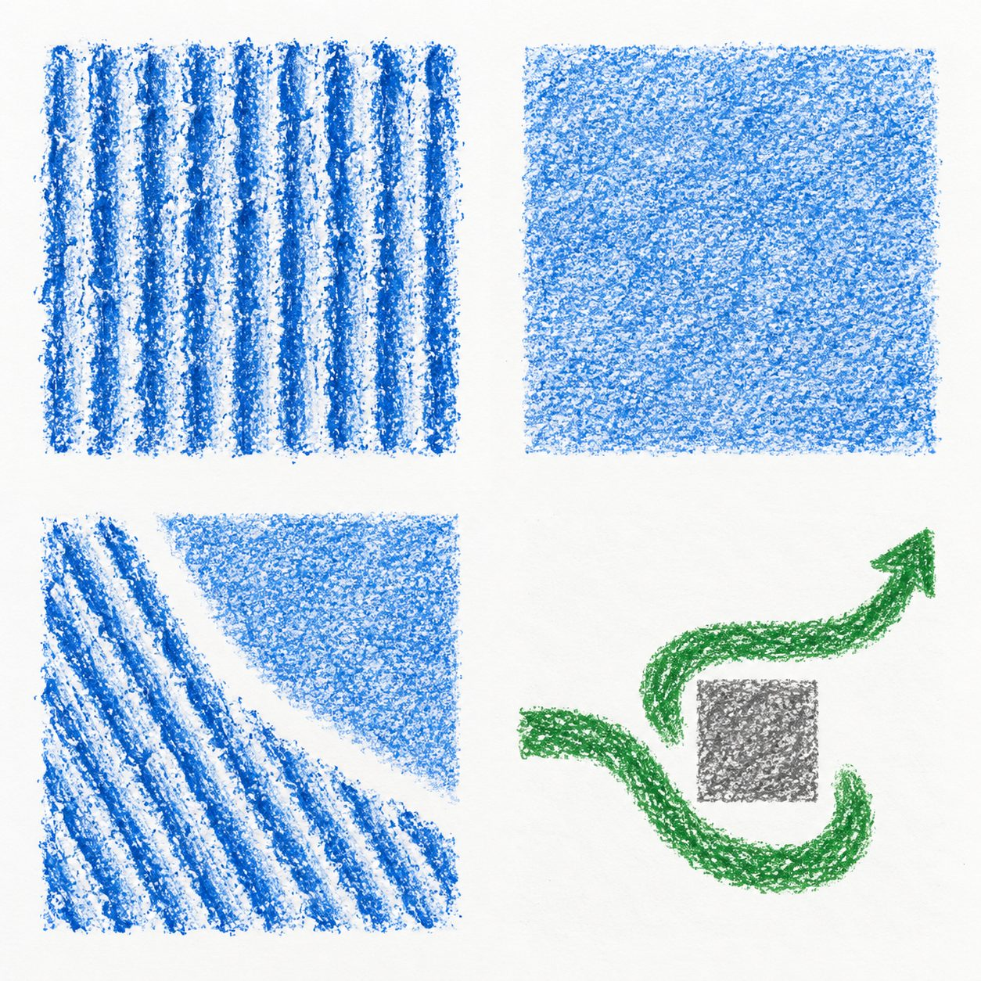

First version
A line reaches a block and starts a turn.
The ending has not been made.

Chosen version
The new route continues into open space. A pause or gap stays short.
The maker chose a short pause after comparing both versions.
Say what you notice. The maker can choose a different meaning.

GROW · Wednesday 27 January 2027 · P5 · ART_GROW_S1_W04_P2

My arts log
In your book or existing arts log. You can draw, speak, sign or direct an adult.
My piece shows ___ through ___.
Today I actually made or refined ___.
I kept / changed ___ because ___.
Compared with my Week 3 plan, ___.
My work or witness note is ___.
The piece is finished / still needs ___.
My next step is ___.

Keep a true record
Actual activity date ___. Method used ___. Help used ___.
Adult scribed my words: yes / no. I checked them: yes / not yet.
Keep your own tests or actual work. A witness note should say exactly what happened.

