Review and choose one change
GROW Spring 1 Week 5 Monday 1 February 2027 P6 Year A Explore
I can review my real work and test one change for a reason.
Weekly outcome: Review and improve my work.
I can review my intention, features and real progress.
I can choose one small change and test it.
I can record the actual result and my next step.
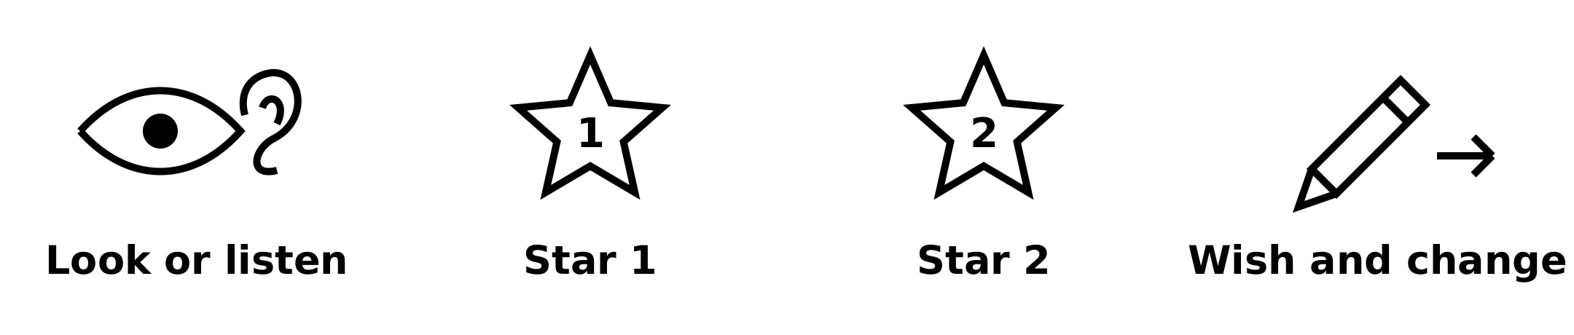
Picture prompts have words as well as symbols. Use your own real work; these prompts are not pupil evidence.
Choose a quiet or silent route if helpful. Ask for help or take a calm pause. Review against your real plan. Peer feedback is private and optional.

My task and routes
GROW Spring 1 Week 5 Monday 1 February 2027 P6 Year A Explore

The main task
Choose one small change from your review.
Test it in your actual form or a small test version.
Keep the real starting feature and the test result.
Record what the test did and what you will revise next time.

Supported
Review one prompt at a time with an adult.
Choose one small change. Test it.
Tell or show what the test did.
Keep the real record and next revision. Peer feedback is optional.

Independent
Review intention, features, form, progress and help.
Choose and test one small change.
Record the real effect and one next revision.
Use self, staff or one agreed private peer comment.

Aspire
Use your real review and test.
Explain why the change fits your intention.
Say what a comment helped you notice, or use self-review.
The next level task is optional.

My words
My intention and a feature I notice are ___.
My form, progress and help were ___.
I tested ___ because ___.
The actual effect was ___.
Feedback route: self / staff / one agreed private peer comment.
Peer comment: used / not used / declined / unavailable / stopped.
My next revision is ___.

My review and one revision
GROW Spring 1 Week 5 Monday 1 February 2027 P6 Year A Explore
Use your actual Week 3 plan and your own current work. Compare what you meant with what exists. If either is missing, make a fresh small starting point and date it honestly.

Self review
Check the resilience idea, chosen features, form and current stage. Identify a feature that matches the plan and one small change that could help.

Optional private peer comment
Ask only if both pupils choose it. Share only a part the maker agrees to show, privately and never to the class. Either pupil can stop. Keep at most one peer comment. If the route is not used, record that and use staff feedback or self-review instead.

One improvement made
Make the chosen revision. Keep a before note, the real change and the actual result. If a new version is needed, retain both versions. A change is not proof of a better effect; say what actually happened.
My chosen change was ___.
I changed ___. The result was ___.
The feedback source and next step are ___.

My arts log entry
GROW Spring 1 Week 5 Monday 1 February 2027 P6 Year A Explore
Actual date __________ Lesson ART_GROW_S1_W05_P1
Use your own book or this log page. You can speak, sign or point. An adult can scribe your words and read them back.
Before and revised work sketch or sequence notes
My intention and a feature I notice are ___.
My form, progress and help were ___.
I tested ___ because ___.
The actual effect was ___.
Feedback route: self / staff / one agreed private peer comment.
Peer comment: used / not used / declined / unavailable / stopped.
My next revision is ___.
Adult scribed my words: yes / no. I checked them: yes / not yet.
Staff note: actual help used and exact observed work. Keep the starting work, real revision and support honest.

