Week 3 Build the world
Step by step · GROW computing · 40 minutes
Name: _____________________ Date: __________
I can create a maze, a player and a finish as three sprites.
Point, say, draw or write. Someone may record your exact words.
Arrival > Starter > I Do > We Do
I Do 2 > We Do 2 · Task > Independent Task > Exit

Arrival 0 to 3 minutes
Start a new project with W03_Blank.sb3.

Starter 3 to 6 minutes
Look at the small player and the large player. Which can fit through the gap?
My prediction
________________________________________________________________

I Do 6 to 11 minutes
Watch the model. Point to the sprite or block that matters.

We Do 11 to 18 minutes
Predict. Ask a partner or adult to check your idea. Test together. Explain what changed.
Shared test | We expect | We see
Player is small | Can it pass a gap?
Player is much larger | Can the same gap still work?
My three sprites | Can I select each one?

I Do 2 18 to 21 minutes
Place Player away from a wall. Place Finish where Player can reach it.

We Do 2 · Task 21 to 25 minutes
Show your next action. Choose a task route with your teacher.
Name each of the three sprites. Check the first passage with a token.

My coding task
Step by step · Independent Task 25 to 35 minutes
□ Open W03_Blank.sb3.
□ Choose Paint from the Choose a Sprite menu.
□ Name the new sprite Maze.
□ Draw two border walls and one wall with a gap.
□ Paint a small square sprite. Name it Player.
□ Paint a finish sign sprite. Name it Finish.
□ Place Player at a clear start. Place Finish at the end.
□ Trace a route. Make a gap wider if Player will not fit.
My three sprites: Maze / Player / Finish
One test I ran | Expected result | Actual result

Exit 35 to 40 minutes
□ Save as W03_Maze.sb3.
□ Load the saved file.
□ Run the check or select the three sprites.
File > Save to your computer. Then File > Load from your computer. Keep the .sb3 file in your school folder.

Help for the next step
Step by step reference · Keep beside your device
Find this | Use it like this
Maze | Choose a Sprite > Paint. Name it Maze. Draw walls on its costume.
Player | Paint or choose a small sprite. Name it Player.
Finish | Paint or choose a visible sign. Name it Finish.
Position | Drag Player to its start. Note the x and y boxes below the stage.

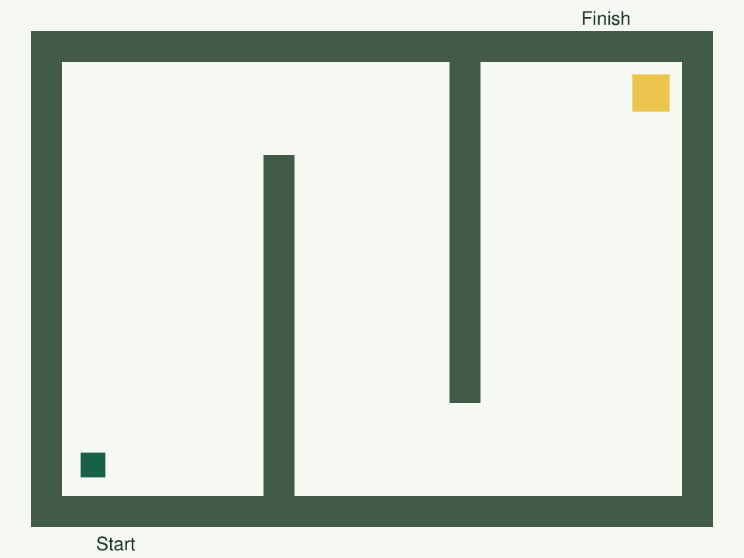
Example only. Trace a route with a small token.
Pupils create their own Maze, Player and Finish sprites.

My help signals
NOW | NEXT | HELP
Show one action. | Show the next block. | Read or model it.
PAUSE: I need a break. | RETURN: same action. | CHECK: watch my test.

Paper rehearsal prepares the idea. Complete the code, tests and save on a device.

My voice
Tell someone your idea. Ask what changed.
“What I said, and what it changed”
My idea and the reply
________________________________________________________________

