Week 5 Make a rule work
Step by step · GROW computing · 40 minutes
Name: _____________________ Date: __________
I can make Player return to the start when it touches Maze.
Point, say, draw or write. Someone may record your exact words.
Arrival > Starter > I Do > We Do
I Do 2 > We Do 2 · Task > Independent Task > Exit

Arrival 0 to 3 minutes
Open your own W04_Controls.sb3.

Starter 3 to 6 minutes
The script checks only at the green flag. Player touches a wall later.
My prediction
________________________________________________________________

I Do 6 to 11 minutes
Watch the model. Point to the sprite or block that matters.

We Do 11 to 18 minutes
Predict. Ask a partner or adult to check your idea. Test together. Explain what changed.
Shared test | We expect | We see
Move through clear space | No return to start
Touch one wall | Return to the safe start
Touch another wall | Return to the safe start

I Do 2 18 to 21 minutes
Put if then inside forever. Put touching Maze? in its question space.

We Do 2 · Task 21 to 25 minutes
Show your next action. Choose a task route with your teacher.
Point to the condition. Point to the action that follows contact.

My coding task
Step by step · Independent Task 25 to 35 minutes
□ Select Player. Keep your four key scripts.
□ Find when green flag clicked in Events.
□ Join forever from Control underneath it.
□ Put if then inside forever.
□ Put touching [Maze]? from Sensing into the condition.
□ Put go to x [start x] y [start y] inside if then.
□ Run the flag. Touch a wall. Check the return.
□ Test a second wall and a clear space.
My safe start: x ______ y ______
One test I ran | Expected result | Actual result

Exit 35 to 40 minutes
□ Save as W05_Walls.sb3.
□ Load the saved file.
□ Run the check or select the three sprites.
File > Save to your computer. Then File > Load from your computer. Keep the .sb3 file in your school folder.

Help for the next step
Step by step reference · Keep beside your device
Find this | Use it like this
Events | when green flag clicked
Control | forever contains the if then block
Sensing | touching [Maze]? fits in the if condition
Motion | go to x [start x] y [start y] fits inside if then
Keep | The four key scripts and the original start script remain on Player.

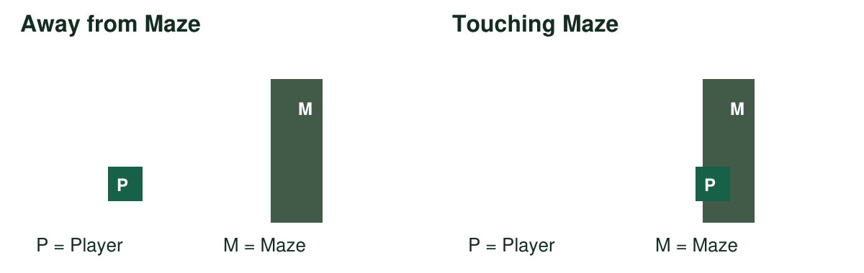
Point to the picture where the condition is true. Point to the action that should run.

My help signals
NOW | NEXT | HELP
Show one action. | Show the next block. | Read or model it.
PAUSE: I need a break. | RETURN: same action. | CHECK: watch my test.

Paper rehearsal prepares the idea. Complete the code, tests and save on a device.

My voice
Tell someone your idea. Ask what changed.
“What I said, and what it changed”
My idea and the reply
________________________________________________________________

