Week 6 Finish and restart
Step by step · GROW computing · 40 minutes
Name: _____________________ Date: __________
I can create a win response and start a fresh game.
Point, say, draw or write. Someone may record your exact words.
Arrival > Starter > I Do > We Do
I Do 2 > We Do 2 · Task > Independent Task > Exit

Arrival 0 to 3 minutes
Open your own W05_Walls.sb3.

Starter 3 to 6 minutes
Player reaches Finish. What should the game do?
My prediction
________________________________________________________________

I Do 6 to 11 minutes
Watch the model. Point to the sprite or block that matters.

We Do 11 to 18 minutes
Predict. Ask a partner or adult to check your idea. Test together. Explain what changed.
Shared test | We expect | We see
Fresh flag, away from Finish | No win message
Reach Finish | Win message appears once
Stay at Finish for another check | No repeated win response

I Do 2 18 to 21 minutes
First clear the old message. Go to a safe start before waiting for Finish.

We Do 2 · Task 21 to 25 minutes
Show your next action. Choose a task route with your teacher.
Win once. Click the green flag. Check the message clears.

My coding task
Step by step · Independent Task 25 to 35 minutes
□ Select Player.
□ Add a new when green flag clicked block.
□ Join say [blank] from Looks. Leave its text box empty.
□ Join go to your safe x and y.
□ Join wait until from Control.
□ Put touching [Finish]? in the condition.
□ Join say [Made it!] below wait until.
□ Test a win. Restart with the flag. Check the wall rule and win again.
My safe start: x ______ y ______
One test I ran | Expected result | Actual result

Exit 35 to 40 minutes
□ Save as W06_Win.sb3.
□ Load the saved file.
□ Run the check or select the three sprites.
File > Save to your computer. Then File > Load from your computer. Keep the .sb3 file in your school folder.

Help for the next step
Step by step reference · Keep beside your device
Find this | Use it like this
First | when green flag clicked; say [blank]; go to your start
Control | wait until contains touching [Finish]? from Sensing
Win action | Join say [your message] below wait until. The script then reaches its end.
Looks choice | Use say [message], with no seconds. Leave the first say text box empty.
During play | Keep the four key scripts and wall rule. They still work after the win message.

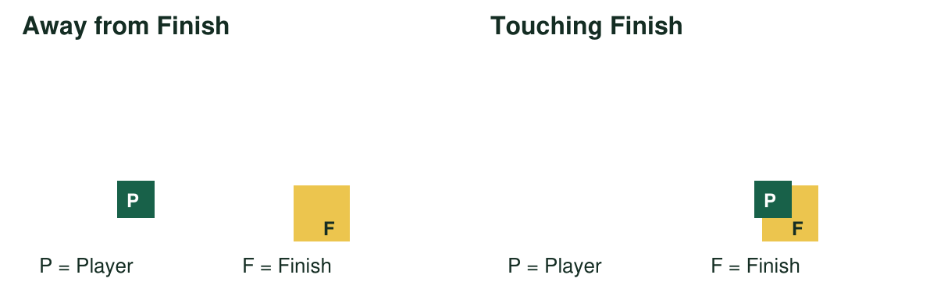
Point to the picture where the condition is true. Point to the action that should run.

My help signals
NOW | NEXT | HELP
Show one action. | Show the next block. | Read or model it.
PAUSE: I need a break. | RETURN: same action. | CHECK: watch my test.

Paper rehearsal prepares the idea. Complete the code, tests and save on a device.

My voice
Tell someone your idea. Ask what changed.
“What I said, and what it changed”
My idea and the reply
________________________________________________________________

