Safe dish preparation knowledge organiser
Design and Technology LAUNCH Spring 1 Week 2 Thursday 14 January 2027 P1 Year A
Weekly outcome verbatim: FOODWISE: prepare a 2-3 step dish safely.
I can follow my checked plan to prepare a simple dish and show safe working.

Today I can
[ ] I can complete the agreed preparation steps with the support I need.
[ ] I can show hygiene and safe tool use before, during and after making.
[ ] I can keep an honest record of my finished plate and the support used.

Our three step model
Prepare the washed produce using agreed tools or adult-prepared vegetables. Mash ready-to-eat beans and mix the filling. Fill and fold the wrap and serve the sides.

A safe change
If a label, ingredient, tool or support need changes, stop and ask the adult to check it. A familiar package is not permission to use it.

Evidence to keep
Keep a record of the actual dish, safety actions, support and real changes. Record a food-only plate photo privately, or leave photo status pending. A teaching picture or simulation does not prove preparation.

Resilience and change
A useful adjustment keeps the meal possible and safe. Ask for help, prepared ingredients or another approved route when needed.
In your book. Rehearse in any language. No tasting is compulsory. Share personal health information privately with the adult.

Picture step card
Design and Technology LAUNCH Spring 1 Week 2 Thursday 14 January 2027 P1 Year A
Use your checked Week 1 plan. The adult gives GO before ingredients or tools are issued. Follow the actual approved quantities and any agreed substitution.
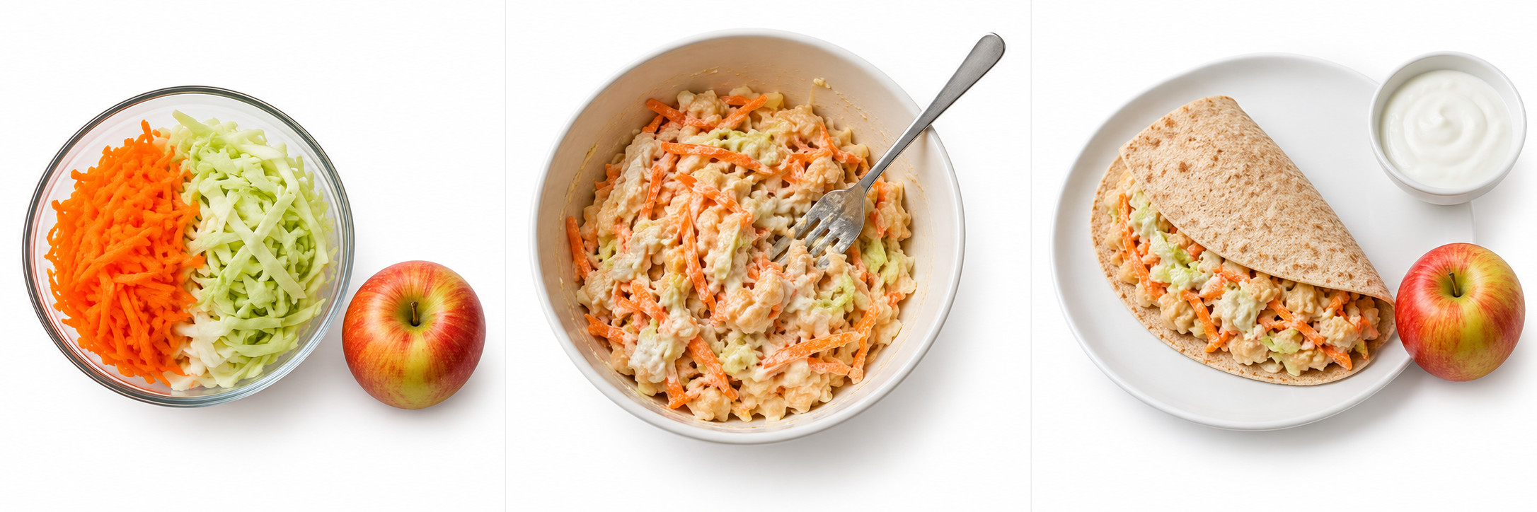
Original invented teaching pictures. Read left to right: prepare, mix, assemble. These are not pupil work or an exact guide to quantities.

1 Prepare
After the adult’s checks, wash hands with soap and water and dry them. Wash the carrot, cabbage and apple. Grate the carrot and finely slice the cabbage with adult-approved tools and supervision. Use prepared vegetables if agreed.

2 Mix
Mash 80 g of cooked beans labelled ready to eat with a fork. Mix in about 20 g from the single 60 g yoghurt portion. Add the carrot and cabbage. An adult opens tins and removes sharp lids.

3 Assemble
Put the filling on the wholemeal wrap and fold it. Serve with the apple and the remaining yoghurt. Ask the adult to check the plate and store or serve it safely. Tasting is optional.

Ingredients and the agreed method
Design and Technology LAUNCH Spring 1 Week 2 Thursday 14 January 2027 P1 Year A
Cold bean and vegetable wrap with fruit and plain yoghurt
Model ingredient | Amount for one person
Wholemeal wrap | 1 wrap
Ready-to-eat cooked beans | 80 g drained
Carrot | 60 g
Cabbage | 40 g
Plain yoghurt | 60 g
Apple | 1 small

These are the Week 1 model quantities for one person. Use the pupil’s actual approved plan and any checked substitution. Individual needs and appetite vary. One 60 g yoghurt portion is split: about 20 g in the filling and 40 g alongside.

Check the actual plan
Read the dish, ingredients, amounts and changes from the pupil’s own Week 1 plan. Keep it beside the station. A different ingredient or tool needs the adult’s approval first. Check every actual label against current individual records.

Tool and food choices
Only cooked beans labelled ready to eat go into this cold dish. Dry or merely soaked beans need a different cooking process. An adult opens tins and removes sharp lids. The adult demonstrates and supervises any knife or grater use. Offer prepared vegetables or pupil-directed adult handling.

Finishing safely
Put tools down at the stop point. Ask for the adult’s serving, storage or disposal decision. Follow the cleaning routine. Tasting is optional. An unfinished dish is recorded honestly.

If there is no kitchen
Use the checked cold assembly route. If clean handwashing, preparation, label checks or chilling cannot be approved, simulate and keep practical competence pending.

Before during and after safety check
Design and Technology LAUNCH Spring 1 Week 2 Thursday 14 January 2027 P1 Year A
Use these prompts with the adult. A tick follows an actual check or action. A blank check does not mean it is safe to continue.

Before
[ ] Adult clears the private allergy and dietary checks from current school records and actual ingredient labels.
[ ] Wash and dry hands. Clean the surface and tools. Tie hair back and cover cuts.
[ ] Use the checked plan, agreed tools and cooked ready-to-eat beans. Keep chilled food refrigerated until needed.

During
[ ] Use only approved tools with the agreed supervision. Put a tool down before asking for help.
[ ] Keep food and utensils protected from raw-food contamination and allergen cross-contact. Use clean utensils and do not share tasting spoons.
[ ] If there is a spill, a cut, an unexpected ingredient or uncertainty, stop and tell the adult. Keep chilled food out for the shortest preparation time.

After
[ ] Adult agrees immediate serving, refrigeration at 0–5°C, or disposal. Follow use-by and storage instructions.
[ ] Adult transfers unused beans from an opened tin into a clean covered food container before refrigeration.
[ ] Clear and clean using the agreed routine. Put waste away, wash hands and complete the actual record.

My actual record
In your book: one action before ___. One action during ___. One action after ___. Help used ___. Anything unfinished or changed ___.
GO depends on the adult’s checks from records, actual ingredients and facilities. Stop for uncertainty. Tasting is optional.

Cold assembly without a kitchen
Design and Technology LAUNCH Spring 1 Week 2 Thursday 14 January 2027 P1 Year A
The planned meal is already a no-heat dish. This route removes pupil knife and grater use by supplying prepared vegetables.

Adult approval first
Approve the actual food, individual records, labels, hygiene facilities, clean equipment and cold storage. A room without a kitchen still needs potable handwashing water, suitable cleaning and a food-safe work surface. A checked cold container must maintain 0–5°C. If any condition fails, use simulation.

The agreed cold assembly dish
Use the pupil’s checked bean and vegetable wrap plan. An adult supplies washed, pre-cut vegetables, washed fruit and cooked ready-to-eat beans. Use a fork, bowl and clean surface. Keep the same approved ingredient amounts.
1 Prepare the clean station and wash and dry hands. Use the adult-prepared produce.
2 Mash the beans. Mix in about 20 g from the single 60 g yoghurt portion and add the vegetables.
3 Fill and fold the wrap. Serve fruit and remaining yoghurt. Follow the adult’s storage and cleaning decision.

No safe facilities or materials
With no safe food facilities, food or equipment, rehearse with empty hands or pictures. The pupil explains or directs the three steps and names a safety action at each point. Record this as planning or simulation, not preparation. Mark the practical and any plate photo pending. Rebook the practical when the adult can meet all safety requirements.

Record the actual route
In your book: cold assembly / simulation ___. Actions I completed ___. Adult actions ___. Safe checks observed ___. Plate photo actual location / pending ___. No tasting or photo is invented.

Food only plate photo record
Design and Technology LAUNCH Spring 1 Week 2 Thursday 14 January 2027 P1 Year A
Use only a photograph of the pupil’s actual food. The recipe pictures are teaching models and must never be submitted as pupil evidence.

Before capture
The adult uses an approved device after food handling stops. Place the food on a plain surface. Keep all people, faces, hands, names, labels, screens and reflections out of the frame. Keep the device away from food preparation.

Private evidence checks
Use the approved private storage process. Prevent automatic upload or public posting. Before export or attachment, the adult verifies a copy with location and other identifying metadata removed. Restore hand hygiene before returning to food handling.

Actual record to complete
Actual date ___. Dish ___. Private plan or book reference ___. Photo status captured and verified / pending ___. Private image reference or location ___. Checking adult role ___. Metadata check completed ___. Food-only frame checked ___. No public or automatic upload confirmed ___. Support used ___.

Pupil explanation
I prepared ___ with ___ help. One safe action I used was ___. One real change was ___.

If a photo cannot be taken
Mark the photo pending. Keep a truthful drawing or written plate description with the adult’s observations of preparation. Label the record as a drawing or description. It is not a photo. Record what actually happened and arrange a suitable photo opportunity only if appropriate.
A photograph shows the plate. It does not prove safe preparation or independent tool use. Keep process observations alongside it. Do not include completed private records in public teaching files.

Practical evidence record
Design and Technology LAUNCH Spring 1 Week 2 Thursday 14 January 2027 P1 Year A
Outcome verbatim: FOODWISE: prepare a 2-3 step dish safely.
Actual date ___. Private pupil record or book page ___. Dish and plan reference ___. Route used practical / cold assembly / simulation ___. Record only what happened.
Evidence feature | Actual observation and comment
Preparation steps completed or directed | ________________________________
Hygiene and safe tool actions observed | ________________________________
Pupil actions and adult support separated | ________________________________
Real change from the Week 1 plan | ________________________________
Storage serving or disposal decision | ________________________________
Food-only plate photo location or pending | ________________________________

Pupil words
I prepared ___. A safe action I used was ___. Help I used ___. Words read back and confirmed yes / not yet ___. One next step ___.

Evidence boundary
A photo records the food, not the whole process. Record safe preparation through actual observation. Pupil-directed adult handling is valid participation but does not prove an unperformed knife or grater skill. A simulation leaves practical competence pending.

