Body words on a diagram
The diagrams and stories are not real people.
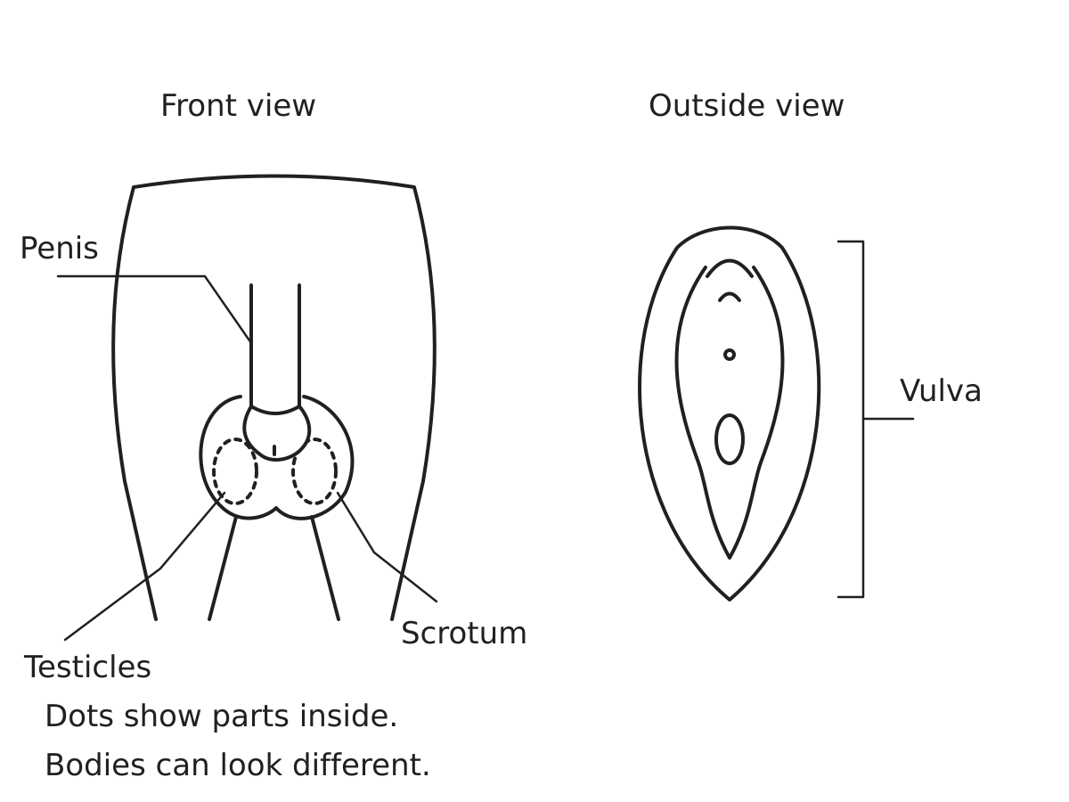
The dotted parts are inside the scrotum. They are not seen through the skin.
A young person can use these words to ask for help. No one needs to show a body part.
Word cards to cut | Word cards to cut
penis | scrotum
testicles | vulva
Which taught word matches each label or part?

Cards for the fictional case
What should happen in each story? All the people are made up.
Story card | Story card
A. A young person is changing clothes. Another person knocks and waits outside. | B. A young person is using a toilet. Someone opens the closed door without asking.
C. A young person has a worry about a private body part. They tell a trusted adult. | D. Someone asks a young person to show a part under their pants and keep it secret.
E. A young person needs help to wash. A care adult explains the help, asks first and gives privacy. | F. A young person asks for help with a worry. The first adult is busy.
A choice can be spoken, pointed to, drawn or written. An adult can read the card.

A response for the fictional person
Action choice | Action choice
Give space and wait | Open the door at once
Tell a trusted adult | Keep a worry secret
Taught word and diagram match
________________________________________________
A private body part is not dirty or bad. The person can seek help with a worry.
Two different story choices
Record | First story | Second story
Story card | ________ | ________
Action chosen
Reason from the story
Every answer is about the made-up young person.

